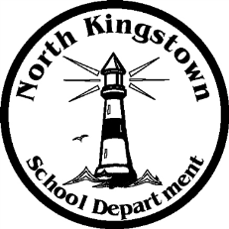
North Kingstown School Department

Payroll Department

100 Romano Vineyard Way Suite 120
North Kingstown, RI 02852-6202
(401) 268-6461 www.nksd.net
Fax: 268-6445 TDD: 268-6457
Alicia_jones@nksd.net
Educate

Inspire

Challenge

PAYROLL SCHEDULE SYE 17-18

PAY DATE PAY DATE

7/14/2017 1/12/2018

7/28/2017 1/26/2018

8/11/2017 2/9/2018

8/25/2017 2/23/2018

9/8/2017* 3/9/2018

9/22/2017 3/23/2018

10/6/2017 4/6/2018

10/20/2017 4/20/2018

11/3/2017 5/4/2018

11/17/2017 5/18/2018

12/1/2017 6/1/2018

12/15/2017 6/13/2018***
6/15/2018**

12/29/2017 6/29/2018**

* First pay for Teachers SYE 17-18
** Only Admin, 10 & 12 month ESP (NO Teachers paid)
*** Teachers only Balloon Pay x 6 pays

