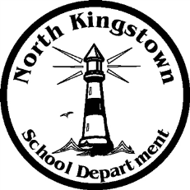
North Kingstown School Department

Payroll Department

100 Romano Vineyard Way Suite 120
North Kingstown, RI 02852-6202
(401) 268-6461 www.nksd.net
Fax: 268-6445 TDD: 268-6457
Alicia_jones@nksd.net
Educate

Inspire

Challenge

PAYROLL SCHEDULE SYE 19-20

PAY DATE PAY DATE

7/12/2019 1/10/2020

7/26/2019 1/24/2020

8/9/2019 2/7/2020

8/23/2019 2/21/2020

9/6/2019* 3/6/2020

9/20/2019 3/20/2020

10/4/2019 4/3/2020

10/18/2019 4/17/2020

11/1/2019 5/1/2020

11/15/2019 5/15/2020

11/29/2019 5/29/2020

12/13/2019 6/12/2020***

12/27/2019 6/26/2020**

* First pay for Teachers SYE 19-20
** Only Admin, 10 & 12 month ESP (NO Teachers paid)
*** Teachers only Balloon Pay x 6 pays

