Van Dyke Public Schools
Device Turn-in Checklist 2020-2021
Building__________________________ Asset Tag#____________
Student Name______________________ Grade Level during 2020-21__________

- Power adapter returned? Yes No ($50)

- Does device turn on? Yes No ($800)

- Any damage to display? Yes No ($80)

- Is the power jack damaged? ($5)

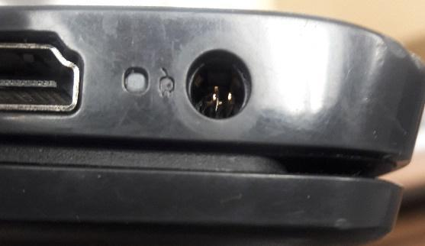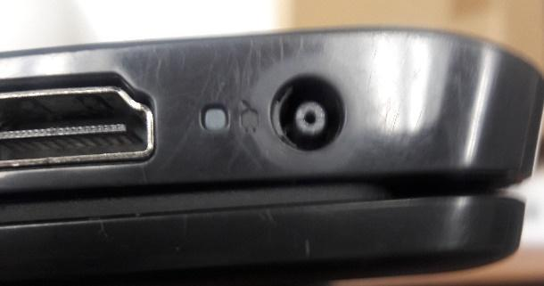

Broken Good

- Do keyboard keys seem to work normally (no sticking, hard to press, etc.)
Yes No ($17)

- Overall condition
A – No major damage. Overall good condition

B – Minor cosmetic damage. Dirty but cleanable

C – Cracked plastic case. Missing keys. ($TBD)

D – Bad condition. Stickers or other customizations. ($TBD)

- Any additional reported issues
_____________________________________________________________
- Total Fines $_______________________Amount Paid $_______________
- Payment Plan? Yes ____ No _____

