Summer Lunch June 2021
Sunday | Monday | Tuesday | Wednesday | Thursday | Friday | Saturday
 |  | 1 | 2 | 3 | 4 | 5
Summer Lunch:  June 1, 2021  Thru  July 31, 2021 |  | Chicken Nuggets  Potato Smiles  Broccoli  Fruit Cup | Cheesy Goulash  Corn  Fruit Cup  Breadstick | Cheeseburger  French Fries  Fruit Cup | Mini Corndogs  Green Beans  Fruit Cup  Goldfish Crackers | 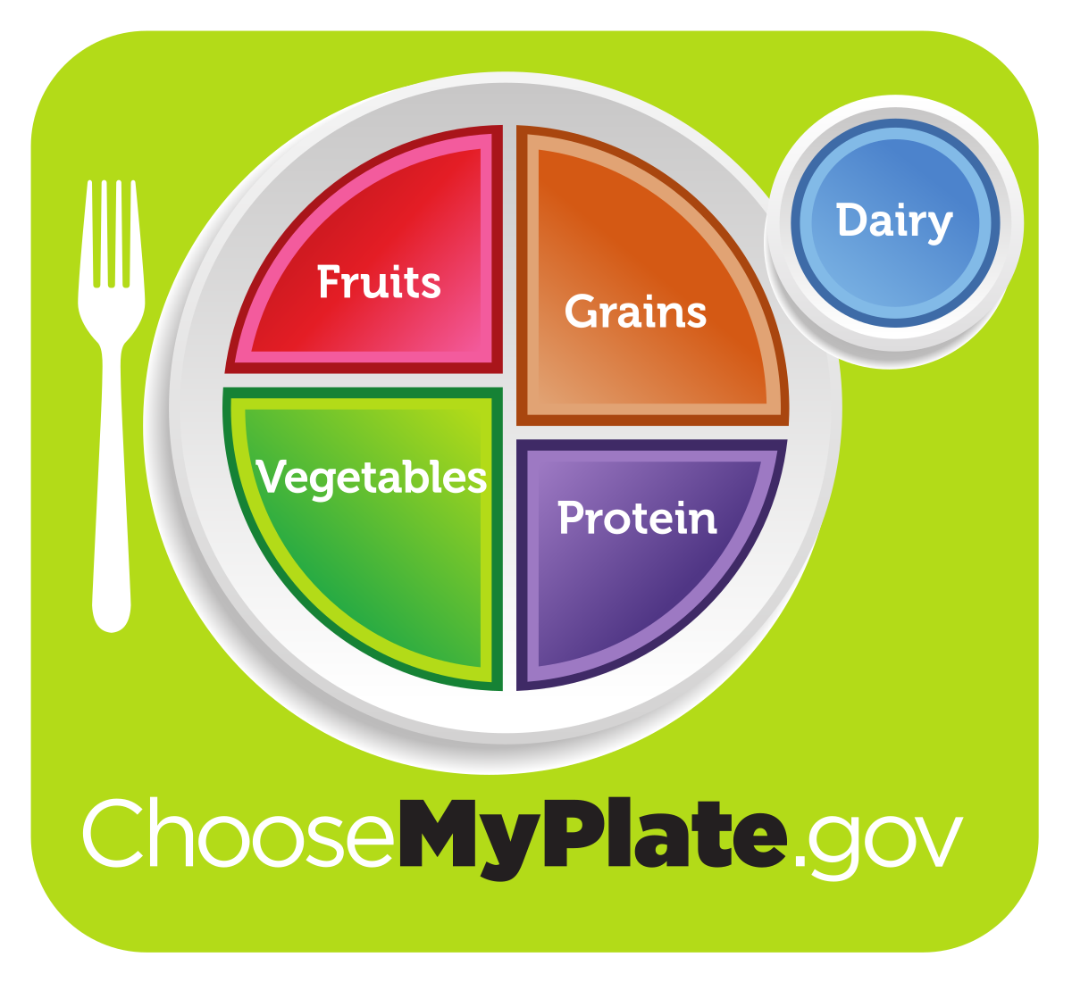
6 | 7 | 8 | 9 | 10 | 11 | 12
Meal pickup times are 11am -12:30pm Monday thru  Friday | Fiestada  Oven Potatoes  Fruit Cup | Chicken OR Cheese Quesadilla  Corn  Fruit Cup | Spaghetti  Cheese Stick  Green Beans  Fruit Cup  French Bread | Chicken Flatbread  Lettuce Salad  Fruit Cup | Fish Sticks  Sweet Potato Trax  Fruit Cup  Animal Crackers
13 | 14 | 15 | 16 | 17 | 18 | 19
 | Popcorn Chicken  Potato Smiles  Peas  Fruit Cup | Salisbury Steak  Mashed Potatoes  Fruit Cup  Hot Roll | Peanut Butter & Jelly Sandwich  Cheese Stick  Green Beans  Fruit Cup | Chicken Patty Sandwich  Corn  Fruit Cup | Hot Dog/ Bun  Baby Carrots  Fruit Cup  Chips
20 | 21 | 22 | 23 | 24 | 25 | 26
All Meals Include ½ Pint of Milk | Chicken Strips  Green Beans  Fruit Cup | Walking Tacos  Tri- Potatoes  Fruit Cup | Pulled Pork Sandwich  Corn  Fruit Cup  Chips | Pancakes /Yogurt  Sausage Patty  Hash Browns  Fruit Cup | Calzone  Broccoli  Fruit Cup
27 | 28 | 29 | 30
Menu Subject to Change | Chicken Taquitos  Corn  Fruit Cup | Beef Burger  Green Beans  Fruit Cup  Chips | Country Fried Steak  Mashed Potatoes  Peas & Carrots  Fruit Cup/ Hot Roll | Rib Patty Sandwich  Oven Potatoes  Broccoli  Fruit Cup | Pepperoni Pizza  Lettuce Salad  Fruit Cup | 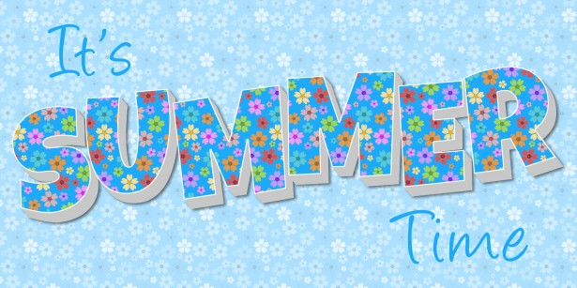
This institution is an equal opportunity provider. See other side for Food Safety Tips!

