Summer Breakfast June 2021
Sunday | Monday | Tuesday | Wednesday | Thursday | Friday | Saturday
 |  | 1 | 2 | 3 | 4 | 5
Summer Lunch:  June 1, 2021  Thru  July 31, 2021 |  | Cereal  Fruit or Juice  8oz Milk | Blueberry Muffin  Fruit or Juice  8oz Milk | French Toast  Fruit or Juice  8oz Milk | Pancake on a Stick  Fruit or Juice  8oz Milk | 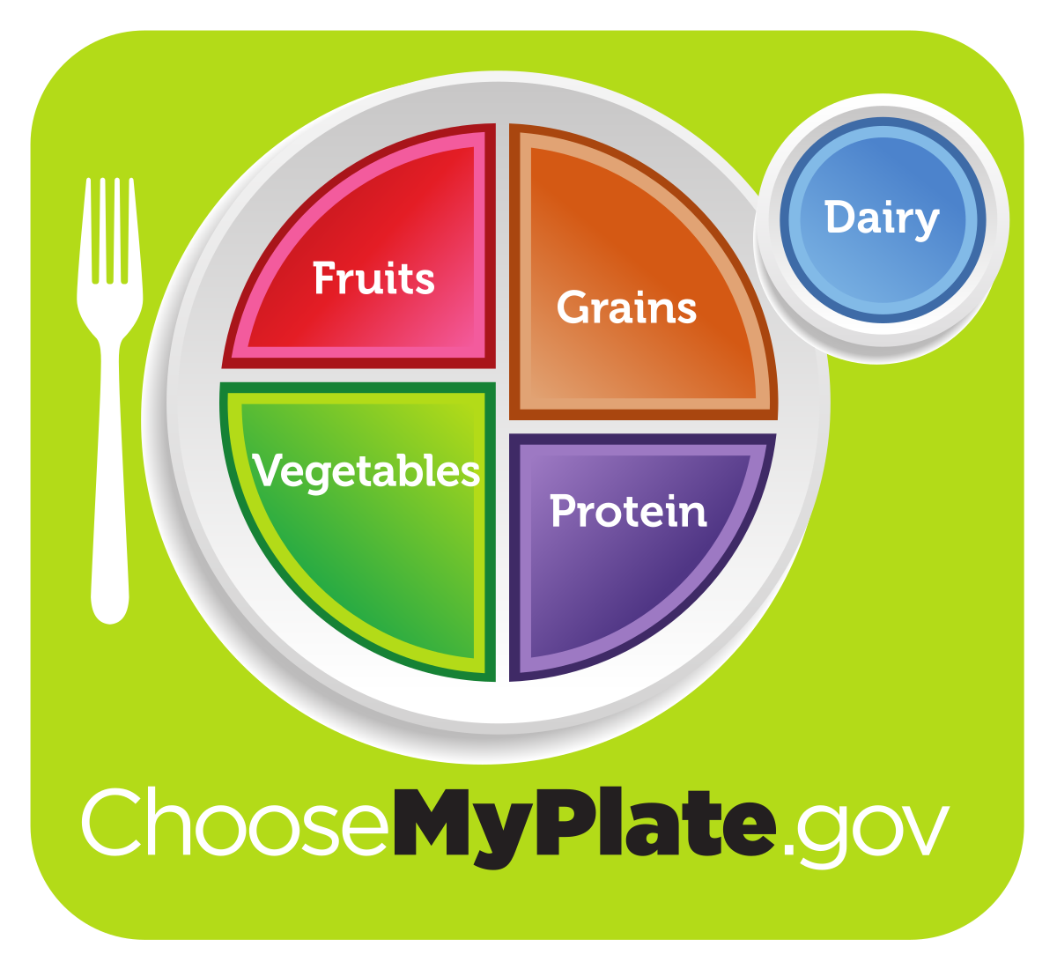
6 | 7 | 8 | 9 | 10 | 11 | 12
Meal pickup times are 11am -12:30pm Monday thru  Friday | Breakfast Tac-go  Fruit or Juice  8oz Milk | Yogurt Parfait  Fruit or Juice  8oz Milk | Cereal  Fruit or Juice  8oz Milk | Fruit Strudel  Fruit or Juice  8oz Milk | Banana Bread  Fruit or Juice  8oz Milk
13 | 14 | 15 | 16 | 17 | 18 | 19
 | Cereal  Fruit or Juice  8oz Milk | Honey Bun  Fruit or Juice  8oz Milk | Cereal  Fruit or Juice  8oz Milk | Chocolate Muffin  Fruit or Juice  8oz Milk | Pancake on a Stick  Fruit or Juice  8oz Milk
20 | 21 | 22 | 23 | 24 | 25 | 26
 | French Toast  Fruit or Juice  8oz Milk | Yogurt Parfait  Fruit or Juice  8oz Milk | Cereal  Fruit or Juice  8oz Milk | Zucchini Bread  Fruit or Juice  8oz Milk | Breakfast Sandwich  Fruit or Juice  8oz Milk
27 | 28 | 29 | 30
Menu Subject to Change | Breakfast Tac-go  Fruit or Juice  8oz Milk | Cereal  Fruit or Juice  8oz Milk | Strawberry Bagel  Fruit or Juice  8oz Milk | Cereal  Fruit or Juice  8oz Milk | Pancake on a Stick  Fruit or Juice  8oz Milk | 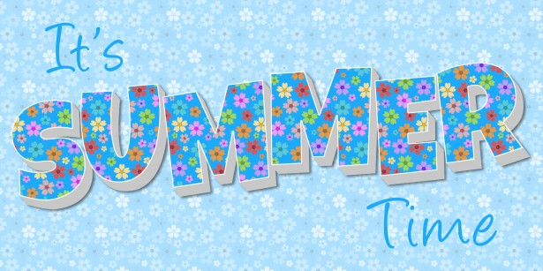
This institution is an equal opportunity provider. See other side for Food Safety Tips!

