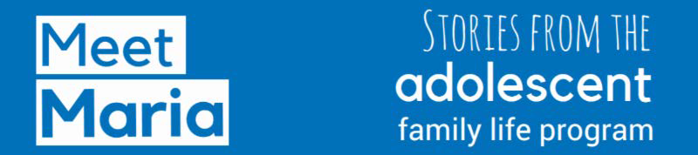

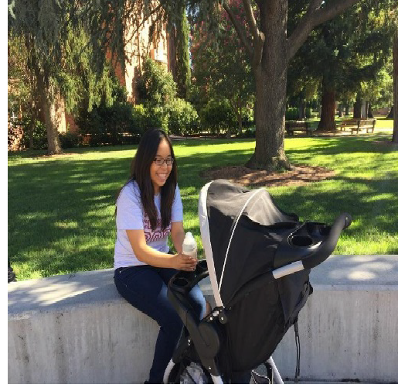
Youth Embraces Her Strengths, Heads to Chico State

Maria's senior year of high school differed from those of her peers. She discovered she was pregnant and kept it a secret while continuing cheerleading and Zumba. "Because my pregnancy was hidden, I was in a bad place," Maria recalls.

Finally, after months of hiding her pregnancy, she shared her situation with her school counselor who

Maria and her daughter on the
Chico State campus.

recommended she get in touch with TAPP - the Teenage Pregnancy and Parenting Program in Butte County, the locally-funded Adolescent Family Life Program. This voluntary case management program provides expectant and parenting youth with support and education focused on their strengths and needs. Maria's interest in the program was immediate. She knew she needed someone to guide her through this life event of becoming a first-time mother.

Maria and her case manager, Natalia, instantly hit it off. Natalia's warmth and willingness to listen made it easy for Maria to confide in her. Says Maria, "She came over to my house and I felt really comfortable with her... I trusted her." Natalia noticed that Maria was a strong young woman, but that she needed some encouragement and tools to guide her through this major life event. Maria was doubting herself and her ability to continue school as a young mother.
Fortunately, Natalia had a tool box of knowledge, information and activities to rebuild her confidence and help her achieve her goals.

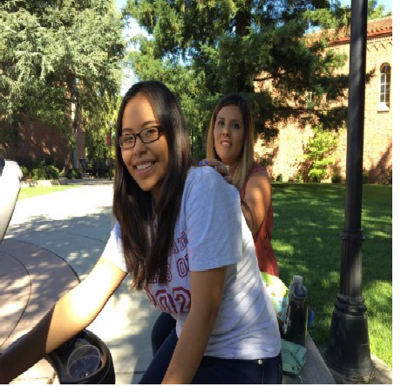
Maria and her case manager, Natalia.
Twice a month, Natalia and Maria would meet face-to-face to explore Maria's wants and needs. Natalia would share information about pregnancy and delivery, breastfeeding and how life would be with a newborn baby. Natalia emphasized the value of goal-setting as Maria began to work on life planning. California Department of Public Health Adolescent Family Life Programs (AFLP) like TAPP are designed to empower youth like Maria to pursue their

life goals. They provide ongoing support and opportunities to develop the resilience and skills needed to thrive as new mothers and young women.

Natalia's unwavering support of Maria helped Maria to believe in herself again. By going through the program-specific activities, Maria realized that she had a lot of strengths and that she needed to work hard not only herself, but also for her daughter.

One of Maria's main goals when starting the program was to graduate from high school. Not only has she graduated, but she is now attending Chico State, majoring in Pre-Nursing. Maria stuck with her dreams and didn't let having a baby stop her from pursuing an education. Maria is excited about her future and looks forward to becoming a nurse and ultimately the pediatrician she's always wanted to be.

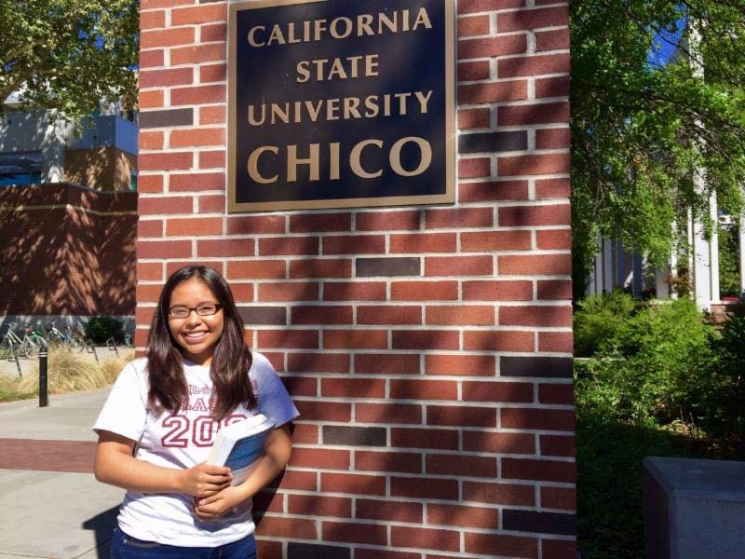

Maria is a freshman at Chico State.

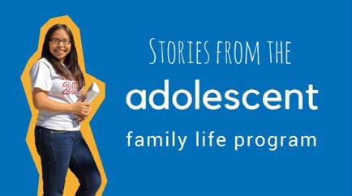
Help us share Maria's story!
You can help us share Maria's story in a variety of ways:
- On social media
- At community events,
- With potential clients,
- By forwarding this email to your colleagues and local stakeholders.

We have everything you need to do this, including sample social media posts and a draft newsletter blurb. Below you will find links to all the Meet Maria tools:

Meet Maria: Handout Meet Maria: Video Link
Meet Maria: Promotional Toolkit

