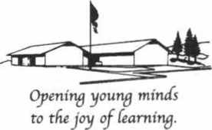
Tres Pinos Union School
5635 Airline Highway - P.O. Box 188
Tres Pinos, California 95075-0188
(831) 637-0503
Fax: (831) 637-9423

Last week of School Protocol

Dear Tres Pinos Parents:

Please be aware of the last week of school changes:

June 4th – 8th Grade Field Trip
June 4th – Last day for Thursday-Friday students (return Chrome book, textbooks and SRA books)
June 7th - Release for all students 2:00 p.m.
June 7th - Students return Chromebooks, textbooks and SRA books)
June 8th - Minimum day release 1:30
June 9th - Report Cards can be picked up in front of school.
June 9th – Graduation on campus (immediate family only) 5:00 p.m.

Tres Pinos staff want to thank all of the families who have been a part of this school during the COVID pandemic and survived all the changes to education this year. You have been such a support to all of us. We are anticipating for the 2021/2022 school year as a normal school scenario. This would mean no on-line learning will take place and all students will be in person learners.

There will be no Kindergarten graduation ceremony this year, students will receive a diploma in the classroom.

If you have any questions, please do not hesitate to dojo your child’s teacher or call the office.

Thank you,
Mrs. Mendes-LoBue
Superintendent/Principal

