STUDENT DESK RETURN
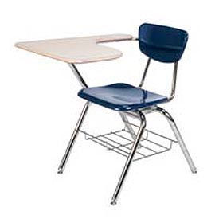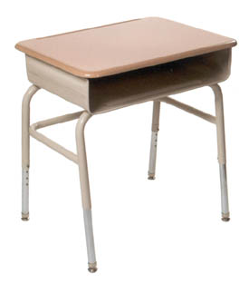

  - Belen Consolidated Schools
Please return student desks on the following dates. June 8th, 9th, 10th, & 11th between the hours of 8:00 AM and 3:00 PM
Please return to the following address
Belen Schools Warehouse, 19383 HWY 314 Belen, NM 87002
If you have any questions, please feel free to contact Claudia at 505-966-1709.
Thank you,

