EJES 2nd Annual Talent Showcase
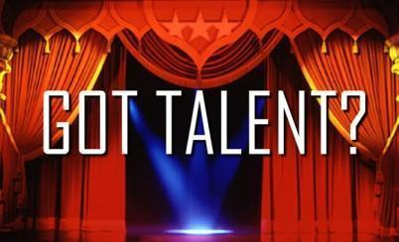

EJES Talent Showcase will be held on June 1st, 2021 at 8:45 AM
Please fill out this form if you plan on participating.
If you plan on participating, you must fill out this survey by no later than May 27th. This survey also provides a link for those uploading a talent for the showcase.

https://forms.gle/XcyaTeW1Jz1NDJJe8
-Video performances should be around 2 minutes long and must be uploaded using the link provided
-Live performances should be 3-4 minutes long (please fill the form out indicating performance details)
-Examples could include:
-Musical Talents (vocal, instrumental)
-Lego Builds
-Artistic Talent
-Comedy
-Poems
-Mine-Craft Builds
-iMovie Creation
-Dance
-Talent such as juggling
-Oratory/Theater reading
-Animal and bird calls
-Impressions of famous people
-Magician
-Maybe you have trained your pet to do a special trick or have a show animal
-Showcase your crafts
-Adult talent by staff are welcomed and encouraged

-This is not a competition but is a showcase of our school’s many talents.
-Videos will be previewed to make sure they are appropriate and are complete
-Depending on the number of submissions, presentations may need to be limited
-Only submit a video if you are giving permission to share your child's talent through a zoom session for all students and parents to watch.
-Submissions must be entered no later than May 27th
-All music must be school age appropriate

