What is the purpose of the Tri-Valley Facilities Task Force?
The purpose of the Tri-Valley Facilities Task Force is to gather members of the community to develop a long-term facilities solution for our growing district.
How did we get to the current Task Force?
- April 2017, board approves a purchase agreement for 20 acres of land in Crooks and 7 acres of land at the current site.
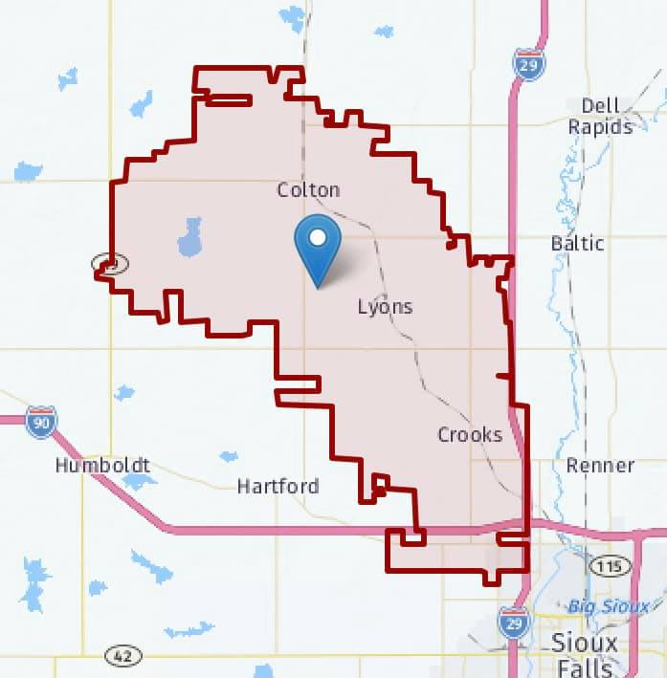
- 2019 facilities task force brings forth recommendation to board for facilities. This was for a K-4 school in Crooks (did not have sufficient land available to build at current site per task force instruction), updates to current facility, and consideration of a gym addition (utilizing capital outlays if deemed financially responsible by the board).
- June 2019 bond fails at 49% for three section K-4 school in Crooks. A super majority of 60% is needed in order to pass a bond.
- October 2019-10 acres to the West of the school was offered to the board for consideration of purchase.
- November 2019-20 acres to the East of the school was offered to the board for consideration of purchase.
- December 2019-bond fails at 46% for a five section K-4 school in Crooks.
- April 2020-Board makes a motion to utilize certificates to fund a Jr K and five section Kindergarten only building in Crooks. Use of up to 1.5% assessed value does not require a public vote. This proposal was under this threshold, thus no vote.
- December 2020-Board purchases additional 20 acres to the east at the current site. This land was not available prior to 2019 bonds being published to the public for voting.
- The current construction in the district is the Jr. K and five section Kindergarten. This is known as the Early Learning Center. This is continuing and the goal of this task force is to determine the best way to move forward with facilities in the future.

What is the history of OUR district?
- The first school at the current site was a sod shanty in 1879.
- Reorganization of students from Crooks to Colton occurred in 1967. Lower grades went to Crooks, upper and middle went to Lyons and Colton.
- The current site was chosen as it was geographically in the middle of the district. Property 2 ½ miles northwest of Lyons was purchased.
- In 1979, capital outlay certificates were issued, and a new High School site was selected. Completion of a high school was done in October 1980 with the gymnasium completion occurring in January 1984 marking the completion of the 9-12 facility.
- The middle school portion was added at the current site in 1989.
- 2nd and 3rd grade Elementary and a High School addition were completed in 1994.
- Kindergarten and 1st grade were added in 1999.
- Commons, wrestling room, band rooms, remodel of HS science labs, upgrades to track were completed in 2010.
- The Tri Valley School District consists of students from several communities - Hartford, Crooks, Sioux Falls, Lyons, Colton, and various townships.
- South Dakota has a legislative code (codified law) that protects school boundary lines (SDLC 13-6) This protects our district from losing land and territory to neighboring districts.

What kind of growth has Tri-Valley seen in recent years?
Over the last 20 years, Tri-Valley enrollment has increased 24.77%
- 1999 Enrollment: 783
- 2019 Enrollment: 977

What is the potential growth for the Tri-Valley District?

Crooks-200+ units
  - Harvest Acres CHRC/VB Development=~100 family units (combination single family/townhomes).
  - Sunset Addition=~20 units remain (could be less if twin homes are not built as planned and it switches to single family homes).
  - 50 acres S and W of ELC=~120 family units (combination single family/townhomes).
  - Development Corporation (Land across from library) =~20 single family homes.
Sioux Falls-~300 single family homes
  - Harder to estimate non-single-family homes due to wide variations of multi-family projected (see below).
  - Hazeltine-250 family units (combination single family/townhomes).
  - University Hills-4th apartment building (133 apartments) in process, 8 total planned, 1 completed every 3 years (currently no Tri-Valley students are coming from apartments).
  - Pinnacle Point-193 apartment units in 6 buildings-opening over a 2-year timeframe
  - NW Residential Development (not yet named)-250 family units (combination townhomes/SFR)

The term unit does not necessarily equal rooftop, it could be an apartment, townhome, etc.

Colton is in the process of a housing study but there is no data to share currently. No known growth plans in Lyons and rural areas (no known new developments).

Where are the Tri-Valley Students coming from? (This data was provided to the task force and is 2019-2020 information.)

Baltic-36
Chester - 2
Colton Country - 81
Colton Town - 128
Crooks Country - 41
Crooks Town - 328
Dell Rapids - 3
Hartford Country - 43
Hartford Town - 18
Humboldt- 14
Lyons - 7
Renner - 11
Salem - 1
Sioux Falls Country - 12
Sioux Falls Town - 251
Wentworth - 3

Are Students enrolling INTO Tri-Valley?
Fall 2020 Data-Total 80
- 26 Sioux Falls
- 21 West Central
- 12 Chester
- 11 Baltic
- 1-4 from Harrisburg, Montrose, McCook, and Dell Rapids.
Are Students enrolling OUT of Tri-Valley?
Fall 2020 Data-Total 129
- 57 Sioux Falls
- 38 West Central
- 20 Chester
- 1-4 to Harrisburg, Tea, Baltic, Brandon, Dell Rapids, and Parker.
What are bussing needs for Tri-Valley?
(All information provided by Foreman Bus)
- Tri-Valley utilizes 13 bus routes
  - 2016-736 Students utilized bussing
  - 2019-815 students utilized bussing
- Tri-Valley pays a flat per route fee, not per mile
Bus Number | Route Destination | Duration (based on morning pick up from 1st student to school drop off)
1 | Rural and Crooks | 50 minutes
2 | Rural and Colton | 48 minutes
3 | Rural and Crooks | 35 minutes
4 | Lyons, Rural and Crooks | 40 minutes
5 | Rural and Crooks | 40 minutes
6 | Rural and Sioux Falls | 45 minutes
7 | Rural and Colton | 45 minutes
8 | Sioux Falls (1 rural stop) | 40 minutes
9 | Rural and Crooks | 48 minutes
10 | Rural and Colton | 60 minutes
11 | Rural | 45 minutes
12 | SF (a few rural stops on the way) | 43 minutes
13 | SF and Hartford (few rural stops on the way) | 45 minutes

What kind of financial impact do taxes have on the district?
56% of the school districts funding comes from property taxes.
Total District Valuation is $697,506,331 (2021 data)
(Based on School Valuation Worksheet for taxes payable 2021, provided by Minnehaha County on October 2, 2020)
- Agriculture provides $185,731,336 or 26.6% of the total
- Owner occupied, manufactured homes, and manufactured owner occupied is $340,120,476 or 48.8% of the total
- Commercial/Industrial provide $169,152,514 or 24.3% of the total
- Utility Taxable Valuation is $3,306,690 or 0.47% of the total
How do Levies work?
- Ag: 6.405 or 11/15 - The average levy is 7.10. Our total property value in this category was $187,364,503 or 28.80% of our district’s valuation.
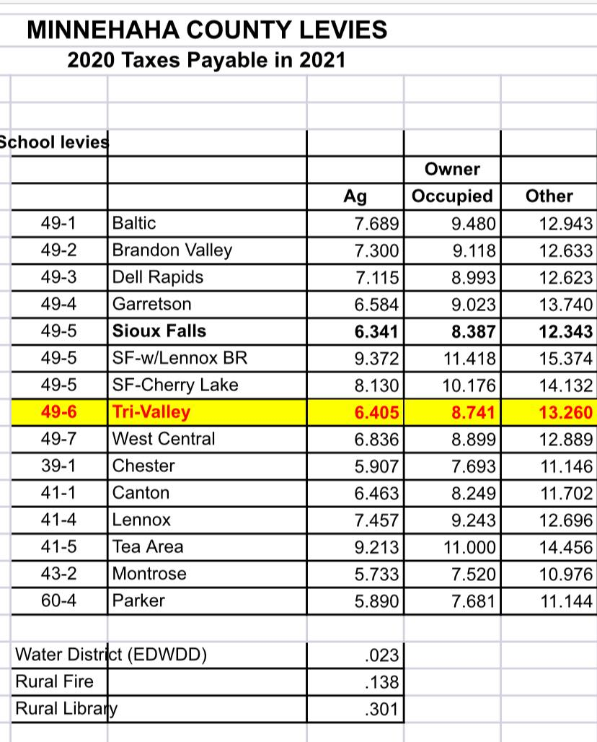
- Owner Occupied: 8.741 or 10/15 -The average levy is 9.04. Our total property value in this category was $315,334,497 or 48.47% of our district’s valuation.
- Other: 12.804 or 5/15 - The average levy is 12.804. Our total property value in this category was $144,723,033 or 22.25% of our district’s valuation.
- The property value numbers will NOT add to 100 (nor %) - this is because we have a small portion of value associated with manufacturer homes and utilities. Manufactured home values are excluded from our district valuation.
- What does this mean???? Well for most of us either in the ag or owner-occupied space, we are paying far less for our school district compared to others. We are in the bottom third!
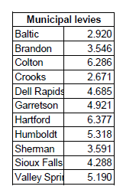
- If a bond passes, these levies or taxes will go up. Funding for education is critical and keeping things in perspective always helps. Our district has never passed a bond to help fund education.
- To calculate your property tax, calculate your total levy as seen in the calculator below.
- Taxable value x total levy/1,000 = total due
      - For Example: Median home price in the Tri-Valley District is $196,100. If it is placed in Grand Meadow Township, the total levy is 12.525, therefore property taxes would equal ($196,100 x 12.525)/1000=$2,456.15
    - A bond is a way to improve our facilities, get additional space, ensure our students have the same great (or better!) opportunities they would have elsewhere. This means taxes will go up - our children are worth it!
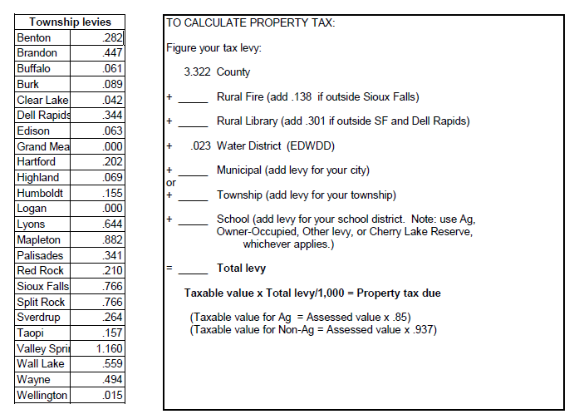
How are funds dispersed per student?
Tri-Valley currently spends $8,691 per pupil. $409 of that is from Federal Funding sources and $8,281 of that is from State and Local Funding sources.
School | Per Pupil Spending | Federal Sources | State and Local Sources
Flandreau | $10,116.00 | $613.00 | $9,503.00
Madison | $9,071.00 | $ 467.00 | $8,604.00
Garretson | $9,065.00 | $487.00 | $8,578.00
Canton | $8,993.00 | $220.00 | $8,773.00
Baltic | $8,946.00 | $434.00 | $8,512.00
Beresford | $8,822.00 | $172.00 | $8,651.00
Tri-Valley | $8,691.00 | $401.00 | $8,281.00
Dell Rapids | $8,605.00 | $442.00 | $8,163.00
West Central | $8,537.00 | $464.00 | $8,072.00
Chester Area | $8,440.00 | $338.00 | $8,102.00
Dakota Valley | $8,427.00 | $308.00 | $8,119.00
Information found on each school report card from the South Dakota Department of Education website http://doe.sd.gov Information obtained from 2019-2020 school year Note: * includes addition of colonies within district
How many facilities are maintained in other Districts?
District Name | TOTAL PK-12 | Number of Facilities | Comments
Aberdeen 06-1 | 4,477 | 9 | 6 Elementary, 2 MS, 1 HS
Belle Fourche 09-1 | 1,375 | 4 | 2 Elementary, 1 MS, 1 HS
Brandon Valley 49-2 | 4,682 | 7 | 4 Elementary, 1 Intermediate (5-6), 1 MS, 1 HS
Brookings 05-1 | 3,344 | 6 | 4 Elementary, 1 MS, 1 HS
Dakota Valley 61-8 | 1,376 | 2 | 1 Elementary, 1 large, connected building for MS and HS
Dell Rapids 49-3 | 975 | 2 | 1 Elementary, 1large, connected building for MS and HS
Douglas 51-1 | 2,757 | 4 | 2 Elementary, 1 MS, 1 HS
Harrisburg 41-2 | 5,449 | 9 | 6 Elementary, 1 MS, 1 HS
Huron 02-2 | 2,775 | 7 | 3 Elementary, 2 K-8 Colony Locations, 1 MS, 1 HS
Lennox 41-4 | 1,201 | 4 | 2 Elementary, 1 MS, 1 HS
Madison Central 39-2 | 1,127 | 2 | 1 Elementary, 1 large, connected building for MS and HS
Meade 46-1 | 2,997 | 12 | 5 K-8, 3 Elementary, 1 Intermediate, 2 MS, 1 HS
Milbank 25-4 | 1,005 | 4 | 1 Elementary, 1 K-8 Colony Location, 1 MS, 1 HS
Mitchell 17-2 | 2,791 | 8 | 3 Elementary, 2 K-8 Colony Locations, 1 MS, 2 HS
Oglala Lakota 65-1 | 1,811 | 5 | 4 K-8, 1 HS
Pierre 32-2 | 2,767 | 5 | 3 Elementary, 1 MS, 1 HS
Spearfish 40-2 | 2,359 | 7 | 3 Elementary, 1 MS, 2 HS, 1 (4-12)
Tea Area 41-5 | 2,045 | 5 | 3 Elementary, 1 MS, 1 HS
Todd County 66-1 | 2,156 | 11 | 2 Elementary, 6 K-8 locations, 1 MS, 1 HS, 1 6-12
Tri-Valley 49-6 | 980 | 1 | 1 large building for PK-12
Vermillion 13-1 | 1,287 | 4 | 2 Elementary, 1 MS, 1 HS
Watertown 14-4 | 3,951 | 8 | 6 Elementary, 1 MS, 1 HS
West Central 49-7 | 1,372 | 3 | 2 Elementary, 1 large, connected building for MS and HS
Yankton 63-3 | 2,952 | 6 | 4 Elementary, 1 MS, 1 HS
South Dakota School Information on Enrollment of 1,000-5,000 Students (All Information sourced from South Dakota Department of Education at doe.sd.gov, school report card for 2019-2020, and Google Earth)
What is a TIF (Tax Increment Financing)?
- TIFs have been authorized for use in South Dakota since 1978. TIFs have become a popular tool for communities to upgrade existing infrastructure or as a means of incentivizing new investments in infrastructure for economic development.
- TIFs are under four classifications: Local, Industrial, Economic Development and Affordable Housing.
- There are currently 193 TIF Districts within the state of SD.
- A dissolved TIF is defined as a TIF that has reached the maturity of 20 years since the inception or if the approved project has been completed prior to its maturity date.
What TIFs affect the Tri-Valley School District?
Below are current TIFs listed in the TV District
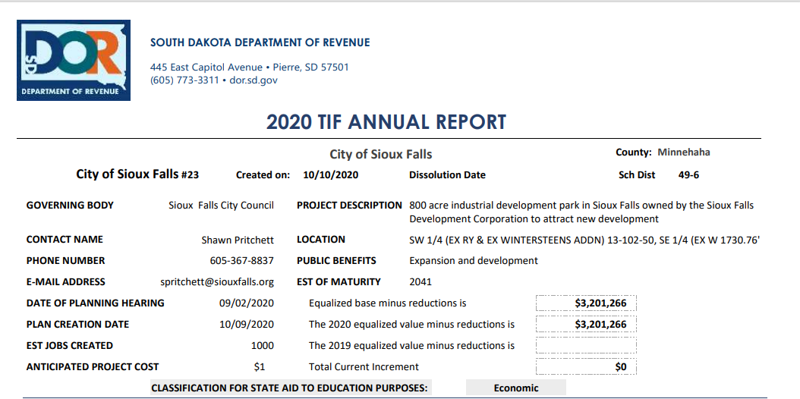
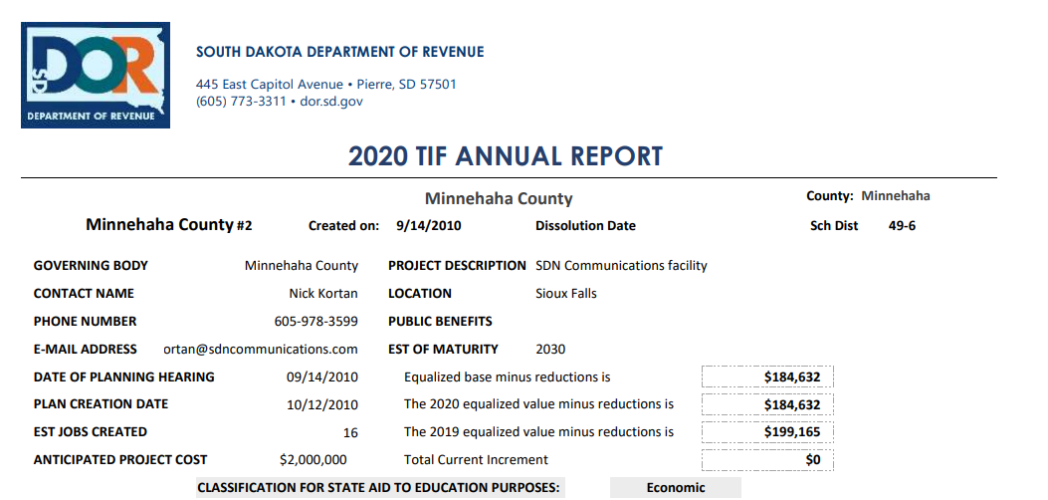

What does a TIF mean for Tri-Valley School District?
A TIF in the school district means that the district will only receive the taxes that are frozen at the time of approval. Anything that will increase on the valuation will go towards the TIF pool for infrastructure improvements and new business recruitment.

What is an Opt Out?
An Opt Out is an increase in taxes that a school district can take to help with operating costs
Does Tri-Valley have an Opt Out?
School | 2011 | 2012 | 2013 | 2014 | 2015 | 2016 | 2017 | 2018 | 2019 | 2020
Baltic | - | - | - | - | - | - | - | - | - | -
Beresford | - | - | - | - | - | $400,000 | $400,000 | $400,000 | $400,000 | $400,000
Canton | - | - | - | - | - | - | - | - | - | -
Chester | - | - | - | - | - | - | - | - | - | -
Dakota Valley | $600,000 | $600,000 | $600,000 | $600,000 | $455,000 | $600,000 | $600,000 | $600,000 | $600,000 | $600,000
Dell Rapids | - | - | - | - | - | - | - | - | - | -
Flandreau | - | $90,000 | $90,000 | $90,000 | $90,000 | $90,000 | - | - | - | -
Garretson | - | - | - | - | - | - | $500,000 | $500,000 | $500,000 | $350,000
Harrisburg | $1,000,000 | $1,200,000 | $1,200,000 | $1,200,000 | $1,200,000 | $1.750,000 | $2,000,000 | $2,000,000 | $2,000,000 | $2,000,000
Lennox | - | - | - | - | - | - | - | - | - | -
Madison Central | $250,000 | $250,000 | $250,000 | $250,000 | $250,000 | $200,000 | $100,000 | $100,000 | $100,000 | $100,000
McCook Central | $295,000 | $295,000 | $295,000 | $295,000 | $295,000 | $295,000 | $295,000 | $295,000 | $295,000 | $295,000
Parker | - | $150,000 | $100,000 | $100,000 | $150,000 | $150,000 | $150,000 | - | - | -
Tea Area | - | - | - | - | - | - | - | - | - | -
Tri-Valley | - | - | - | $700,000 | $700,000 | $400,000 | $400,000 | $400,000 | $700,000 | $700,000
West Central | - | - | - | - | - | - | - | - | $400,000 | $400,000
Yankton | - | - | - | - | - | - | - | - | - | -
Yes, Tri-Valley currently has an opt out for $700,000. The district has been using an opt out since 2014 that has ranged from $400,000 to $700,000. Below is a ten-year history of the Tri-Valley Opt Out compared to other area schools.
As of December 31, 2019 from Department of Revenue and Regulation

What is the difference between an Opt Out and a Bond?
A Bond is a tax increase to help build a facility for a public school system. An Opt Out is a tax increase to operate the facility for a public school system.
What will my taxes increase to if the bond passes?
For the current bond for the facilities to be built, a bond of $52,000,000* will need to be passed. This breaks down to $2.40/$1,000* of tax assessed evaluation. Below is a general outline of what the bond would do to increase taxes at different evaluations in order for Tri-Valley to obtain the facilities desperately needed for our children. If your property tax and insurance is escrowed today, this amount is added to your monthly home payment (see monthly increases noted below based on tax assessed value of your property.)
Tax Valuation | Increase of Taxes Based on Bond Amount per Year | Increase of Taxes per Month
$90,000.00 | $216.00 | $18.00
$100,000.00 | $240.00 | $20.00
$200,000.00 | $480.00 | $40.00
$300,000.00 | $720.00 | $60.00
$400,000.00 | $960.00 | $80.00
$500,000.00 | $1,200.00 | $100.00
$600,000.00 | $1,440.00 | $120.00
$700,000.00 | $1,680.00 | $140.00
$800,000.00 | $1,920.00 | $160.00
$900,000.00 | $2,160.00 | $180.00
$1,000,000.00 | $2,400.00 | $200.00
$1,100,000.00 | $2,640.00 | $220.00
$1,200,000.00 | $2,880.00 | $240.00
$1,300,000.00 | $3,120.00 | $260.00
$1,400,000.00 | $3,360.00 | $280.00
$1,500,000.00 | $3,600.00 | $300.00
*Subject to change based on board acceptance, can change amounts as necessary depending on bond amount

