 Bureau Valley Wyanet Elementary Storm Report
Issue 13 Volume 2 May 7, 2021
Unity, Excellence and Pride!
We are what we believe. What we believe unifies us.
We promise to our students and communities to provide a positive learning environment which promotes both academic and social success

Website-- www.bv340.org

Character Counts for Citizenship

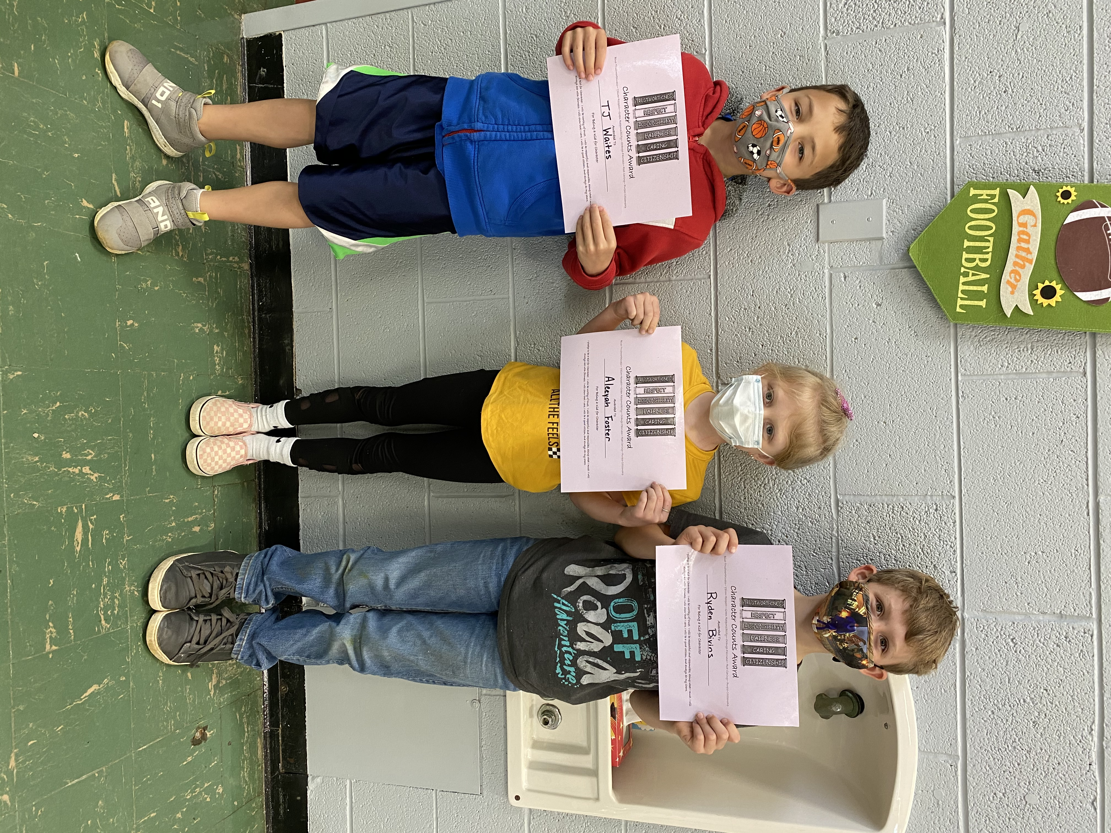
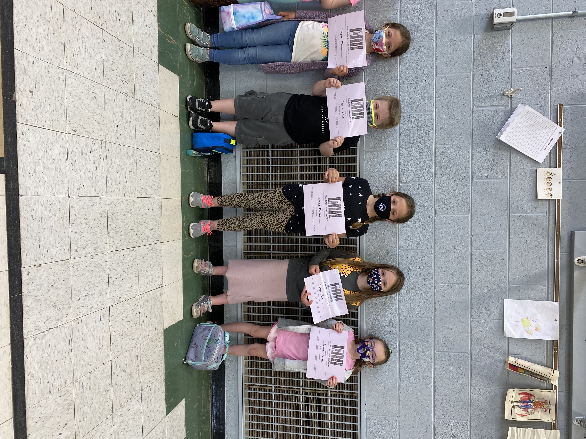
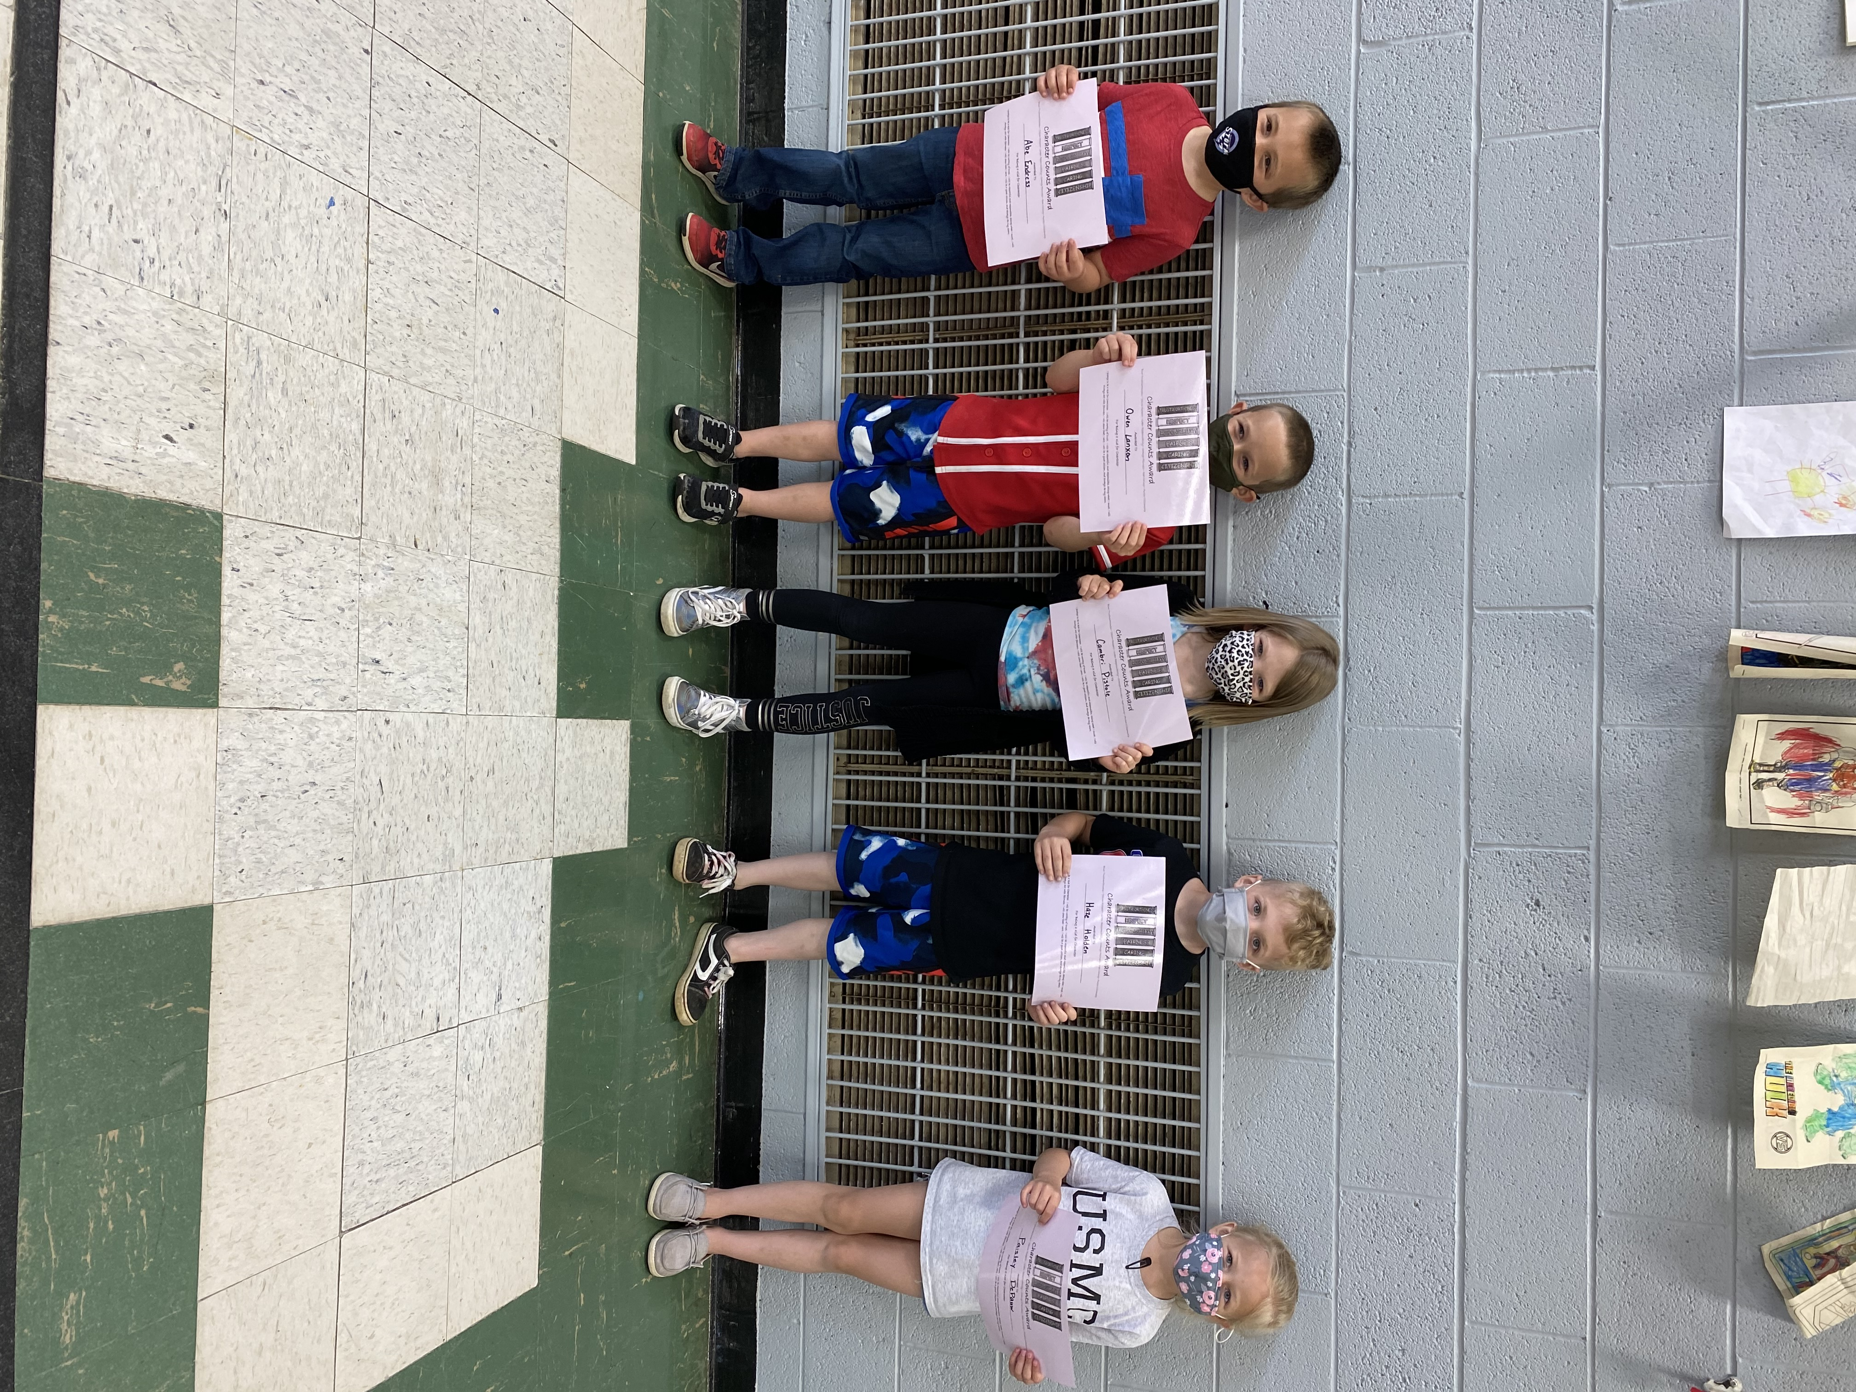

On April 28th students received certificates for the Citizenship pillar of Character Counts. The following students received a certificate: Abe Endress, Owen Lanxon, Cambri Pistole, Paisley DePauw, Haze Hogeboom, Jaelyn Decker, Brantly Fritz, Sophie Wunder, Andrew Ehnle, Kinley Munson, Teegan Munson, Anna June Ohlson, TJ Waites, Ryden Bivins, Aleeyah Foster. Congratulations to all of you!

Field Day on Thursday, May 13th

We will be having an all-day field day on May 13th (Rain date May 18th). Please put sun screen on your child(ren) before they come to school, have them dress in outdoor play clothes, and a hat if they would like to wear one.

Alphabet Cookies
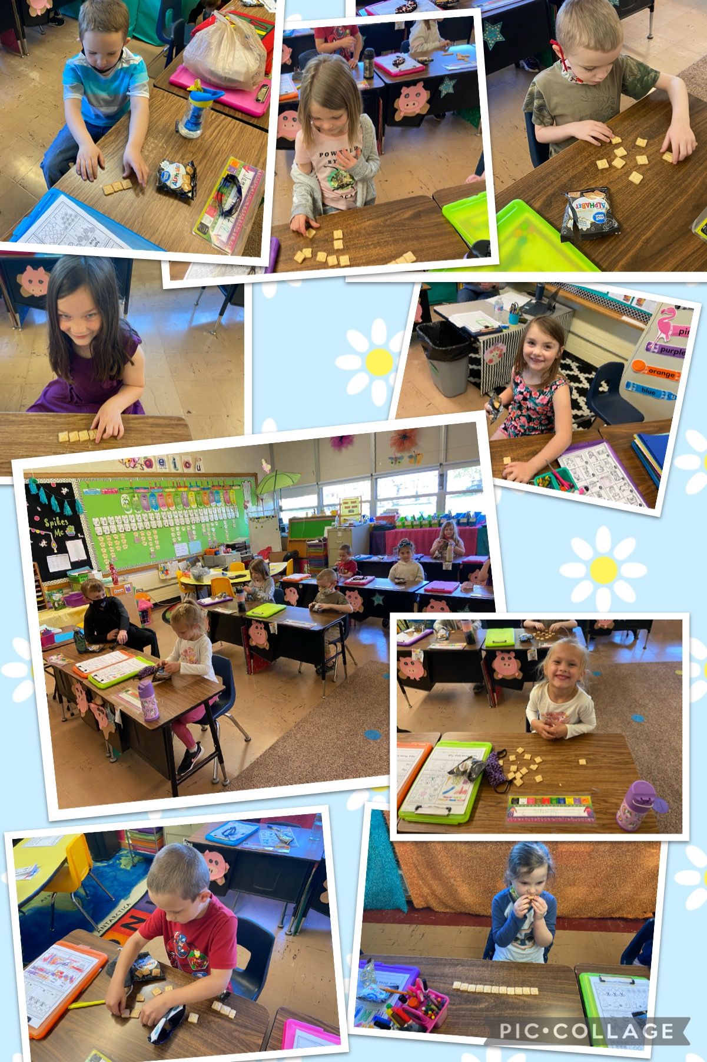
Mrs. L., Izzy's grandma, brought kindergarten alphabet cookies. We enjoyed spelling real words and nonsense words!

Z-A Countdown Until the End of the Year
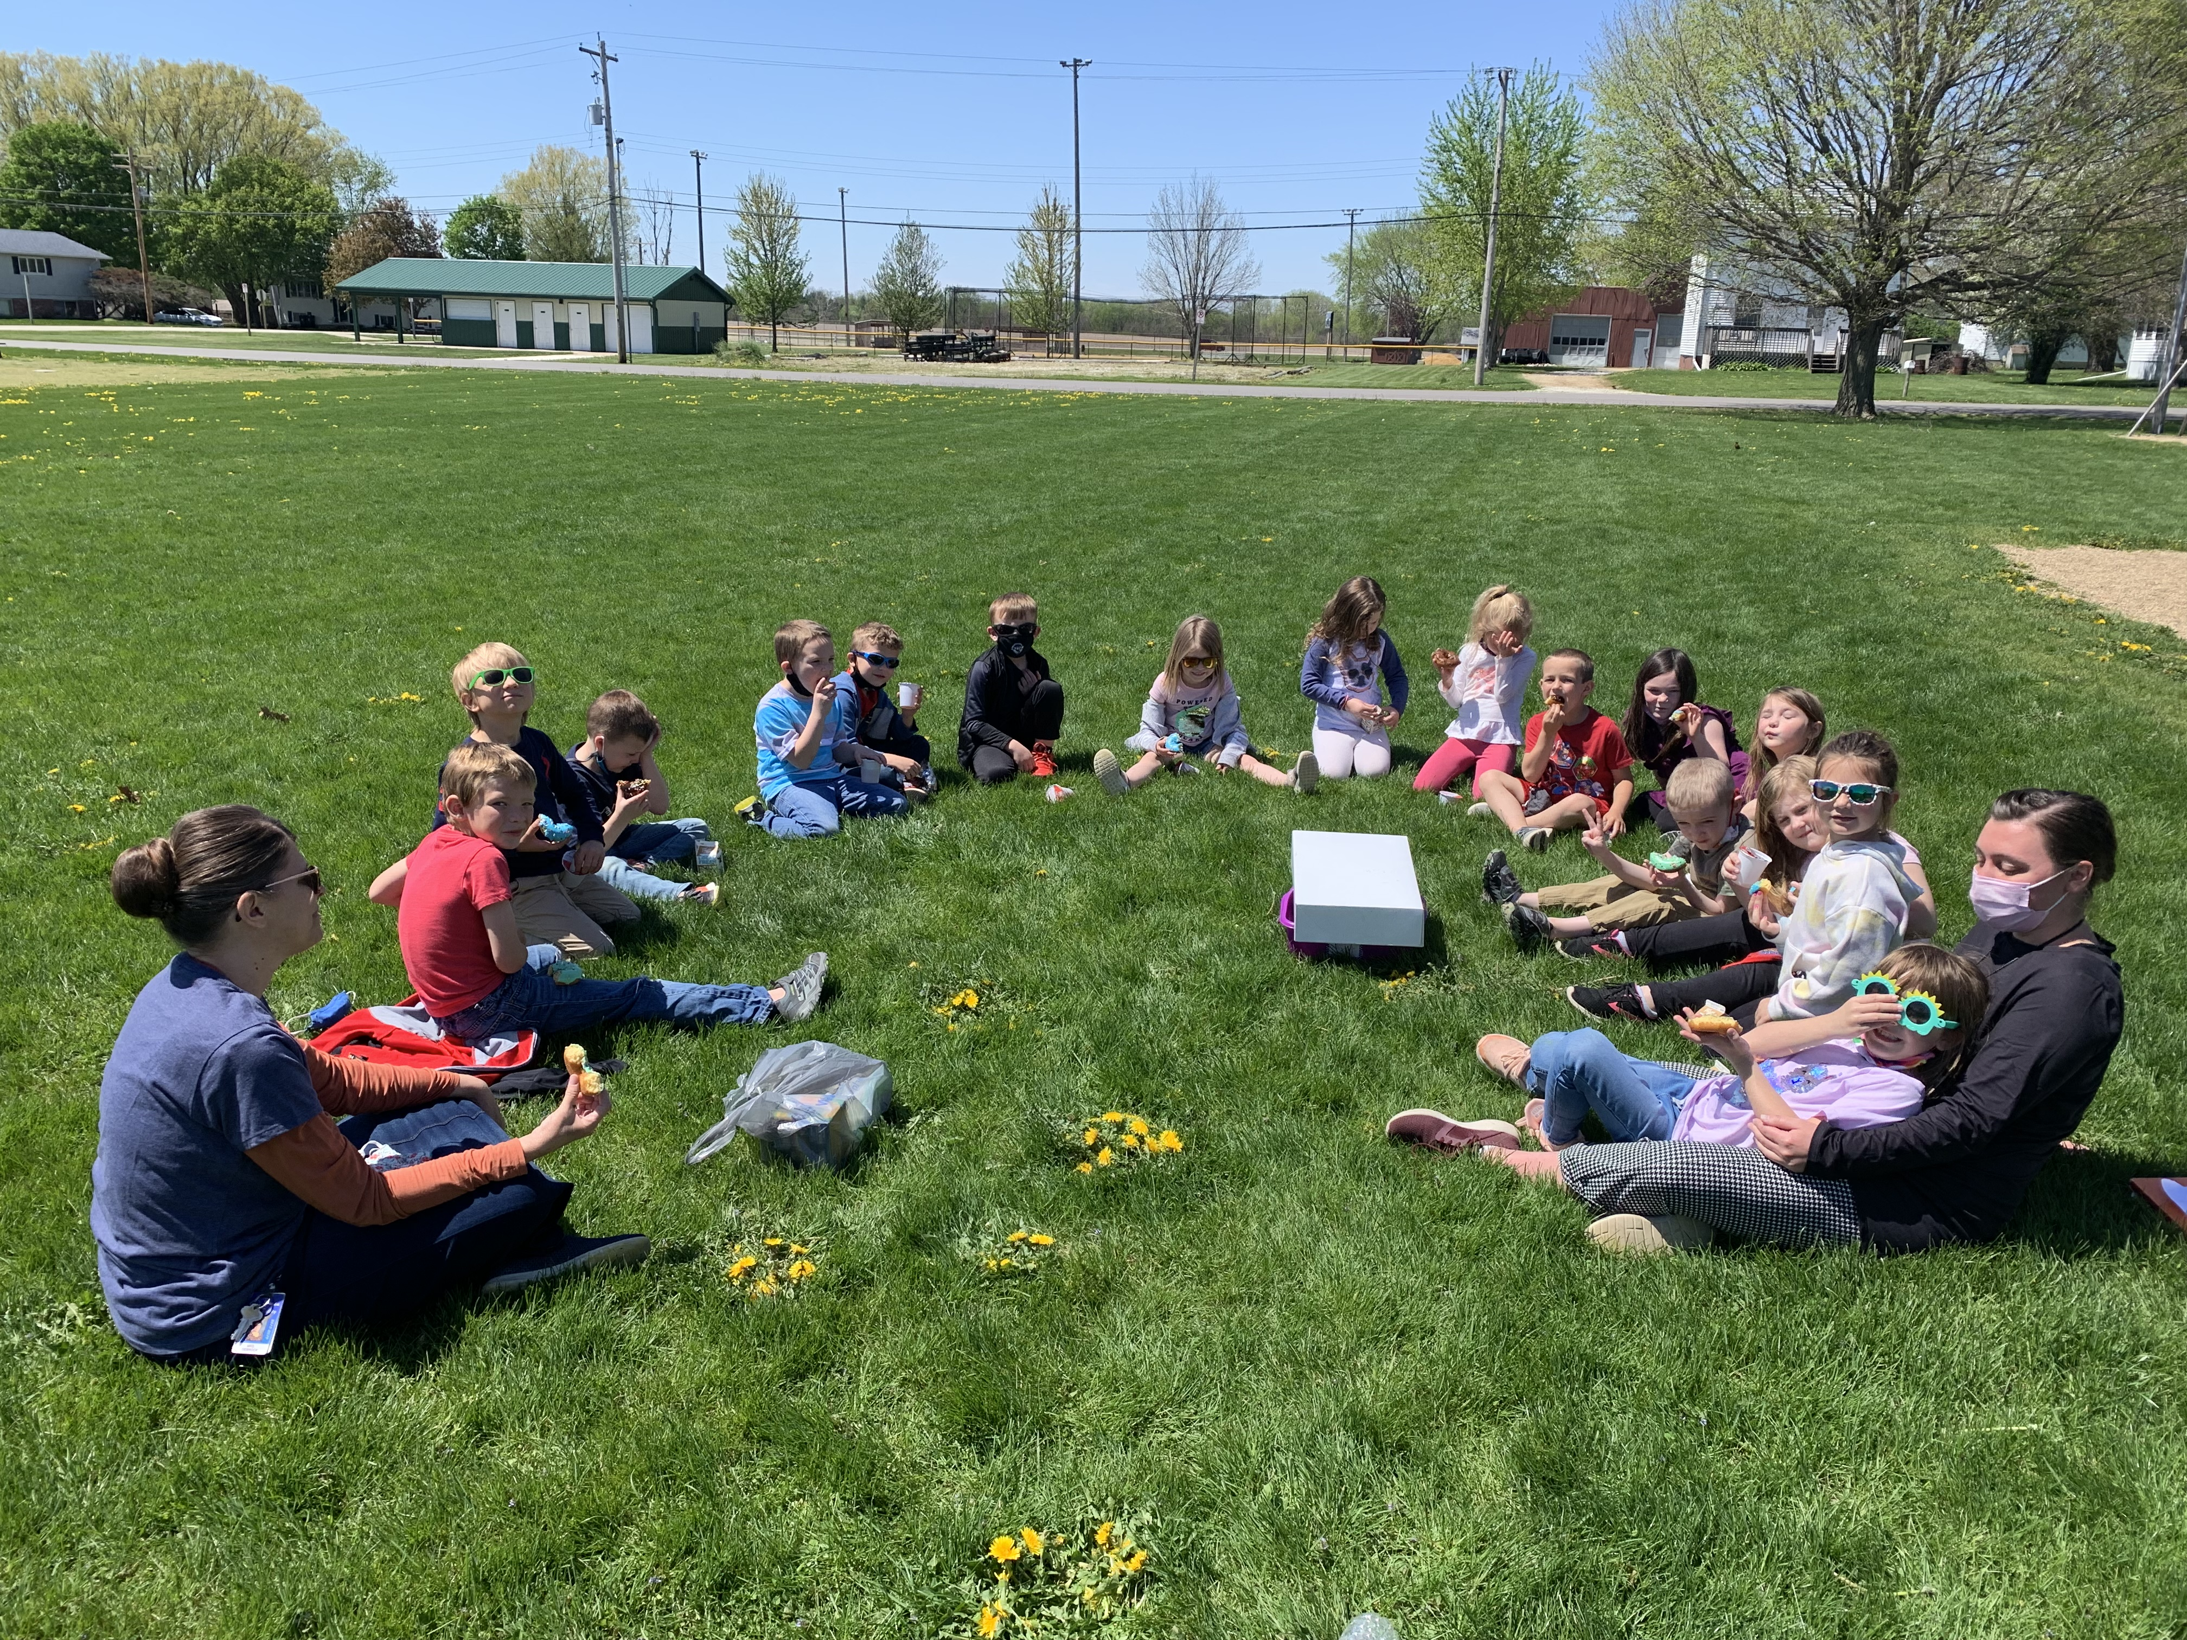
Kindergarten is using the alphabet to countdown until the end of the school year. Each day they have either a dress up day or a fun activity. Mrs. DeBrock’s class is pictured in their sunglasses enjoying the sunshine.
Free Children’s Orthopedic Clinic
Provided by the
Illinois Elks Children’s Care Corporation,
The Galesburg Elks Lodge #894, and
The Kewanee Elks Lodge #724
with Dr. Steven Potaczek
Tuesday, May 11, 2021
8:00 am – 9:30 am
(By Appointment Only)
OSF Galesburg Clinic
3315 N. Seminary
Galesburg IL
For Appointments
Please Contact the Elks Children’s Care Program
1-800-272-0074 Weekdays from 9 a.m. to 4 p.m.

 Dates to Remember

  - Thursday, May 13th Wyanet Field Day
  - Monday, May 17th 6pm Board of Education Meeting
  - Tuesday, May 18th Rain date for Field Day/Pre-K Walking to the Wyanet park during class (1 adult per child)
  - Wednesday, May 19th No Pre-K classes
  - Thursday, May 20th No Pre-K classes
  - Friday, May 21st No Pre-K classes
  - Monday, May 24th No Pre-K classes
  - Tuesday, May 25th No Pre-K Classes
  - Wednesday, May 26th Last Day of Student Attendance/Report Cards distributed/Pre-K attends
  - Thursday, May 27th Teacher Institute -No School

Next newsletter will be sent home on Friday, May 21st.

