Brunswick

Central School District



District Wide

Safety Plan

2021/2022

Update February 2021

Purpose
The Brunswick Central School District-wide School Safety Plan was developed pursuant to Commissioner’s Regulation 155.17. At the direction of the Brunswick Central School District Board of Education, Brunswick Central School District appointed a District-wide School Safety Team and charged it with the development and maintenance of the District-wide School Safety Plan.

Identification of School Teams
The Brunswick Central School District has appointed a District-wide School Safety Team consisting of, but not limited to, students, teachers, administrators, parent representative; school safety personnel; and other school personnel. The members of the team and their positions or affiliations are as follows:

Dr. Angelina Maloney: Superintendent of Schools
Stephanie Steinhart: Asst. Superintendent of Business
Whitney Colvin: Supervisor of Transportation and Maintenance
Kenneth Rizzo: High School/Middle School Principal
Jaymes White: High School/Middle School Assistant Principal
Richard Pogue: Elementary Principal:
Rochelle Hoot: Director of Special Education
Tim LeVan: Questar Health & Safety
Eric Olson: Teacher rep
Tim Jacques:Teacher rep
Amy Brock: PTSA
Donna VanZant: Athletic Director
Jeff Zovistoski: CSEA rep
Carol Crucetti/Mary Beth Farley: High/Middle School Nurse
Jamie Baska: Elementary Nurse

CHIEF EMERGENCY OFFICER:
The Chief Emergency Officer, required by Education Law §2801-a, is defined by both the statute and the implementing regulation, §155.17(a) as either the superintendent or the superintendent’s designee. Education Law §2801-a and the implementing regulations, require the Chief Emergency Officer to coordinate appropriate safety, security, and emergency training for district and school staff, annually update all Building-Level Emergency Response Plans, assist with decisions related to security related technology and development of policies for the use of such technology, and to ensure that required evacuation and lock-down drills are conducted in accordance with the requirements of Education Law §807. This position will be filled by Superintendent.

PUBLIC HEALTH EMERGENCY – CONTINUATION OF OPERATIONS PLAN
The Brunswick central school district has developed a Public Health Emergency – Continuation of Operations Plan. This plan has been developed in accordance with the amended New York State Labor Law section 27-c and New York State Education Law paragraphs k and l of subdivision 2 of section 2801-a (as amended by section 1 of part B of chapter 56 of the laws of 2016), as applicable. These laws were amended by the passing of legislation S8617B/A10832 signed by the Governor of New York State on September 7, 2020, requires public employers to adopt a plan for operations in the event of a declared public health emergency involving a communicable disease. The plan includes the identification of essential positions, facilitation of remote work for non-essential positions, provision of personal protective equipment, and protocols for supporting contact tracing. See Appendix 2

SCHOOL INCIDENT COMMAND STAFF:
Each building has established a SCHOOL EMERGENCY RESPONSE TEAM (SERT) with the following roles:

Incident Command- Sets objectives, strategies and overall responsibility for safe response, and makes decisions (administrators, Superintendent); has Incident Command Training.

Public information Officer - Communicates with media & parents as the designated District spokesperson (Superintendent, district). Has media training.

Safety Officer - Establish safe zones, monitors for protective equipment and safe/unsafe conditions. Can suspend work activities if unsafe. Has advanced training in HAZMAT, emergency response and worker safety.

Liaison- Is the go-between IC and other response facilities, briefs school administration.

OPERATIONS

- Facilities Team-Conduct sweeps and assess damage, survey and controls utility systems, investigate, report & deal with fires, secures damaged areas (Facilities staff)

- Evacuation/Shelter Team-gather reports on missing persons & report to command post, organize staff & students for safe relocation, manage student supervision, coordinate evacuation site, manage personal needs-food, sanitation

- Search & Rescue Team-check with accountability captain for missing persons, search for injured/missing persons, coordinate transportation for first aid needs, report injuries to command post, assist with first aid

- First Aid Team-Procures and organizes first aid area and supplies, maintains first aid station, provides first aid care, coordinates with EMS, reports status to command post, keeps records of where injured are taken and by whom, ensures injured who are transported for further medical care are tagged with name, address, medical & contact information, prepare for medication administration and special needs populations (Nurse, first aid responders)

- Reunification team-accounts for all students at all times, manages release of students, maintains copies of student emergency cards, sign-out sheets, validates identification and documents release of student by name and time, ensures staff remains with students until all are released and accounted for, reports status to command post (attendance)

- Crisis Response- assist students, staff and families and with needs, counseling for both responders & staff/students (guidance)

PLANNING/FINANCE

- Planning/Finance Team – tracks resources, documents events, controls maps, handles demobilization (administrative)

LOGISTICS

- Logistics Team –Provides resources and services necessary for incident, coordinates communication equipment, handles transportation, coordinates food, water & sanitation, response personnel, medical services for responders, manages traffic, set up cones, maintains flow, direct emergency assistance to correct locations, directs parents to reunification area, directs media to media outpost, arranges appropriate transportation vehicles-busses, other (transportation).

Each team shall be lead by a team leader.

Concept of Operations

This District-wide School Safety Plan provides an overview on how the school district will operate in the event of emergency situations. The School Safety plans will be further descriptive of how to carry out the overall plan.

The District Wide School Safety Plan will be reviewed by the District Wide School Safety Team and assessed based on local environment, emergency potential, incident trends, and best practices developed both internally and externally with, BOCES Health & Safety & SERT Team, local emergency responders and community resources.

In the event of an emergency or violent incident, the initial response to all emergencies at an individual school will be by the School Emergency Response Team. The communication designee will notify the district Superintendent by the best means available at that time.

Upon the activation of the School Emergency Response Team, the Superintendent of Schools or his/her designee will be notified and, where appropriate, local emergency officials will also be notified as per the plan.

The District will use State Police and Rensselaer County Sheriff Department and local emergency services to supplement the districts efforts through existing protocols by additional support, resources and coordination of the emergency by the following:

- Law enforcement will assist with building reviews, prevention and staff training.
- Local law enforcement and emergency services participate in planning & training exercised and develop strategies for managing building-level emergencies.
- A protocol exists with Red Cross for the High school building for use of sheltering during times of emergency.

D. Plan Review and Public Comment

Pursuant to Commissioner’s Regulation, Section 155.17 (e) (3), this plan will be made available for public comment at least 30 days prior to its adoption. The district-wide plan may be adopted by the School Board only after at least one public hearing that provides for the participation of school personnel, parents, students and any other interested parties. The plan must be formally adopted by the Board of Education.

Full copies of the District-wide School Safety Plan and any amendments will be submitted to the New York State Education Department within 30 days of adoption.

This plan will be reviewed periodically during the year and will be maintained by the District-wide School Safety Team. The required annual review will be completed on or before July 1 of each year after its adoption by the Board of Education. A copy of the plan will be available at the District Office.

Section II: Risk Reduction/Prevention and Intervention

Prevention/Intervention Strategies Program Initiatives

The programs and activities the district utilizes for improving communication among students and between students and staff, and reporting of potentially violent incidents, such as the establishment of:
- Non-violent conflict resolution training programs
- Multicultural education programs; School wide assemblies and Character Education and academic programs
- Extended day, intramurals, music programs, homework clubs and other club activities
- After school programs/clubs; art, drama, trivia, business, homework, student council, school newspapers, technology, theater, computer, yearbook, mock trial, science, and ski club; freshman/sophomore/junior/senior class leaders, band and chorus, Olympics of Visual Arts, Odyssey of the Mind, and others.
- Before and After School Child Care
- Athletics: soccer, cross country, football, basketball, wrestling, track, baseball & softball; cheerleading, interscholastic
- Youth-run programs: Student Council Government,
- School DARE Officer
- Individual and group counseling with guidance office, Psychologist
- Training programs under guidance to include: Anger management, bullying, sexual harassment, date-rape, diversity included in group/classroom/guidance & PE
- Drug & alcohol surveys
- Adoption of in-school suspension program that incorporates behavior modification skill training & counseling services to help address the underlying causes of student defiance and misbehavior
- Comprehensive Codes-of-Conduct for students, employees and visitors to school premises that describes appropriate behavior, reporting mechanisms and consequences for non-compliance, located in student & faculty handbook, website, posted in buildings
- Character education
- Anti-bullying programs
- Substance abuse prevention programs
- After School detention
- Peer mediators club

The district utilizes the following strategies to create a positive, safe learning environment for students:
- community involvement in the schools
- DARE Program
- mentoring programs for new students
- mentoring and Social Worker intervention for elementary school students
- adjusting scheduling to minimize potential for conflicts or altercations
- School Community Partnership

Training, Drills, and Exercises

All administrators are required to participate in:
- School Violence Prevention
- Incident Command
- ICS for Schools
- Table top exercises

ERT members shall be trained in the above, plus:
- Bomb threat training – also for new clerical staff
- Emergency Response, sweeper training
- Other training as required to fulfill effective response

Annual multi-hazard school safety training & drills for staff and students includes the following:
- annual review of the Building Level Emergency Plan for each building occupants
- early go-home drill to test evacuation & sheltering procedures
- fire drill (8 per year)
- bus drills
- lock down drills (4 per year)
- table top exercise
- live drill
- Emergency Management Team exercise
- Detection of potentially violent behaviors- awareness through staff meetings, violence assessment forms
- Students with disabilities have structured care plans
  - Training of staff in the following activities:
    - Lifting and carrying wheelchair students and staff when fire or other rescue personnel are not readily available
    - Planning for the notification of deaf students
    - Checking lavatories and special education areas
    - Inclusion of persons with disabilities in all emergency drills
    - Medical needs requiring specific procedures

After each drill or exercise, the principal and safety team will review the actions to test the components of our own emergency response plan, with local and county emergency response and preparedness officials and BOCES Health and Safety as appropriate and provide a summary of response to the Superintendent.

The hiring and screening process includes the following:
- Interview
- Screening of potential new employees which includes:
  - Providing a resume and three references
  - Fingerprinting (for all new employees hired after July 1, 2001)

Implementation of School Security/Staffing
Our policies and procedures related to school building security include the following:
- Locked outside doors
- Entrance security and/or single point of entry
- All doors shall be locked when rooms are unattended by adults
- All chemical storage/use rooms shall be locked when unattended
- Adult supervision in hallways/locker/bus loading and all areas students are present
- Monitor hallways, entranceways, exits and outside grounds during school hours for unusual occurrences or unauthorized visitors
- Participate in both building and district safety teams
- Participate in school investigation
- Visitor ID tag/sign in procedure
- Staff photo Id’s
- Video surveillance
- Security audits by security and safety professionals
- Policies on locker use
- Student, staff & visitor code of conduct
- Classroom management
- Greeting students & visitors at the door
- A sign at the main entrance will direct all visitors to "Report to the Office".
- All visitors are required to sign in, and if they need access to other areas of the building, they will be issued a "Visitor" ID tag or escorted by an employee
- Video cameras will be utilized to monitor certain locations
- Radio communication devices will be utilized for inside to outside communication during Physical Education classes, recess and other outside activities
- Bus cameras

Vital Educational Agency Information
The communications teams shall maintain information on each educational agency located in the school district, including: school population, number of staff, transportation needs, and the business and home telephone numbers of key officials of each such educational agency by an annual review and update at the beginning of each school calendar year or as key people change roles.

B. Early Detection of Potentially Violent Behaviors

We disseminate informative materials periodically regarding the early detection of potentially violent behaviors, which include the identification of family, community and environmental factors to teachers, administrators, parents and other persons in parental relation to students of the school district or board, students and other persons deemed appropriate to receive such information.

To prepare for violent incidents and lessen their impact, staff is trained annually during conference days. Topics may include identifying early warning signs in students, early intervention/prevention strategies, or development of violence prevention instruction; based on recommendations from the health and safety team, other relevant topics and an assessment of current needs of the district/school may be included. Specific violence assessments are conducted when needed or recommended.

C. Hazard Identification

Sites of potential emergency for fire, natural disaster, violence include the following:
- all school buildings
- playground areas
- properties adjacent to schools
- on and off-site athletic fields
- buses
- off-site field trips
- hazardous locations within the community have been evaluated and are spelled out in the building level plans

State Police, Fire Departments and Mohawk Ambulance are all within close proximity of the school district.

Section III: Response

A. Notification and Activation (Internal and External Communications)
Members of the communications team are designated to contact appropriate law enforcement officials off of our designated list in the event of a violent incident.

We will inform all educational agencies within a school district of a disaster or an act of violence by means of:
- Telephone, Intercom, two-way radio, cell phone
- Fax/Email
- Emergency Responders
- Local Media

In the event of an emergency, or impending emergency, the communications team will notify all principals/designees of facilities within the district of the impending emergency and to take the appropriate action.

Parents, guardians or persons in parental relation to the students will be contacted in the event of a violent incident or an early dismissal by the communications team by phone and/or website and/or letter.

B. Situational Responses

Multi-Hazard Response
The district’s has multi-hazard response plans for each school to take actions in an emergency that may include the following hazards:

Criminal:
- Threats of Violence Intruder
- Suspected weapon Suicide
- Hostage/Kidnapping Civil Disturbance

Natural Hazards:
- Earthquake Flood
- Hurricane/Tropical Storm Electrical Storm/Tornado
- Explosive/Bomb Threat/Fire Natural/Weather Related
- Winter Storm

Technological Hazards
- Hazardous Material Release Radiological
- Biological Air Pollution

Explosion/Fire
- Fire Gas Leak

Systems Failure

- Building Structure Failure Electrical System Failure
- Heating System Failure Transportation Fleet Loss
- Sewage System Failure Water system failure

Medical Emergencies
- School Bus Accident Mass Causality
- Transportation Disaster Epidemic/Pandemic

Others as determined by the District-wide School Safety Team

Due to security reasons, specifics are listed in each building plan.

Responses to Acts of Violence: Implied or Direct Threats
Our district’s policies and procedures for responding to implied or direct threats of violence by students, teachers, other school personnel and visitors to the school include the following:
- Assume all threats are serious
- Immediately report threat to school administrator or designee
- Use of staff trained in de-escalation or other strategies to diffuse the situation
- Trained staff/administrator to conduct an assessment interview of the subject making threat
- Determine level of threat with Superintendent/Designee
- Contact appropriate law enforcement agency, if necessary, as well as parent/guardian
- Monitor situation, adjust response as appropriate, and include the possible use of the Emergency Response Team
- Appropriate collection of information and documentation for VADIR reports
- Maintain confidentiality of person reporting threat to the greatest extent possible

The training and professional development that is available to assist personnel with the above responses include: training in de-escalation or identification of early warning signs of potentially violent behavior, threat analysis and is included in annual updates during conference days.

Acts of Violence
Our district’s policies and procedures for responding to acts of violence by students, teachers, other school personnel and visitors to the school, including the following:
- Zero-tolerance policies for school violence
- Determine level of threat with trained staff
- If the situation warrants, isolate the immediate area and evacuate if appropriate
- Inform Building Principal/Superintendent
- If necessary, initiate lockdown procedure, and contact appropriate law enforcement agency
- Monitor situation; adjust response as appropriate; if necessary, initiate early dismissal, sheltering or evacuation procedures
- Discipline, legal action

Response Protocols
Our district’s selection of appropriate responses to emergencies, including protocols for responding to bomb threats, hostage takings, intrusions and kidnappings. The following protocols are provided as examples:
- Activation of SERT
- Assemble Incident Command Team
- Plans to safeguard students and staff
- Procedures to provide transportation, if necessary
- Procedures to notify parents
- Procedures to notify media
- Procedures to unify parents with students
- Debriefing procedures

Arrangements for Obtaining Emergency Assistance from Local Government
The arrangements for obtaining assistance during emergencies from emergency services organizations and local government agencies include the following:
- Incident Command Team in an emergency contacts dispatch point or 911 center for fire or EMS response
- SERT is activated
- Communications team contacts law enforcement for notification and/or assistance.

Procedures for Obtaining Advice and Assistance from Local Government Officials
In order to obtain advice and assistance from local government officials including the county or city officials responsible for implementation of Article 2-B of the Executive Law we shall work through State Police:
– Communications team in an emergency will contact emergency management coordinator and/or the highest-ranking local government official for obtaining advice and assistance by notifying State Police.
– The district has identified resources for an emergency from the following agencies with American Red Cross, Fire Department/Police.

District Resources Available for Use in an Emergency
During an emergency, the following district resources are available:
- Facilities for sheltering
- Buses for transportation
- Trucks for transporting materials
- Machinery for moving items, supplying electricity, lighting
- Emergency response equipment, lights, first aid supplies, barriers, emergency response kits, temporary shelter
- Personnel with advanced training in emergency services, crisis management
- Food for temporary sheltering
- Personal needs (blankets, medicine, toilet facilities)

Procedures to Coordinate the Use of School District Resources and Manpower during

Emergencies

The School Emergency Response Team is authorized to make decisions regarding the staff members assigned to provide assistance during emergencies. The team shall also coordinate the use of school district resources and manpower during emergencies.

Protective Action Options
The following actions shall be taken in response to an emergency where appropriate, and initiate contact with local media and the parent notification system.
- Early dismissal - for situations that warrant sending students home safely prior to the end of regular school day.
- Evacuation - for situations that warrant removing the students/staff from the school buildings.
- School cancellation – when situations warrant the safety of the students to remain at home. If the school remains closed or closes early because of hazardous road/weather conditions, there shall be NO activities sponsored by the school in any of the school facilities.
- Lock Down/Lock Out - during situations of hostile criminal act or where students/staff must be safely secured, provisions shall be in place to secure the building and occupants.
- Security of a Crime Scene - procedures are in place to protect any area from disturbance where a potential crime has been committed.
- Weather Related-the designated district employee will investigate road conditions and shall contact and report conditions and recommendations to the Superintendent.
- Questar III (BOCES), Private & Parochial Transportation – If the district closed because of hazardous conditions of roads, students who live in the district will not be transported to Questar III or private/parochial school. If schools other than Brunswick Central Schools close because of hazardous road conditions in that district, students living in the district will not be transported to Questar III classes or to private/parochial schools in that district.
- Post Incident Response - for initiating and establishing crisis intervention to affected employees/students and Critical Incident Stress De-Briefing for response personnel.

Section IV: Recovery

After an incident the school teams shall meet and review the following:
- Document findings
- Tabulate costs
- Assesses any changes needed to the plan, added training or resources
- Reevaluate the current violence prevention and school safety activities and to determine if there are any further items needed
- Ensure appropriate de-briefing and counseling services have been put in place
- Determine if any additional resources are still needed post-incident
- Restock any supplies needed
- Meet with staff, students, families, public meeting and or other methods to communicate with affected persons-students, staff, families, other affected schools
- Coordinate substitutes as needed
- Prepare staff to handle phone calls – content and volume
- Update Board
- Provide for communal support, grief and/or memorial services
- Protocols for tributes and memorials
- Address cultural awareness
- Develop lessons learned

District Support for Buildings & Mental Health Services
Our district resources will support the Emergency Response Teams and the Post-Incident Response Teams in the affected school(s) by:
- Providing time & place for regular (quarterly) meetings
- Financial resources for supplies
- Training to fulfill duty needs
- Authority to lead in emergency situations

APPENDICES

Appendix 1:
Listing of all school buildings covered by the District-wide School Safety Plan with addresses of buildings, and contact names and telephone numbers for building staff.

Appendix 2:
Public Health Emergency – Continuation of Operations Plan

Appendix 1
Brunswick Central School District
Building List

Tamarac Elementary
3992 NY Route 2
Troy, NY 12180
Principal – Richard Pogue
Phone – 279-4600 Ext.

Tamarac Middle and High School
3992 NY Route 2
Troy, NY 12180
Principal – Kenneth Rizzo
Phone – 279-4600 Ext. 2401

Appendix 2

Brunswick Central School District



Public Health Emergency – Continuation of Operations Plan

Approved by Brunswick CSD Board of Education February 11, 2021


Health and Safety Services
Date of Revision/Review: January 28, 2021
Purpose 5
Scope 5
Requirements 5
Essential Titles 5
Remote Work and Telecommuting 7
Staggered Work Shifts 9
Transportation 10
Driver/Monitor/Aide/Maintenance 10
Cleaning and Sanitizing 10
Personal Protective Equipment 10
Exposure and Response 12
Emergency Housing for a Public Health Emergency 14
Appendix I 15
Infectious Disease Preparedness and Response Plan 15
Appendix II 37
COVID-19 School Reopening Facilities Cleaning & Disinfection Protocol 37
Appendix III 39
Record of Updates/Revisions 39
This plan has been developed in accordance with the amended New York State Labor Law section 27-c and New York State Education Law paragraphs k and l of subdivision 2 of section 2801-a (as amended by section 1 of part B of chapter 56 of the laws of 2016), as applicable.

This plan has been developed with the input of the Civil Service Employees Association, Inc. (CSEA), the Brittonkill Teachers’ Association (BTA) and the Brittonkill Principals’ Association as required by the amended New York State Labor Law.

No content of this plan is intended to impede, infringe, diminish, or impair the rights of us or our valued employees under any law, rule, regulation, or collectively negotiated agreement, or the rights and benefits which accrue to employees through collective bargaining agreements, or otherwise diminish the integrity of the existing collective bargaining relationship.

This plan has been approved in accordance with requirements applicable to the agency, jurisdiction, authority, or district, as represented by the signature of the authorized individual below.

As the authorized official of the Brunswick Central School District, I hereby attest that this plan has been developed, approved, and placed in full effect in accordance with S8617B/A10832 which amends New York State Labor Law section 27-c and New York State Education Law paragraphs k and l of subdivision 2 of section 2801-a (as amended by section 1 of part B of chapter 56 of the laws of 2016), as applicable, to address public health emergency planning requirements.

Signed on this day: February 12, 2021
By: Dr. Angelina Maloney Signature:
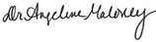
Title: Superintendent

Purpose

On September 7, 2020, Governor Cuomo signed into law Chapter 168 of the Laws of 2020 that requires public employers, including public school districts, to adopt a continuation of operations plan in the event that the governor declares a public health emergency involving communicable disease. The legislation (S.8617-B/ A.10832) amends subdivision 2 of section 2801-a of New York Education Law to require that District Safety Plans include protocols for responding to a declared public health emergency involving a communicable disease that are “substantially consistent” with the provisions of section 27-c of the Labor Law.

Scope

The Public Health Emergency Continuation of Operations Plan (PHECOP) identifies the varied aspects of providing a safe work environment for continued education of students and district operations during a declared public health emergency. Essential roles and critical functions are outlined to assist in delivering required assets and support to instructional and non-instructional functions to effectively continue district operations during a declared public health emergency. Planning and response efforts ultimately support the whole school community: students, parents and staff of our district.

Requirements

Essential Titles

The following provides a list and description of positions and titles considered essential in the event of a state-ordered reduction of in-person workforce, as well as a justification for such consideration for each position and title. This anticipates how certain positions/titles may be necessary to assist in response to a pandemic or communicable disease outbreak.
- Per S8617B/A10832:
  - ‘essential employee’ is defined as a public employee or contractor that is required to be physically present at a work site to perform their job
  - ‘non-essential employee’ is defined as a public employee or contractor that is not required to be physically present at a work site to perform their job
    - Note that per NYS Department of Health COVID-19 toolkit guidance, school staff are not essential workers.

A list of district-identified essential job functions and workers can be found on the chart below. It is important to note that those performing essential job functions will abide by the staggered schedule, in order to maintain and ensure safety for all employees.
Whenever possible, employees should work from home and only be on-site at district premises for the completion of the essential functions listed below.

Department | Essential Position or Title | Description
Operations and Maintenance | Superintendent of Building & Grounds  Head Maintenance Mechanics Maintenance Workers  Head Custodians  Custodians Custodial Workers | Maintain the cleanliness and continued functioning and maintenance of school buildings. Deep clean as necessary based on state and local health department requirements for public health emergencies. Assist with building operations in the event of district provided childcare for fire responders/health care workers
Grounds | Superintendent of Building & Grounds  Head Groundskeepers  Groundskeepers | Snow removal and groundskeeping
District Administration | Superintendent Asst Superintendents  District based Administrators | Required to ensure continuity of the response efforts; coordinated response with state and local health departments; communication to families and staff; ensure all essential daily functions are completed
Information Technology | Network Engineer & Technicians | Maintain internet capability, including remote learning and working from home. Provide troubleshooting for internet and program access. Assist with internet connectivity to ensure Digital Equity.
Transportation | Director of Transportation Head Bus Driver  Bus Drivers Bus Aides Head Mechanic Mechanics | To transport food to students who receive home meals and/or to transport students in the event they are attending in person instruction. Distribution of technology (laptops, hotspots, etc.) as necessary for Digital Equity

Food Service | Food Service Director Food Service Workers Support Staff (as needed) | To prepare and distribute meals to students. (for those at home with remote learning and at district childcare for first responders/health care workers)
Business Office | Business Official Payroll Clerk Accounts Payable Purchasing | Processing of payroll deposits and checks; timely payment of district bills; processing and approving purchase orders for emergency supplies related to the public health emergency
Building Level Administration & Clerical Support | Building Administrators Clerical Support | Required to ensure continuity of the response efforts; communications to parents and staff; processing of purchase orders for emergency supplies; timely payment of building bills
Faculty and Staff | Teachers  Related Service Providers Teaching Assistants School Nurse | Assist with district provided childcare for first responders/health care workers as required. Assist with distribution of meals to students as needed.  Should it become necessary to meet a student’s needs under IDEA and/or Section 504 regulation (FAPE), teachers/related service providers may be deemed essential on an as needed basis.

Remote Work and Telecommuting

The following is a description of the protocols the district will follow in order to enable all non-essential employees and contractors to telecommute. This description is not limited to, facilitating or requesting the procurement, distribution, downloading and installation of any needed devices or technology, including software, data, office laptops or cell phones, and the transferring of office phone lines to work or personal cell phones as
practicable or applicable.

To enable all non-essential employees and contractors to telecommute, the District will follow a contingency plan in a similar format as during the pandemic shut down with full remote instruction in March 2020.

Non-essential employees will complete telecommuting agreements prior to working remotely in the event that the district will need to close for an extended period of time. Staff required to work remotely will be provided with adequate district technology support to carry out their normal daily work functions. All district phones are able to be programmed to transfer to personal phone lines, which will be conducted to ensure continuity communications.

Non-essential employees will continue to have access to various digital platforms, including, but not limited to:

Remote Instructional Technology Platforms
Email and video conferencing technology and software | Google Classroom Suite- Learning Management System Grades 3-12
e-School | Seesaw- Learning Management System K-2
Amplify Reading K-5 | Google Suite Tools (Docs, Slides, Forms, etc.)
Other digital instructional platforms programs required to support remote learning

Additional Remote District Technology Platforms
Finance Manager | e-School
IEP Direct | IT/Help desk technology, work order systems, remote access
Raptor Visitor Management | Google Suite Tools (Docs, Slides, Forms, etc.)
Work order system(s) | Fill with additional district technology to support office functions

District Technology Hardware, Software, and Devices

Laptops and Chromebooks | Video/webcam hardware
Virtual Private Network (VPN) access | Other computer hardware as needed (i.e. printers)
Specialty software available by download | District issued cell phones for appropriate staff

Staggered Work Shifts

In the event of a public health emergency, the school district has determined that essential employees / outside contractors will follow a predetermined work shift schedule set by the district in an effort to minimize viral contact or employee overcrowding within the building.

Essential Employee Title / Outside Contractor | Building Name | Shift / Work Hours
Custodial & Maintenance | Senior High Middle School  Elementary School | 8 hours
Faculty | Senior High Middle School  Elementary School | 6 hours & 55 Minutes
Cafeteria | Senior High Middle School  Elementary School | Cooks: 6 or 6.5 hours  Food Service Helpers:  3.25 hours
Aides | Senior High  Middle School Elementary School | Per contract
Administration | Business Office / Superintendent’s Office | As needed

Before School Program After School Program | Elementary School | 7 am - 8:40 am 3:30pm - 6:00pm

Transportation

For transportation needs, in the event of a public health emergency, the school district will ensure all predetermined protocols and procedures as mentioned in the district’s reopening plan are adhered to. All employees (bus drivers, aides, monitors, etc.) who operate or occupy a district owned vehicle are subject to social distancing, face coverings, and daily health screenings.

Driver/Monitor/Aide/Maintenance

- All employees will be provided all necessary PPE to perform their duties safely. Maintenance personnel operating school owned vehicles will be required to disinfect high touch surfaces periodically during the occupancy of their vehicle.
- Maintenance employees will operate their designated vehicles solo and passengers/coworkers are prohibited.
- All employees are encouraged to sanitize their hands frequently before and after operating vehicles.

Cleaning and Sanitizing

- Each bus will have all high traffic areas properly cleaned between each run.
- Each bus utilized in the school day will be sanitized at least once daily.
- Maintenance vehicles will be routinely cleaned and sanitized placing emphasis on high touch surfaces.

Personal Protective Equipment

The following protocols will be implemented by the district to procure personal protective equipment (PPE) for essential employees, based upon tasks and needs related to the public health emergency. Specific information related to required storage and accessibility can be found in Appendix I, Infectious Disease Preparedness and Response Plan

Procurement
- The district will abide by the Board of Education Procurement Policy. In the event an Executive Order by the Office of the Governor indicates that schools may suspend their procurement policy temporarily due to the public health emergency, the district reserves the right to suspend the BOE Procurement Policy per Governor’s directive. (i.e. Executive Order 202 - 3/7/2020 for
COVID-19)
- The district will secure and provide PPE for employees.
- Procurement of PPE, other than basic preliminary purchases, will be done on a
consolidated basis.
- The district will provide employees with an acceptable face covering at no-cost to the employee and have an adequate supply of coverings in case of replacement.
  - Staff will be allowed to wear their own face covering pending district approval.
- Information shall be provided to staff and students on proper use, removal, and washing of cloth face coverings.
- Masks are most essential in times when physical distancing is difficult.
- The district will promote and reinforce the use of PPE among all staff.
- Specialized PPE (N95s, face shields, gowns, gloves, etc.) may be required for specific work tasks and will be provided as deemed necessary by a hazard assessment.
  - Those individuals that are required to wear N-95 respirators will be medically screened and fit-tested prior to use to assure they are physically able to do so.
PPE Supply Management

The purchasing department will work with each department to determine the overall PPE needs of the district. Centralized purchasing will be used when possible.

All types of PPE must be:
- Selected based upon the hazard to the staff.
- Properly fitted and periodically refitted, as applicable (e.g., respirators).
- Consistently and properly worn when required.
- Regularly inspected, maintained, and replaced, as necessary.
- Properly removed, cleaned, and stored or disposed of, as applicable, to avoid contamination of self, others, or the environment.
- The district will maintain an inventory of PPE in accordance with the NYS
Education Department, NYS Department of Health and CDC guidelines. PPE will be continually restocked as needed.
- Storage of personal protective equipment will be on campus and comply with the manufacturer’s storage recommendations for each item.
- PPE equipment will be readily available to all employees through identified disbursement protocols.

Exposure and Response

Effective prevention and mitigation steps are required to prevent the spread and/or contraction of the virus/disease. In the event an employee or contractor is exposed to a known case of the identified virus/disease, exhibits symptoms of the virus/disease, or tests positive for the virus/disease, the district will follow the current guidance from the Center for Disease Control, the New York Department of Health and the local health department. Appropriate cleaning and disinfection protocols will be followed. Steps will be followed to isolate the positive case and contact trace exposed individuals for
quarantine. Contact tracing protocols will be implemented and followed in accordance with the local health department requirements as the lead agency. Established protocols shall not violate any existing federal, state, or local law, regarding sick leave or health information privacy.
- Detailed actions for both daily and emergency cleaning of work areas, common area surfaces and shared equipment can be found in Appendix II, COVID-19 School Reopening Facilities Cleaning & Disinfection Protocol .
- The District will adhere to privacy, accommodation, and HIPAA laws, and any federal or state requirements relating to protection of identified individuals during the public health emergency.
- The District will adhere to any federal or state paid / unpaid leave provisions regarding quarantine, testing, exposure, and treatment protocols during a declared public health emergency.
  - Represented employees will have access to contractual leave as outlined in their respective bargaining unit agreements.
  - Non-represented employees have access to leave based on their current job titles and as outlined in board policy.
- Contact tracing protocols will be implemented and followed in accordance with the local health department requirements as the lead agency.

Onsite Documentation

The following are protocols to limit exposure and facilitate contact tracing during a public health emergency. These protocols are for documenting precise hours and work locations, including off-site visits, for essential employees and contractors will be established. They are designed only to aid in tracking of the disease and to identify exposed employees and contractors for contact tracing and to facilitate the provision of any benefits which may be available.

On-Site Employee Contact Documentation
- Complete daily health screening questionnaire prior to arrival on site or immediately upon arrival on site. If symptomatic, do not enter.
- Employees should use a swipe badge or electronic access system if available. Such a system can be used to stagger access and limit staff numbers to reduce unnecessary interactions.
- Use district contact tracing forms
- Record person to person contacts (other than incidental contacts) as they occur
- Record accurate times of contact
- Masks must be worn at all times
- Social distance whenever possible, if a task limits social distancing
re-examine the task to see if there is another way for it to be accomplished
- Conduct virtual meeting and interactions whenever possible
- Stagger task that involves multiple individuals to use the same space to improve social distancing
- Limit internal travel to location required by designed duties or tasks
- Limit number of staff in public location such as bathrooms or break rooms
- Turn all contact sheets in at the end of each workday

Vendor Contact Documentation
- Vendors must wear face covering at all times while on site
- Vendors must social distance wherever possible
- Deliveries should be scheduled in advance to minimize contact with staff.
- Establish a delivery drop zone where material can be dropped off at designated times contact free
- Vendors who must enter the facility and interact with staff will be screen with a daily health screening questionnaire
- If staff must interact with vendors, they must record the interaction on the district contact tracing form, including accurate times of interaction
- Clean/disinfect the delivery area(s) between uses.
- Vendor visits/meetings that do not involve delivery must be done remotely

Contractors - Construction project related Contact Documentation
- Contractors must complete a daily health screening questionnaire with their employer either prior to arrival on site or immediately upon arrival on site. If symptomatic do not enter.
- Contractors must wear face-coverings at all times while on district grounds
- Contractor tasks should be scheduled to reduce or eliminate interaction will all district staff. The use of closed off zones or after-hours work should be considered.
- If contractors are required to interact with district staff or work in a shared space the district staff must record this interaction on the district contact tracing form, including accurate times of contact
- Contractor and related project meeting must be remote whenever possible

Off-Site Employee Contact Documentation
(The following pertains to employees who work off site; not from home, or must leave the main location to conduct district business:)
- Complete daily health screening questionnaire prior to going to any off-site location
  - Complete screening survey at designated location as well
- Wear a mask at all times
- Social distance whenever possible
- Schedule virtual visits or meetings whenever possible
- Minimize the number of different locations visited in a day
- Record all person-to-person contacts (other than incidental contacts) as they occur
- Record accurate contact times
- Inquire about possible symptoms or exposure of individuals at locations that may need to be entered that are not business. If there are noted symptoms, or known exposure, do not enter these locations

Emergency Housing for a Public Health Emergency

Coordination with the local health department may be necessary in the event emergency housing is necessary during a public health emergency. The District may lodge identified essential employee(s) at a local hotel, if available. If this decision is made, follow-up planning will be in conjunction with union officials.

Appendix I

Infectious Disease Preparedness and Response Plan

Brunswick Central School District

Infectious Disease Preparedness and Response Plan

Infectious Disease Preparedness and Response Plan

This plan was developed to help identify risk levels at Brunswick Central School District and to determine appropriate control measures to implement when faced with infectious diseases. This plan will assist in implementing engineering, administrative, and work practice controls including personal protective equipment (PPE) in order to prepare and respond to infectious diseases.

Risk Factors
Employee risk of occupational exposure to infectious diseases during an outbreak may vary from very high to high, medium, or lower (caution) risk. The level of risk depends on the individuals job requirements, including the requirement for social distancing.
During pandemics, the Occupational Safety and Health Administration (OSHA), may issue guidance on occupational risks for workers. In addition to the levels of occupational risk, there are factors that can greatly affect mortality and certain individual’s ability to fight specific infectious diseases.

The Occupational Risk Pyramid depicts the four exposure risk levels in the shape of a pyramid to represent probable distribution of risk. Most job functions within the district will fall in the medium exposure risk level. (https://www.osha.gov/Publications/OSHA3993.pdf)
Occupational Risk Pyramid
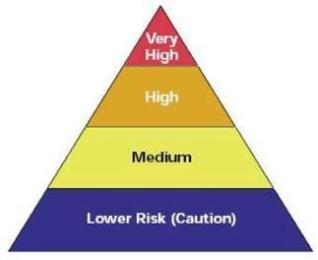

- Very high exposure risk jobs with a high potential for exposure to known or suspected sources of infectious diseases during specific medical, postmortem, or laboratory procedures. Staff in this category include:
  - Healthcare staff performing aerosol-generating procedures on or
collecting/handling specimens from potentially infectious patients or bodies of people known to have, or suspected of having, an infectious disease at the time of death.

- High exposure risk jobs with a high potential for exposure to known or suspected sources of an infectious disease. Staff in this category include:
  - Healthcare delivery, healthcare support, medical transport, and mortuary staff exposed to known or suspected infectious disease patients or bodies of people known to have, or suspected of having, infectious disease at the time of death.

- Medium exposure risk jobs that require frequent/close contact with people who may be infected, but who are not known or suspected patients. Staff in this category include:
  - Those who may have contact with the general public (e.g., schools, high-population-density work environments, some high-volume retail settings), including individuals returning from locations with widespread infectious disease transmission.

- Lower exposure risk (caution) jobs are those that do not require contact with people known to be, or suspected of being, infected nor frequent close contact with (i.e., within 6 feet of) the general public.
  - Staff in this category have minimal occupational contact with the public and other coworkers.

Please refer to Appendix A of this document for OSHA’s Occupational Risk Pyramid and individual factors affecting risk levels specifically for COVID-19.

Risk Control
Monitoring of current situations will be crucial. Federal and state, local department of health (LDOH) recommendations will be followed for situations that may arise as a result of outbreaks, such as:
- Increased rates of staff absenteeism.
- The need for social distancing, staggered work shifts, downsizing operations, delivering educational services remotely, and other exposure-reducing measures.
- Interrupted supply chains or delayed deliveries.
- Positive cases of infectious disease that require facility closures.

Conducting essential operations with a reduced workforce should be planned in advance through Continuity of Operations Planning (COOP). These mission critical
functions would include at least:
  - Payroll
  - Benefits management for staff
  - Accounts receivable/payable
  - Delivery of educational services remotely
  - Meal distribution programs and backpack programs
  - Building cleaning and sanitization
  - IT Support

Risk Reduction
Protecting staff will depend on emphasizing basic infection prevention measures. All staff should implement good hygiene and infection control practices. An aggressive communication plan in the school buildings and community help promote basic infection prevention measures should include:
- Promoting frequent and thorough hand washing by communicating to staff,
students, contractors, visitors, and other individuals the importance of washing their hands.
  - Hand washing should last at least 20 seconds and include scrubbing all surfaces and under the nails.
  - If soap and running water are not immediately available, provide alcohol-based hand sanitizer containing at least 60% alcohol.
    - Handwashing should be conducted immediately when soap and running hot water is available.
- Encourage or enable staff to stay home if they are sick.
- Encourage respiratory etiquette, including covering coughs and sneezes.
  - Provide staff, students, and visitors with tissues and trash receptacles.
- Social distancing
- Discourage staff and students from using other’s cell phones, desks, offices, or other work tools and equipment, whenever possible.

Regular housekeeping practices are also necessary in assisting in keeping facilities open. Proper cleaning, sanitizing, and disinfecting procedures are required to be completed by maintenance staff. Facility directors and staff must:
  - Follow manufacturer’s instructions for use of all cleaning and disinfection products must be followed at all times (e.g., concentration, application method, contact time and required PPE).
  - Ensure selected disinfectant products are on the approved Environmental Protection Agency (EPA) List for use against emerging viral pathogens.

A comprehensive list of approved cleaning, sanitizing, and disinfecting products can be found in Appendix B of this document.

District policies and procedures should be written in advance to address the following needs:
- Reduction in essential workforce
  - Telecommuting
  - Job rotations
  - Staggered shifts
- Distance learning
- Meal/food preparation
- Childcare operations

Policies and Procedures for Prompt Identification and Isolation of Sick People
Prompt identification and isolation of potentially infectious individuals is a critical step in protecting staff, students, visitors, and others. The district must inform and encourage staff to monitor for signs and symptoms of any suspect contagions.
Nursing staff must also have the proper resources to manage students presenting
symptoms as school.
Federal, State, and LDOH guidance must be followed regarding protocols for:
- Stay at home,
- Self-quarantine,
- Mandatory isolation
- Return to school or work
Procedures for immediately isolating staff or students who have signs and/or symptoms of a contagious pathogen:
- Move potentially infectious people to a location away from staff, students, and other visitors. Isolation rooms or areas should be designated areas until potentially sick people can leave the building.
- Follow Federal, State and Local guidance to take steps to limit spread of the respiratory secretions of a person who may have a virus. This would include providing the infected person with a face mask.
- Restrict the number of personnel entering isolation areas.
- Protect staff in close contact with (i.e., within 6 feet of) a sick person or who may have been exposed to or have made contact with a person carrying an infectious disease using additional engineering and administrative controls, safe work practices, and PPE. Staff whose activities involve close or prolonged/repeated contact with sick people are addressed further in later sections covering workplaces classified at medium and very high or high exposure risk.

Develop, Implement, and Communicate about Workplace Flexibilities and Protections
When faced with a contagious disease outbreak, the district shall:
- Follow the recommendations of Federal, State, and Local authorities.
  - Maintain regular or routine proactive communication with these authorities
- Ensure that sick leave policies are flexible and consistent with state and local guidance and that employees are aware of these policies.
- Maintain flexible policies that permit employees to stay home to care for a
sick family member. Employers should be aware that more employees may need to stay at home to care for sick children or other sick family members than is usual.
- Encourage staff to follow the guidance of their physician or LDOH for notification of illnesses and stay at home procedures.
- Monitor staff concerns about pay, leave, safety, health, and other issues that may arise during infectious disease outbreaks.
- Provide adequate and appropriate training regarding essential worker
functions. Ensure protocols are in place for staff health and safety, including proper hygiene practices and the use of any workplace controls. Informed staff who feel safe at work are less likely to be unnecessarily absent.

Implement Workplace Controls
The best way to control a hazard is to systematically remove it from the workplace, rather than relying on staff to reduce their exposure. During an outbreak, when it may not be possible to eliminate the hazard, the most effective protection measures are (listed from most effective to least effective):
- Engineering controls
- Administrative controls
- Personal Protective Equipment (PPE)
There are advantages and disadvantages to each type of control measure when considering the ease of implementation, effectiveness, and cost. In most cases, a combination of control measures will be necessary to protect staff from exposure.

Engineering Controls
Engineering controls involve isolating employees from work related hazards. In workplaces where they are appropriate, these types of controls reduce exposure to hazards without relying on staff behavior. Engineering controls may differ depending on the infectious disease. Controls may include:
  - Increasing HVAC ventilation rates in the work environment.
    - The HVAC system will require an evaluation to determine if this control method will be viable.
  - Installing physical barriers, such as clear plastic sneeze guards.
    - Such barriers will require an evaluation prior to installation to maximize its efficiency.
  - Utilizing exterior/outside methods for meal and schoolwork distribution.
    - Use of bags and boxes
  - Isolation rooms and areas for sick students to use prior to being picked up or leaving the building(s).
    - If possible, select isolation rooms with secondary access so that
compromised student(s) do not travel back into the shared space.

Administrative Controls
Administrative controls require action by the staff or employer. Typically, administrative controls are changes in work policy or procedures to minimize exposure to a hazard. Examples of administrative controls include:
  - Encouraging or enabling sick staff to stay at home.
  - Minimizing contact among staff, students, and visitors by replacing face-to-face meetings with virtual communications and implementing telecommuting when feasible.
  - Establishing alternating days or extra shifts that reduce the total number of employees in a facility at a given time, allowing them to maintain distance from one another while maintaining a full onsite work week.
  - Discontinuing nonessential travel to locations with ongoing outbreaks.
    - Please refer to Appendix A of this document for COVID-19 related travel restriction guidance.
  - Developing emergency communications plans, including a forum for answering staff and family concerns and internet-based communications.
  - Providing staff with up-to-date education and training on contagious disease risk factors and protective behaviors (e.g., cough etiquette and care of PPE, when necessary).
  - Training staff who need to use protective clothing and equipment how to put it on, use/wear it, and take it off correctly, including in the context of their current and potential duties. Training material should be easy to understand and available in the appropriate language and literacy level for all staff.

Safe Work Practices
Safe work practices are types of administrative controls that include procedures for safe and proper work used to reduce the duration, frequency, or intensity of exposure to a hazard. Examples of safe work practices include:
  - Providing resources and a work environment that promotes personal hygiene.
For example, provide tissues, trash cans, alcohol-based hand sanitizer containing at least 60 percent alcohol, cleaners, disinfectants, and disposable towels for staff to clean, sanitize, and disinfect their work surfaces.
  - Requiring regular hand washing and use of alcohol-based hand sanitizer when hand washing is not readily available. Staff should always wash hands when they are visibly soiled and before and after removing any PPE.
  - Post age-appropriate hand washing signs in restrooms.

Personal Protective Equipment (PPE)
While engineering and administrative controls are considered more effective in minimizing exposure to contagions, PPE may also be needed to prevent certain exposures. While correctly using PPE can help prevent some exposures, it should not take the place of other prevention strategies.
Examples of PPE include gloves, goggles, face shields, face masks, and respiratory protection, when appropriate. During an outbreak of an infectious disease, recommendations for PPE specific to occupations or job tasks may change depending on job tasks, updated risk assessments for staff, and information on PPE effectiveness in preventing the spread of the disease.
All types of PPE must be:
  - Selected based upon the hazard to the staff.
  - Properly fitted and periodically refitted, as applicable (e.g., respirators).
  - Consistently and properly worn when required.
  - Regularly inspected, maintained, and replaced, as necessary.
  - Properly removed, cleaned, and stored or disposed of, as applicable, to avoid contamination of self, others, or the environment.
  - Storage of personal protective equipment will be on campus and comply with the manufacturer’s storage recommendations for each item.
  - PPE equipment will be readily available to all employees through identified
disbursement protocols.
Employers are obligated to provide designated staff with PPE needed to keep them safe while performing their jobs. The types of PPE required during an outbreak will be based on the risk of being infected with the contagious disease while working and job tasks that may lead to exposure. This may be directed by the federal, state and or LDOH.
Staff, including those who work within 6 feet of patients known to be, or suspected of being, infected and those performing aerosol-generating procedures, need to use respirators per National Institute for Occupational Safety and Health (NIOSH) standards. These staff would be required to be in a respiratory protection program and follow the requirements to wear a respirator.
Information for Specific Viruses, Pathogens, or Infectious Diseases that are currently present or are an ongoing threat currently on a specific site will be included within Appendix A of this document.
Information requiring the use of facemasks for COVID-19 is located in Appendix A of this document.

Annual Review

This plan should be reviewed annually and be updated as needed. Annual reviews and updates will be recorded in Appendix C of this document.
Appendix A

COVID-19 Specific Guidelines

COVID-19 Specific Guidelines Begin on the Following Page
OSHA Worker Exposure Risk to COVID-19

The Occupational Risk Pyramid depicts the four exposure risk levels in the shape of a pyramid to represent probable distribution of risk. Most job functions within the district will fall in the medium exposure risk level for COVID-19. (https://www.osha.gov/Publications/OSHA3993.pdf)

Occupational Risk Pyramid

  - Very high exposure risk jobs with a high potential for exposure to known or suspected sources of infectious diseases during specific medical, postmortem, or laboratory procedures. Staff in this category include:
    - Healthcare and morgue staff performing aerosol-generating procedures on or collecting/handling specimens from potentially infectious patients or bodies of people known to have, or suspected of having, an infectious disease at the time of death.

  - High exposure risk jobs with a high potential for exposure to known or suspected sources of an infectious disease. Staff in this category include:
    - Healthcare delivery, healthcare support, medical transport, and mortuary staff exposed to known or suspected infectious disease patients or bodies of people known to have, or suspected of having, infectious disease at the time of death.

  - Medium exposure risk jobs that require frequent/close contact with people who may be infected, but who are not known or suspected patients. Staff in this category include:
    - Those who may have contact with the general public (e.g., schools,
high-population-density work environments, some high-volume retail settings), including individuals returning from locations with widespread infectious disease transmission.

  - Lower exposure risk (caution) jobs are those that do not require contact with people known to be, or suspected of being, infected nor frequent close contact with (i.e., within 6 feet of) the general public.
    - Staff in this category have minimal occupational contact with the public and other coworkers.

Individual Factors Affecting Risk Levels for COVID-19

Staff may also have individual factors that will impact risk levels depending on the infectious disease. These factors include, but are not limited to the following for COVID-19:
  - Older age (65 years and older)
  - Presence of chronic medical conditions, including immunocompromising conditions such as:
    - Chronic lung disease or moderate to severe asthma
    - Serious heart conditions
    - Individuals in cancer treatment, having recent transplants
    - HIV or aids
    - Prolonged use of corticosteroids
    - Severe obesity
    - Diabetes
    - Chronic kidney disease and undergoing dialysis
    - Liver disease
  - Pregnancy
  - Certain personal lifestyle choices (i.e. drug use) Source:
https://www.cdc.gov/coronavirus/2019-ncov/need-extra-precautions/groups-at-higher-ris
k.html
Current Executive Orders and Directives

Please visit the following website to view all current executive orders and directives issued by the NYS Governor’s office: https://www.governor.ny.gov/executiveorders

COVID-19 Related Travel Restrictions

For COVID-19 related travel advisories for New York State, regularly check the following website for updated information:
https://coronavirus.health.ny.gov/covid-19-travel-advisory
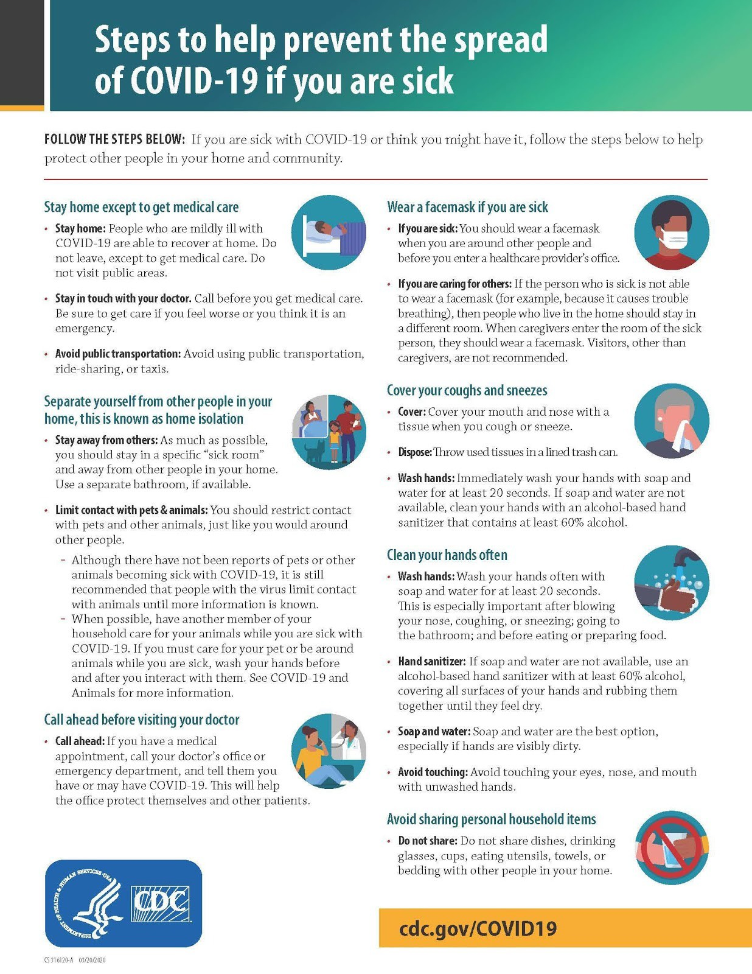
Centers for Disease Control and Prevention

Steps to Help Prevent the Spread of COVID-19 if you are Sick

26
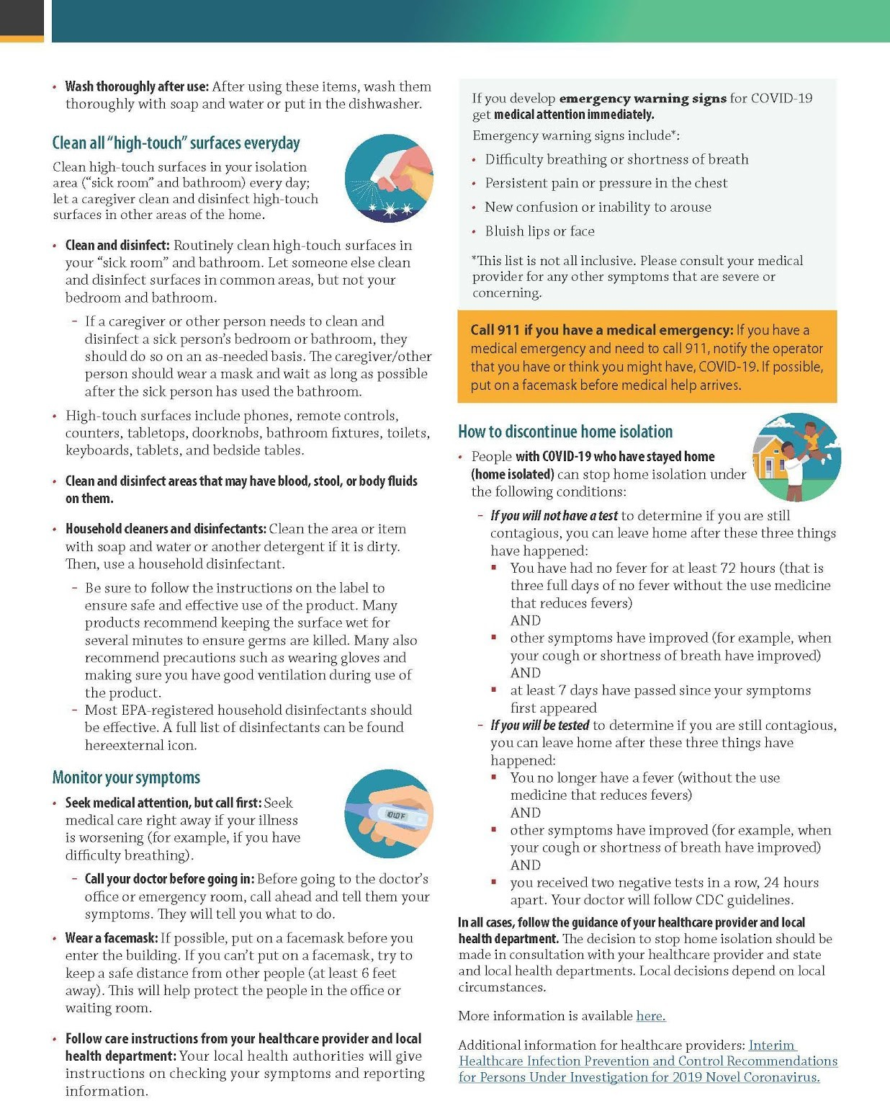

Source:https://www.cdc.gov/coronavirus/2019-ncov/downloads/sick-with-2019-nCoV-fac t-sheet.pdf

27
New York State Department of Health

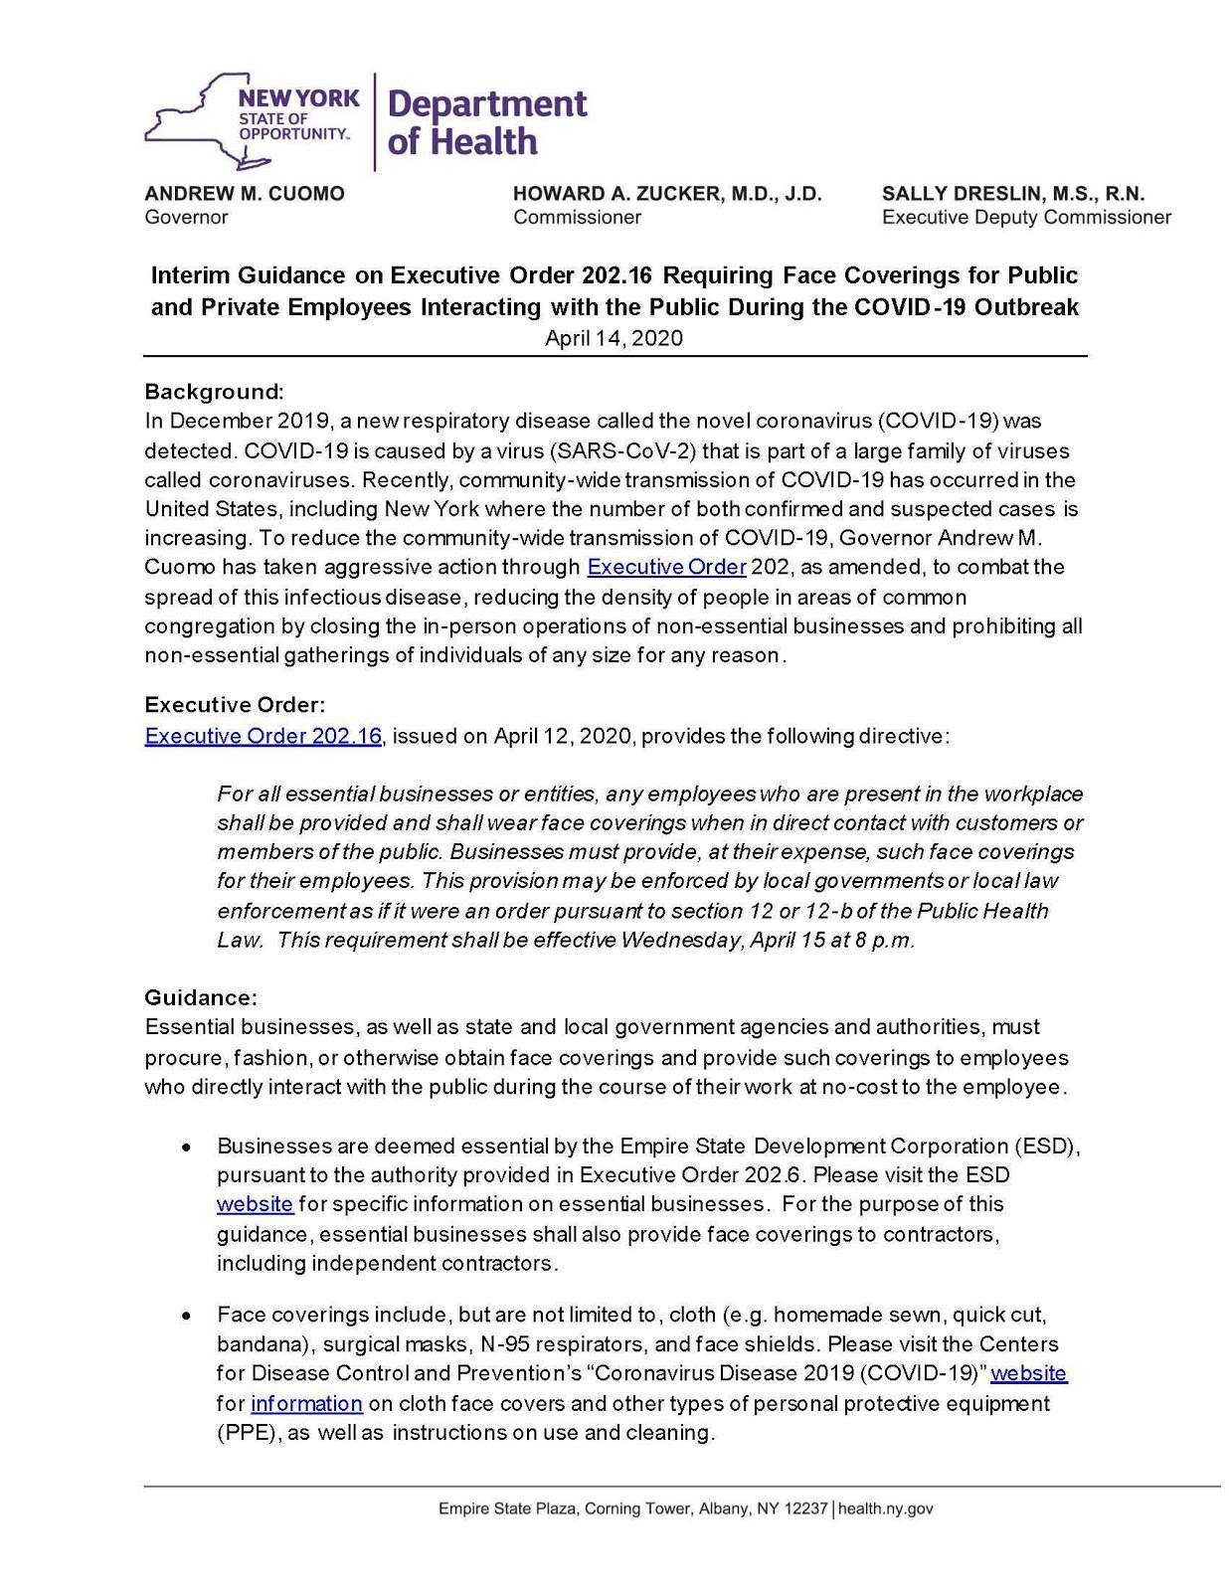
Interim Guidance on Executive Order 202.16 Requiring Face Coverings for Public and Private Employees Interacting with the Public during the COVID-19 Outbreak

28
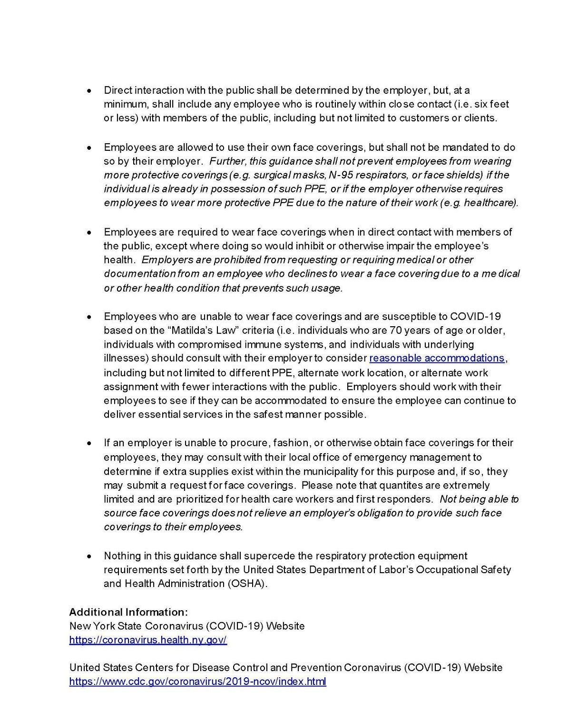

Source: https://coronavirus.health.ny.gov/system/files/documents/2020/04/doh_covid19_e o20216employeefacecovering_041420.pdf

29
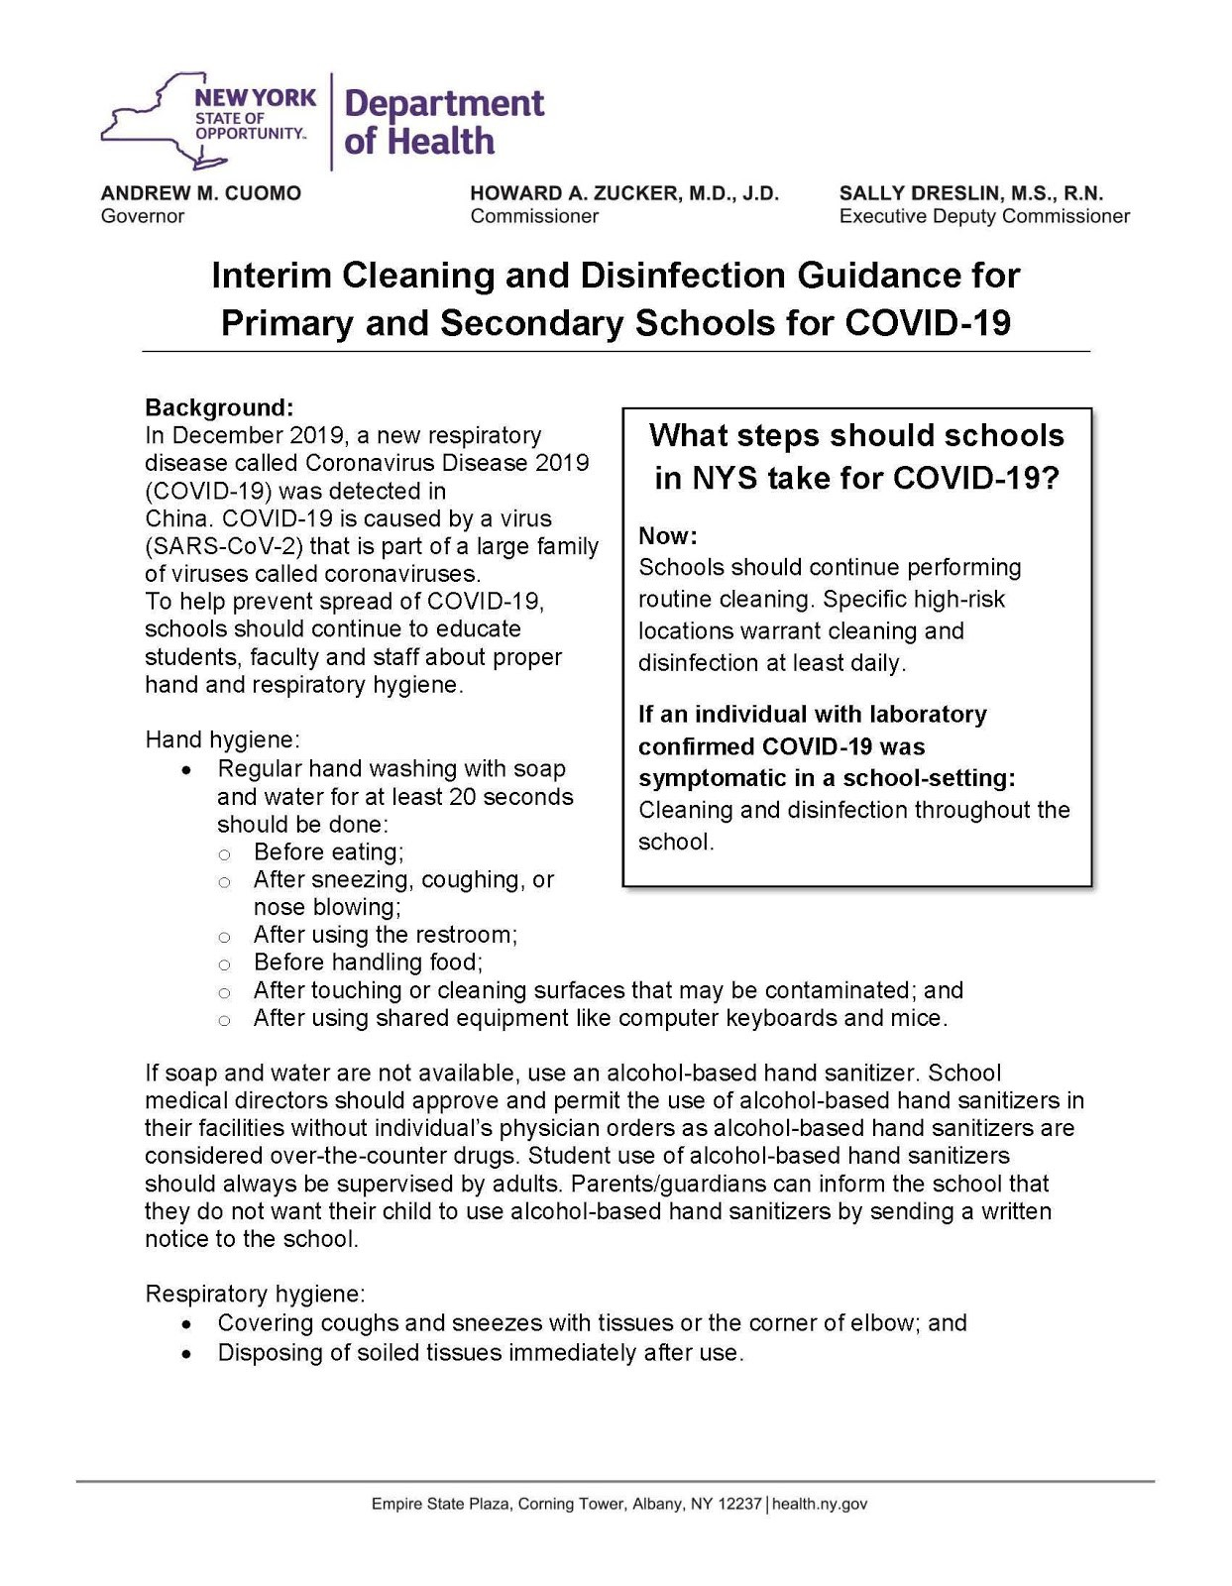
New York State Department of Health Interim Cleaning and Disinfection Guidance
for Primary and Secondary Schools for COVID-19

30
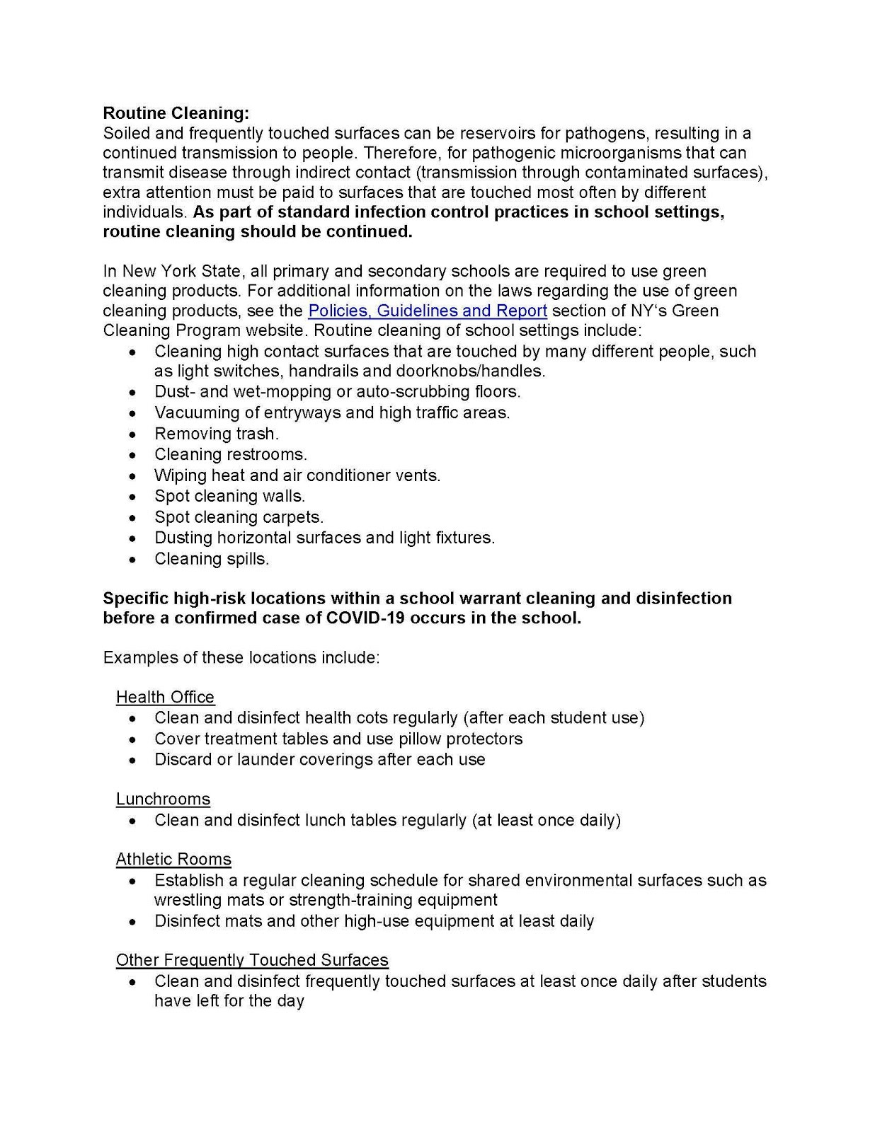

31

Examples of frequently touched areas in schools:
Classroom desks and chairs;
Lunchroom tables and chairs;
Door handles and push plates;
Handrails;
Kitchen and bathroom faucets;
Light switches;
Handles on equipment (e.g. , athletic equipme nt);
Buttons on vending machines and elevators;
Shared telephones;
Shared desktops;
Shared computer keyboards and mice; and
Bus seats and handrails.

Note: Computer keyboards are difficult to clean due to the spaces between keys an d the sensitivi ty of its hardware to liquids. When shared, they may contribute to indirect transmission.
Locations with community use computers should provide posted signs rega rding proper hand hygiene before and after using the computers to minimize disease transmission. Also , consider using keyboard covers to protect the hardware aga inst spills and fac ilitate cleaning.

Cleaning and Disinfection:
Cleaning removes germs, dirt and impurities from surfaces or objects, while disinfecting kills germs on surfaces or objec ts. If a laboratory confirmed case of COVID-19 was symptomatic while in the school setting, custodial staff should perform cleaning and disinfection of frequently touched areas throughout the school.

Step 1: Cleaning: Always clean surfaces prior to use of disinfectants in order to reduce soil and remove germs. Dirt and other materials on surfaces can reduce the effectiveness of disinfectants. For combination products that can both clean and disinfect, always follow the instructions on the specific product label to ensure effective use. In New York State, all primary and secondary schools, state age ncies, and state aut horities are required to use green cleaning products. For ad ditional in format ion on the laws regarding the use of green cleaning products, see the Policies, Guidelines and Report section of NY's Green Cleaning Program website.

Step 2: Disinfection: Cleaning of soiled areas must be completed prior to disinfection to ensure the effectiveness of the disinfectant product. NYS Green Cleaning Program does not address the use of disinfection products.
Disinfection products may be used in school settings as needed at any time. If EPA- and DEC*-registered products specifically labeled for SARS-CoV-2 are not available, disinfect surfaces using a
disinfectant labeled to be effective against rhinovirus and /or human coronavirus. If such products are unavailable, it is also acceptable to use a fresh 2% chlorine bleach solution (approximate ly 1 tablespoon of bleach in 1 quart of water). Prepare the bleach solution daily or as needed. EPA - and DEC* - registered disinfectants specifically labeled as effective against SARS-CoV-2 may become commercially available at a future time and once availa ble, those products should be used for targeted disinfection of frequently touched surfaces.

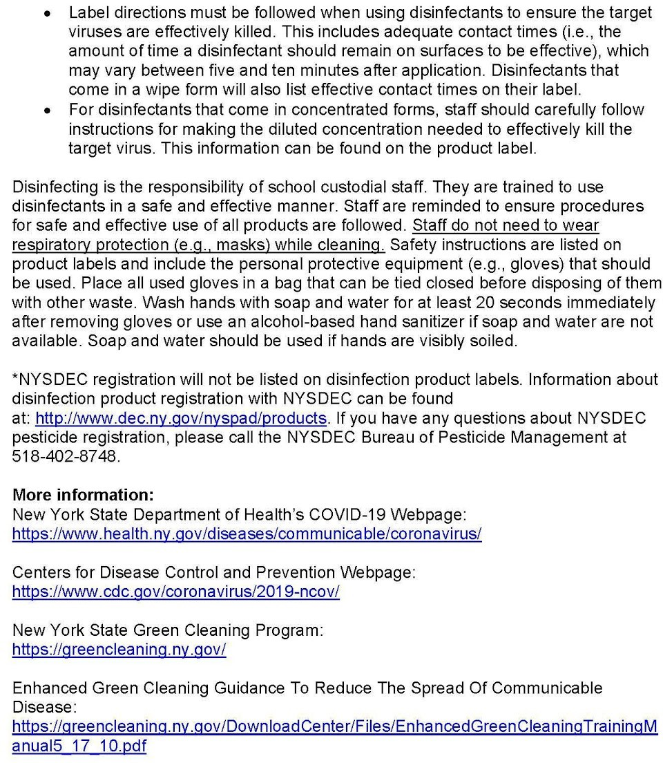

Source: https://coronavirus.health.ny.gov/system/files/documents/2020/03/cleaning_guidance_s chools.pdf
Appendix B

Approved Cleaning, Sanitizing, and Disinfectant Products

Below is a comprehensive list of approved cleaning, sanitizing, and disinfectant products that are currently in use at Brunswick Central School District.

Product Name | Manufacturer
GenEon Sanitizer/Cleaner | GenEon Technologies
BROADBAND Q256 14 | Pro Link
Quat Pro 16 | Pro Link
Glass and Surface Cleaner | Pro Link
Trans Oxy – Oxygenated Cleaner | Pro Link
Neutral Cleaner 3 | Pro link
*Note: Products shall be used in accordance with the manufacturers label and directions
Appendix C

Annual Review/Updates

Date | Reviewed by | Changes and/or Revisions
4/21/2020 | Tim LeVan | Original Document
2/3/2021 | Angelina Maloney | Revised Document

Appendix II

Brunswick Central School District

COVID-19 School Reopening Facilities Cleaning & Disinfection Protocol
The following is Brunswick Central School District’s cleaning and disinfection protocol for reopening during the COVID-19 pandemic. This protocol meets the requirements of the New York State Education Department (NYSED) and New York State Department of Health (NYSDOH) as well as all applicable Federal, State, and local authorities.
- Requirements:
  - Adhere to current federal, state and local guidance regarding COVID-19 at all times.
  - Indoor cleaning and disinfection:
    - Clean and disinfect each space at least daily
      - Maintain daily logs that include the date, time, and scope of cleaning and disinfection. Cleaners and custodians will use this to track their daily/nightly cleaning and disinfection schedules.
    - Clean and disinfect high touch surfaces frequently based upon levels of use:
      - Tables, doorknobs, light switches, countertops, handles, desks, phones, keyboards, tablets, toilets and restrooms, faucets and sinks, etc.
- Clean and disinfect shared equipment between each use by staff and/or students:
- Desks, computers, copiers, office equipment, PE equipment, art supplies, etc.
- School Health Offices
  - Required cleaning and disinfection after each use:
    - Cots, bathrooms, etc.
    - Health office equipment (blood pressure cuffs, otoscopes, stethoscopes, etc.) must be cleaned per manufacturer's directions
- OT/PT Cleaning and Disinfection:
- All equipment used is required to be cleaned and disinfected between each use.
- Outdoor cleaning:
  - Outdoor areas require normal routine cleaning of high touch surfaces and do not require disinfection per Centers for Disease Control (CDC)
  - High touch surfaces:
    - Grab bars, railings, hand holds, rings, chains on swings, etc.
- High touch surfaces will be cleaned as needed based upon levels of use
- Procedures:
  - Cleaning:
    - Follow manufacturers recommendations for proper cleaning.
      - Cleaning procedures will be kept on hand in the buildings and grounds office.
  - Disinfecting:
    - Follow manufacturers recommendations for proper disinfecting.
      - Disinfecting procedures will be kept on hand in the buildings and grounds office.
- District approved disinfectants available for daily use:
  - EPA Approved Disinfectants:
    - The buildings and grounds department maintains a current listing of approved disinfectants.
  - EPA approved alternate disinfectants:
    - Bleach (1/3 cup to gallon mixture of bleach to water, Per NYSED and CDC guidance)
    - 70% or higher alcohol solutions, if available.

- Determining approved disinfecting products:
  - Refer to EPA List N for disinfectants for use against COVID-19
  - If a product is not on the list the CDC states “If you can’t find a product on this list to use against SARS-CoV-2, look at a different product's label to confirm it has an EPA registration number and that human coronavirus is listed as a target pathogen.”
    - Source:
https://www.epa.gov/pesticide-registration/list-n-disinfectants-use-a gainst-sars-cov-2-covid-19

Appendix III

Record of Updates/Revisions

Date | Reviewed by | Updates and/or Revisions

