April, 2021 - School Board Update
The Board of Education (BOE) met on Tuesday evening. The BOE was required to change the meeting date and voted to do so during their March meeting to comply with the rule stating that the meeting be held within 14 days of the set election date. The session was called to order at 7:00 pm by President Mylissa Jennings. The board approved the agenda and heard from Mr. Murphy on the financial update of the district. The district started the month with $1,427,108. The district received $176,986. The district expended $155,503, which left $1,448,591 in the district bank accounts.
The consent agenda items were approved by the board. The consent agenda included the approval of substitute Madison Knight, who has spent the semester student teaching in the Kindergarten and First Grad classroom. The consent agenda also included evaluations of Library/Media, Transportation, and School Climate.
During the principal report, Mr. Wallace discussed the 3 district goals (below).
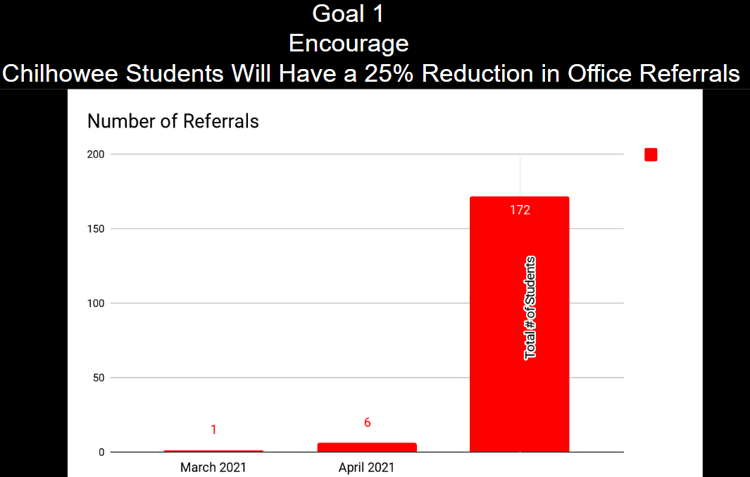
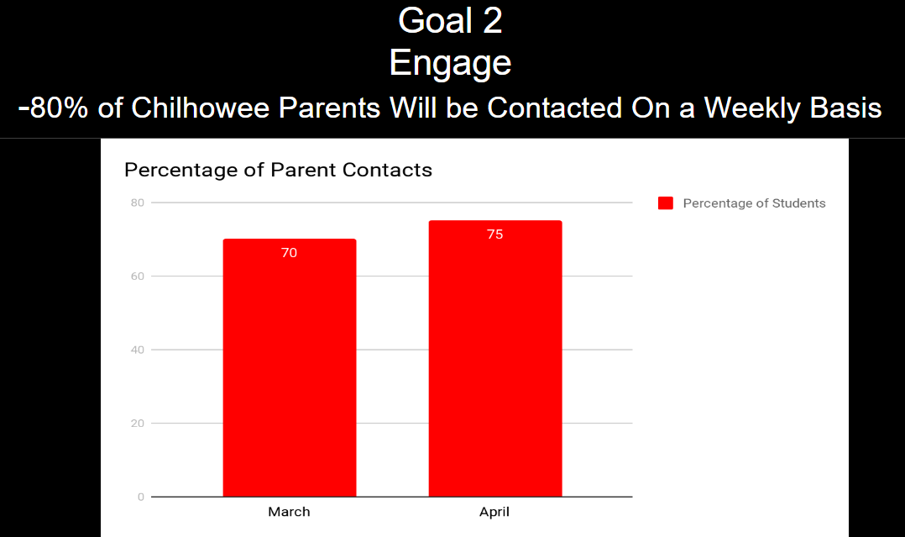
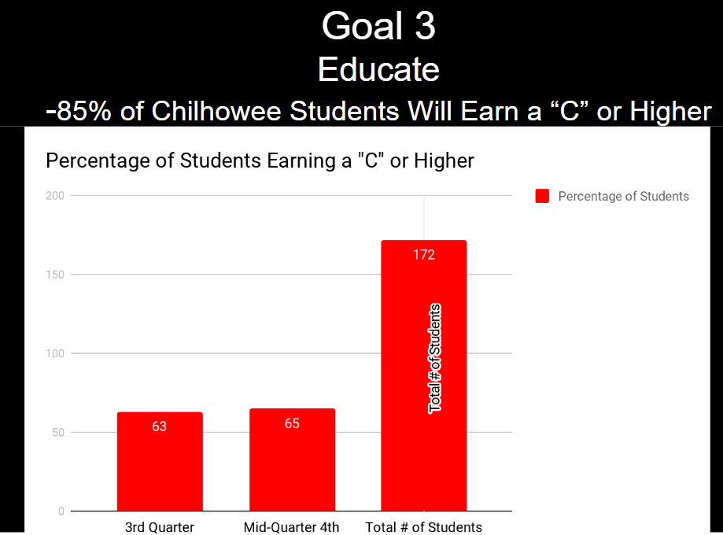
During the Superintendent report Mr. Murphy shared the most current Covid-19 information, which can also be found on the school’s website https://www.chilhowee.k12.mo.us/news . There are currently no cases reported within the district. Mr. Murphy also discussed how the district’s network was being protected and backed up; Currently our network service providers, QNS, has Kaspersky antivirus up to date across the board and installed on all machines in the district. QNS also has these devices setup to run daily/weekly scans to search for malware before we have an issue. QNS also has our networking segmented so that if a computer was compromised, it won't affect everyone like what you have seen in the news with other recent school network compromises. Also add in QNS’s daily backups as a backup measure, if something huge happens like we’ve seen at other districts and businesses, we can have everything back and operating, and usually in less than a few hours.
Mr. Murphy also recognized the following during his report:
- Annie Dillon - for creating the district’s MAP and EOC testing schedule and overseeing that we are prepared in regards to supplies, technology, hardware, and training staff.
- Teachers & Staff – for working hard through April 14th-16th to ensure our doors could remain open to students during our staff’s second dose of the Covid-19 vaccination.
- Misty Miller – Her efforts in working with community organizations and the United Way to secure funds to open a preschool program at Chilhowee R-IV.

There was no old business on the agenda.
The new business portion of the meeting included:
- Board Reorganization: The Chilhowee Board of Education was Disbanded and then reorganized for the upcoming year. Elected officers included President: Mylissa Jennings, Vice President: Chris Postlethwait, Treasurer: Dan Malott, and Secretary: Janise Gardner. Regular Meeting dates were set for the third Wednesday of each month at 7:00PM.
- Support Staff Salaries included a 3% raise as well as offering a step on the salary schedule.
- Support staff hours for the 2021-2022 school year were discussed. It was necessary to adjust days and hours as the district transitions to a 4-day schedule in 2021-22.
- The board voted to approve the addition of preschool for the 2021-22 school year pending the awarding of a grant from the Johnson County United Way.
- Graduation was discussed and it was determined that the District should send out a parent/guardian survey to gain community feedback regarding the best way to honor 8th grade student promoting to high school. The survey will be distributed to parents and guardians of K-8th grade students to gain feedback on the best ways to create a memorable promotion for 8th grade students. The District will use this data to formulate final plans for graduation.
The board held an executive session after the regular meeting per RSMo 610.021 (3), (6) to discuss personnel and student information.
The next meeting for the Board will be on Wednesday, May 19th, 2021 at 7:00 pm in the Library-Media Center.

