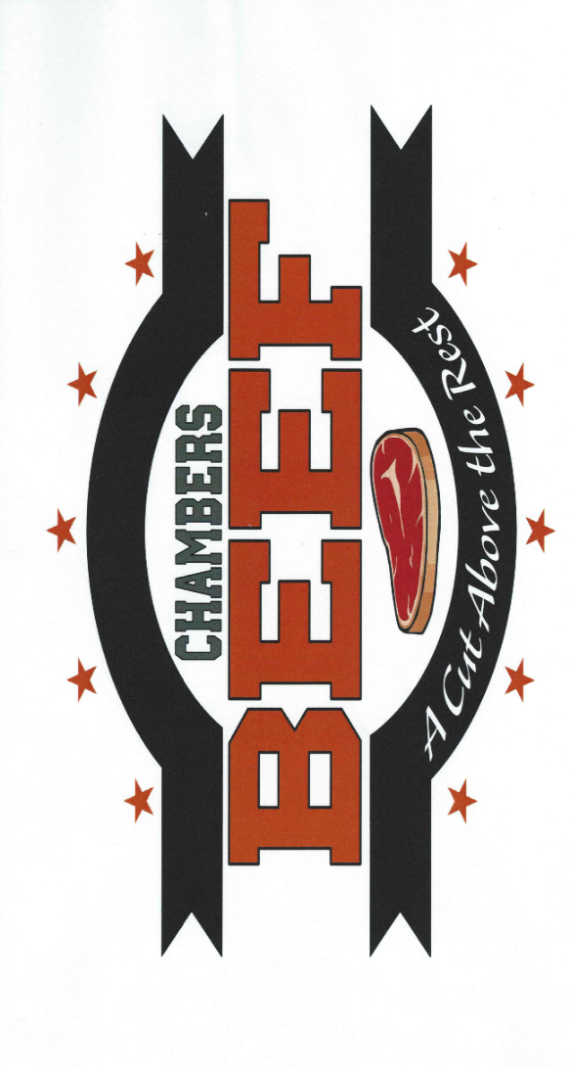

Pledge of Contribution

Donation Type: ______ Beef ______ Monetary
Donor/Business Name: _______________________________________
Address: ___________________________________________________
Phone: _____________________ E-mail: _____________________ ___
Do you wish to be publicly recognized: Yes No
Name for Recognition: ___________________________________ ____

The Chambers Beef Program acknowledges and expresses appreciation for the following contribution:
Date | Description of Donation | Value

Donor Signature: _________________________________ Date:______
Authorized School Representative: ___________________ Date:______
The Chambers Beef Program Fund is a member of the Chambers Community Improvement Foundation Fund which is a subsidiarity of the Nebraska Community Foundation, a recognized 501 (c) (3) not-for-profit organization.

