 Bureau Valley Wyanet Elementary Storm Report
Issue 12 Volume 2 April 16, 2021
Unity, Excellence and Pride!
We are what we believe. What we believe unifies us.
We promise to our students and communities to provide a positive learning environment which promotes both academic and social success

Website-- www.bv340.org

Character Counts for Caring

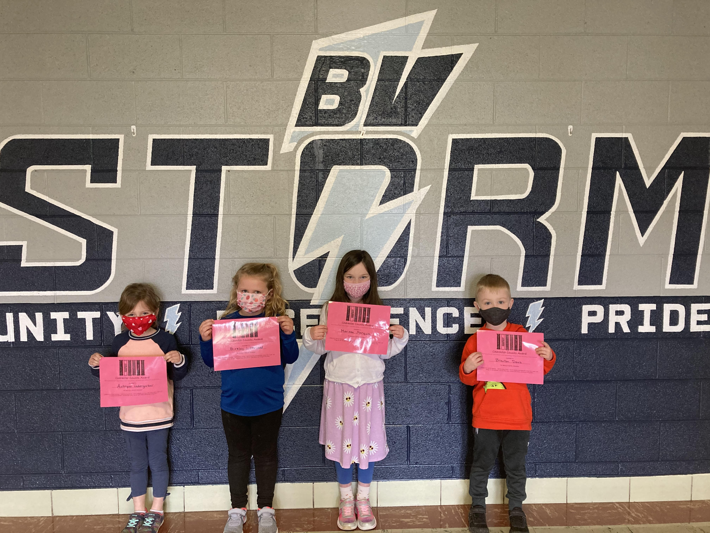
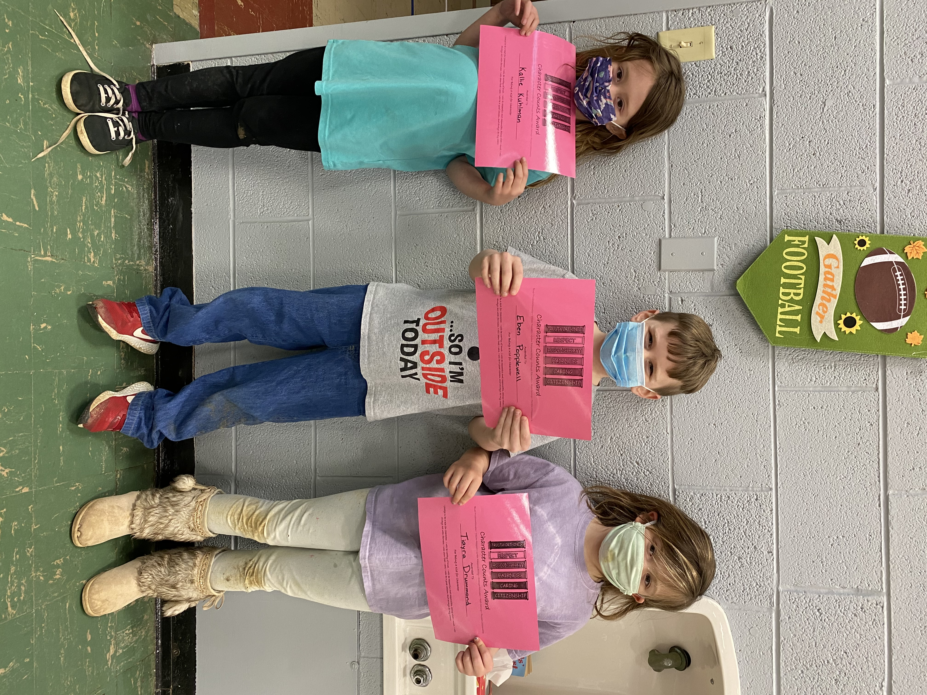
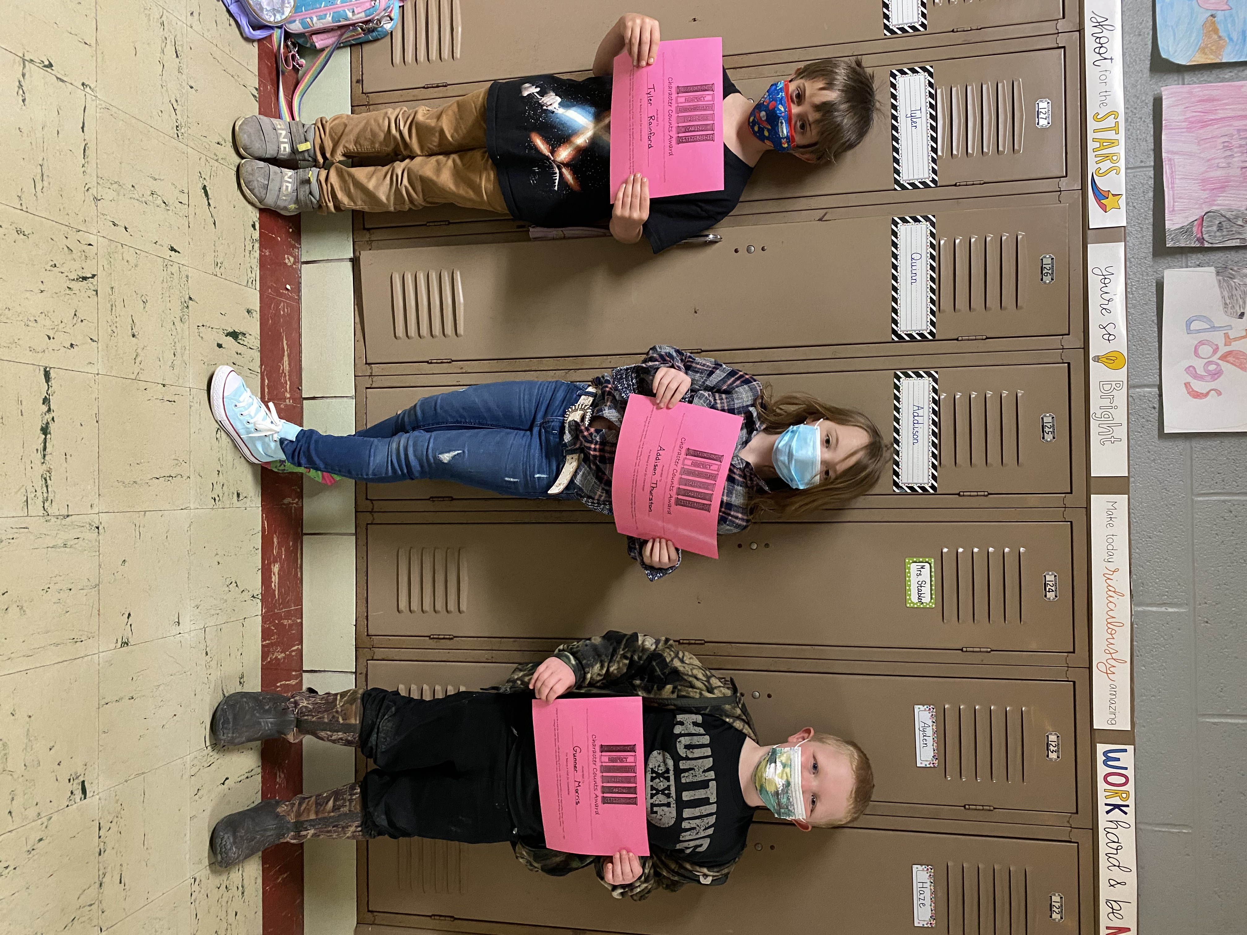
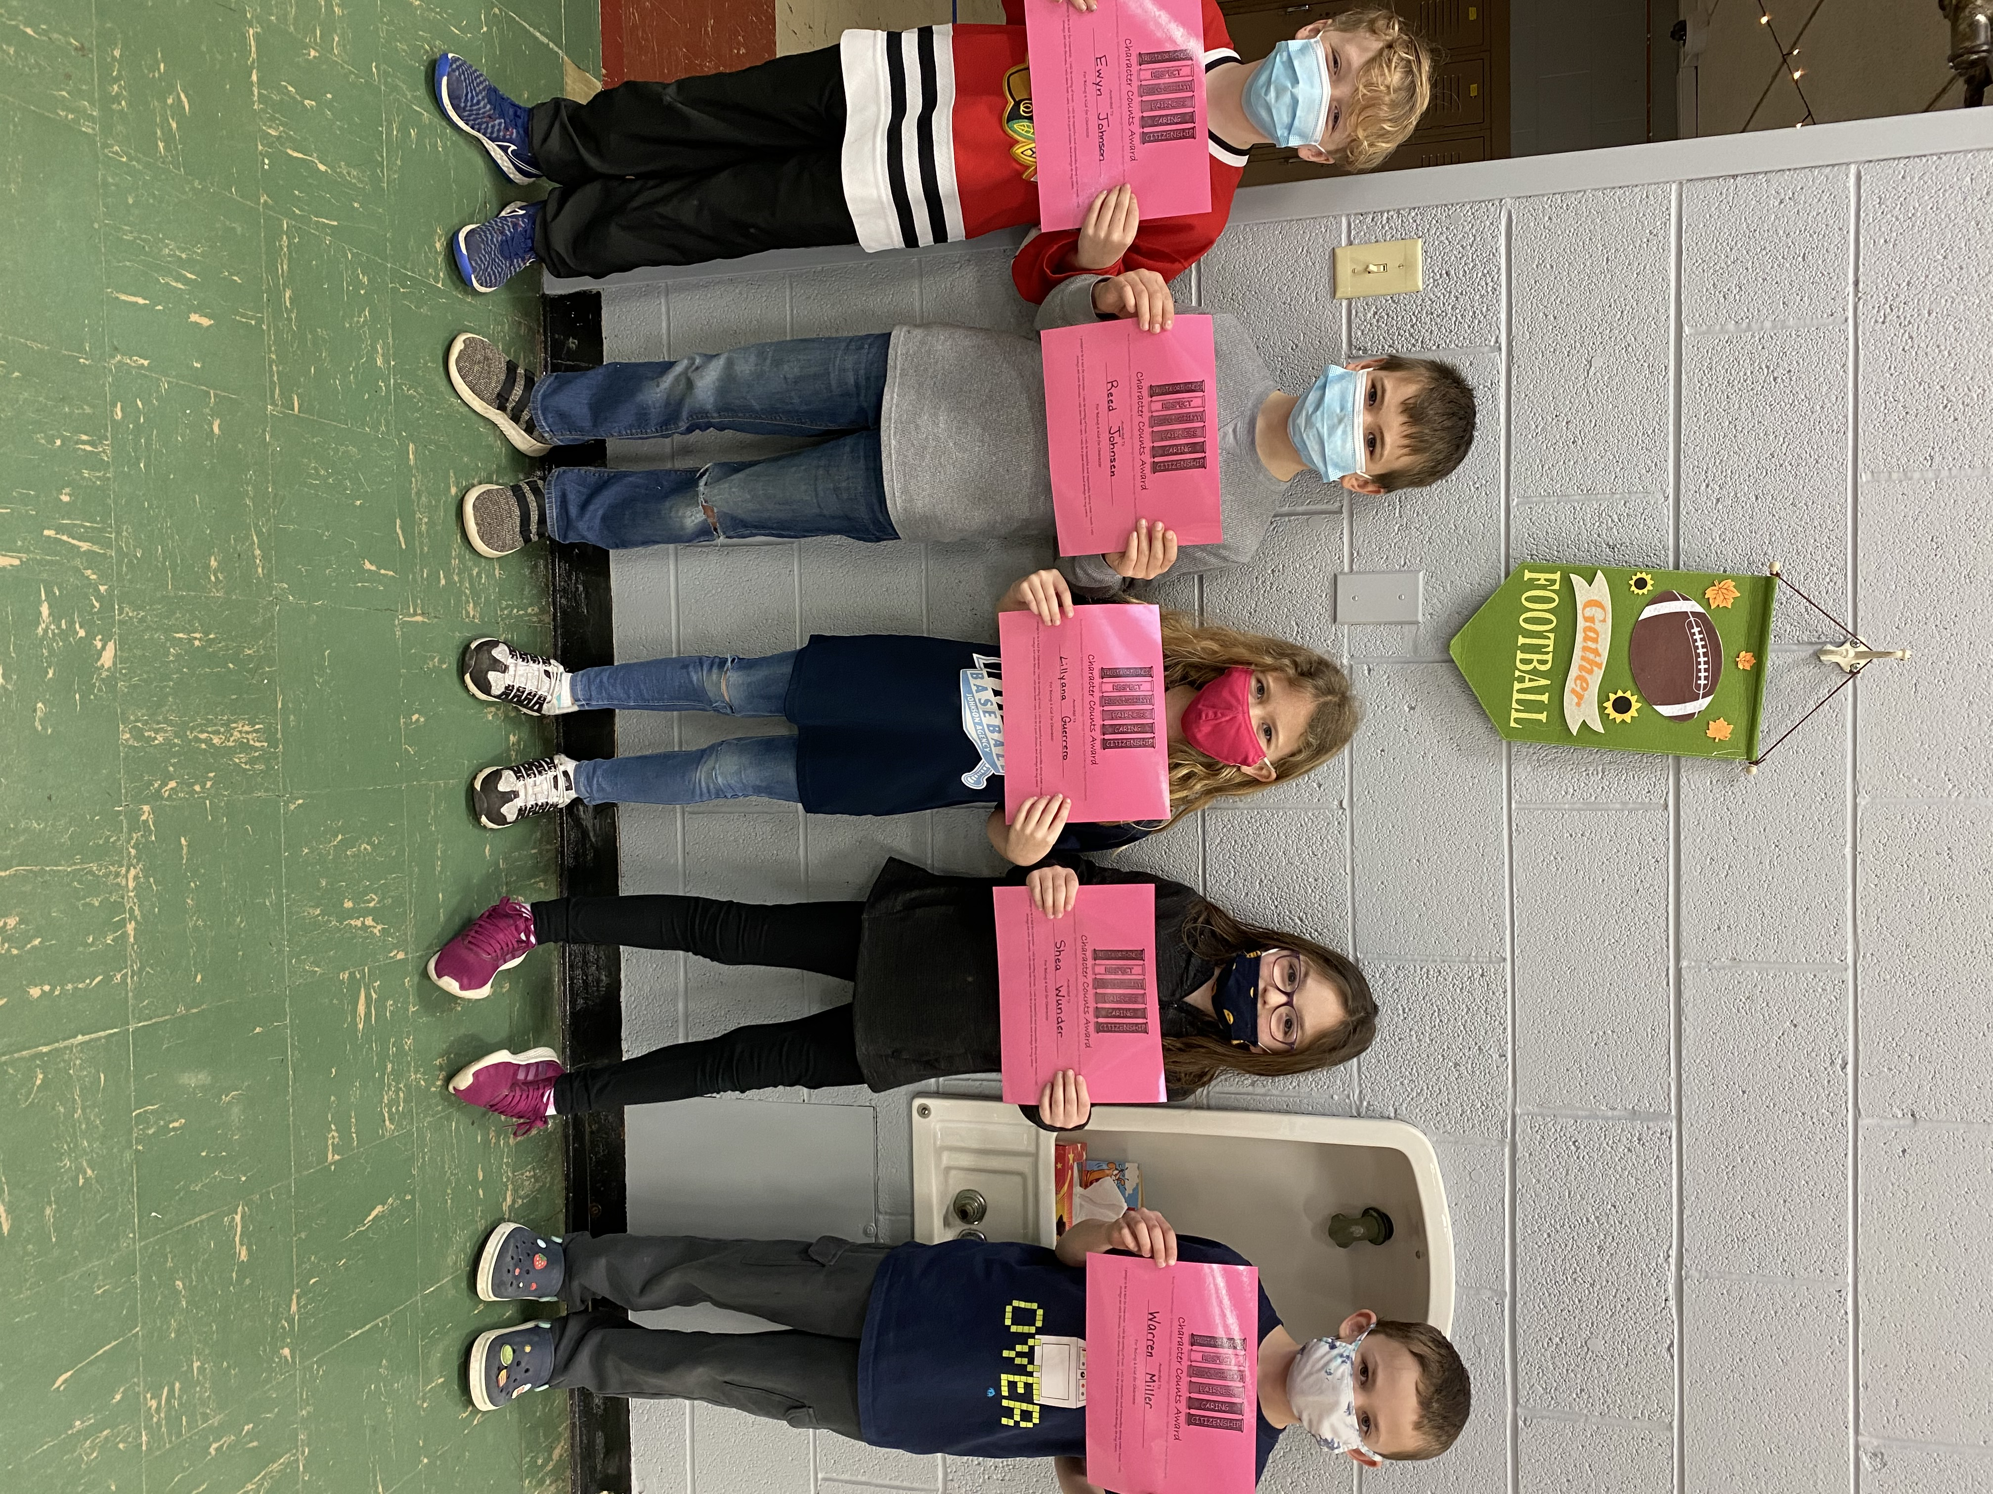

On March 24th students received certificates for the Caring pillar of Character Counts. The following students received a certificate: Aubrynn Ledergerber, Marissa Marquis, Brenton Davis, Birkley Litherland, Gunner Morris, Tyler Rainford, Addison Thurston, Tiayra Drummond, Eben Popplewell, Kallie Kuhlman, Lillyana Guerrero, Reed Johnsen, Ewyn Johnson, Warren Miller, and Shea Wunder. Congratulations to all of you!
2-D & 3-D Shapes
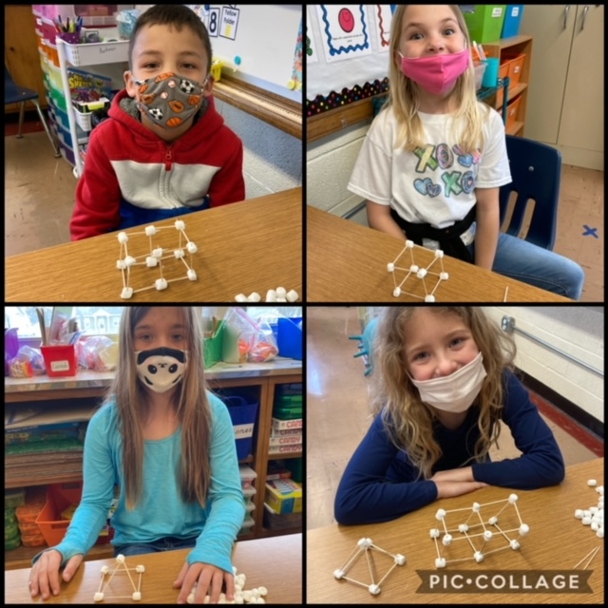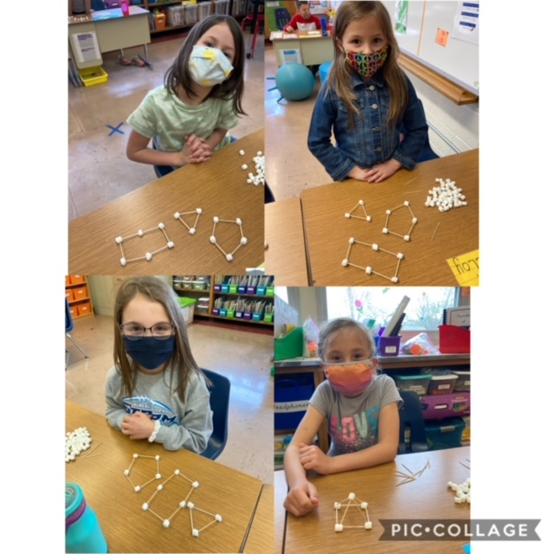
Miss Burkman’s and Miss Daley’s 2nd grade classes have been learning about 2-D & 3-D shapes. Students built 2-D & 3-D shapes with marshmallows and toothpicks.
Additional Clothing

Please send with your child an additional set of clothing to be kept at school in case of spills, mud puddles, or accidents. Please put items in a Ziploc or plastic bag labeled with your child’s name.

Tournament of Books
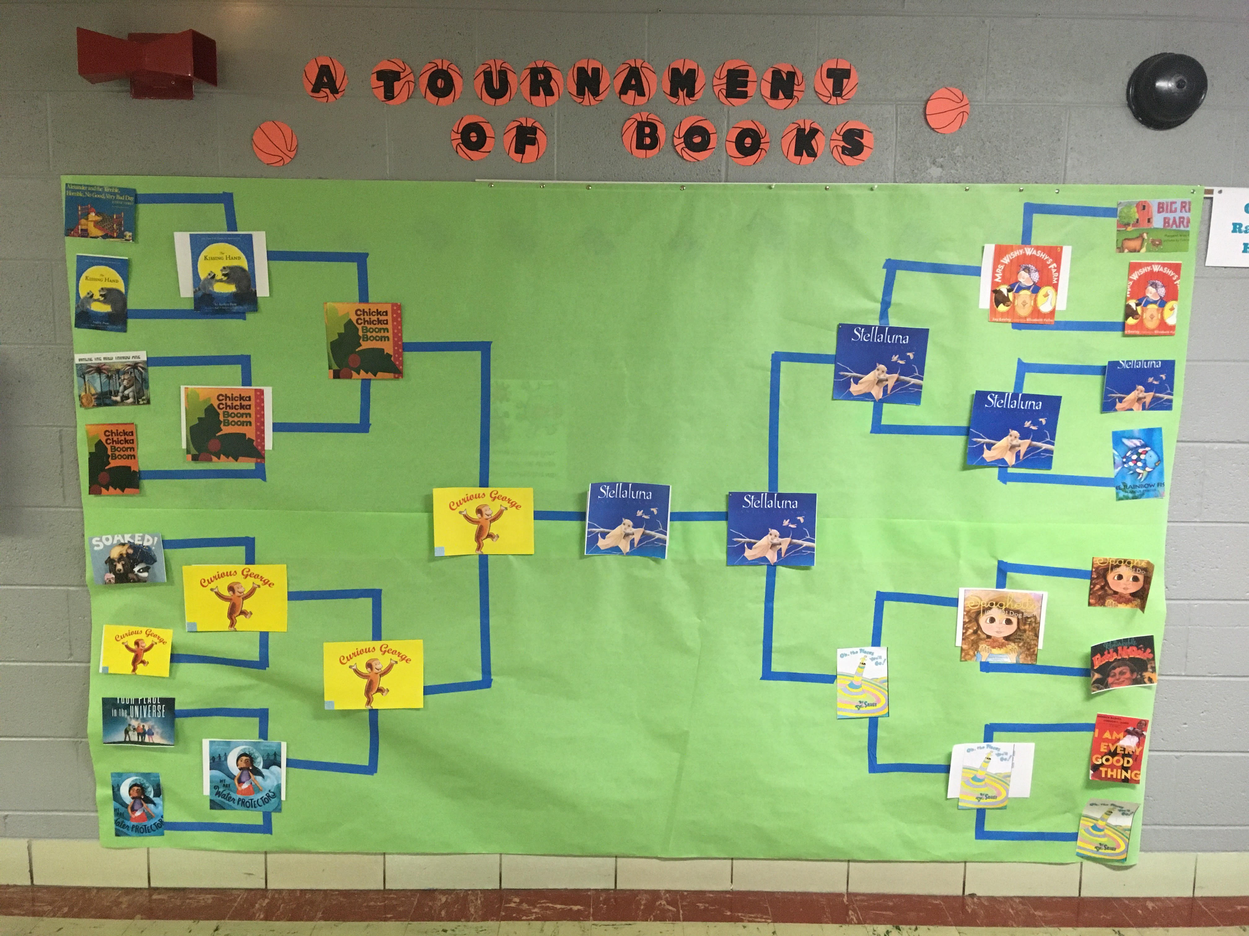
Wyanet held its own March Madness with a tournament of books. Each book was read to the students and the students got to vote for their favorite book. Our March madness winner was Stellaluna with 76 votes.
Free Children’s Orthopedic Clinic
Provided by the
Illinois Elks Children’s Care Corporation,
The Galesburg Elks Lodge #894, and
The Kewanee Elks Lodge #724
with Dr. Steven Potaczek
Tuesday, May 11, 2021
8:00 am – 9:30 am
(By Appointment Only)
OSF Galesburg Clinic
3315 N. Seminary
Galesburg IL
For Appointments
Please Contact the Elks Children’s Care Program
1-800-272-0074 Weekdays from 9 a.m. to 4 p.m.

Attendance Reminder

Please remember to log into Teacherease to sign your child(ren) in for attendance before 10:00am if they are remote learning. Students will need to complete their work on Seesaw to be considered “present” (attending school).

Bureau Valley (Pre-K – 8) Yearbooks

Yearbooks cost $14.00. If you have any questions, please contact the school office in Wyanet at 815-699-2251. Flyers to order were sent home! If you need another flyer, please call the office. You can also order on-line at book.hrimaging.com.

 Dates to Remember

  - Monday, April 19th 6pm Board of Education Meeting
  - Tuesday, April 22nd 11am Dismissal-SIP Day (No lunch served)
  - Friday, April 23rd 4th quarter mid-term
  - Wednesday, April 28th Character Counts for Citizenship
  - Thursday, April 29th Benchmarking
  - Friday, April 30th Benchmarking/4th quarter progress reports sent home
  - Monday, May 3rd Teacher Appreciation Week
  - Thursday, May 13th Wyanet Field Day
  - Monday, May 17th 6pm Board of Education Meeting
  - Tuesday, May 18th Rain date for Field Day

Next newsletter will be sent home on Friday, May 7th.

