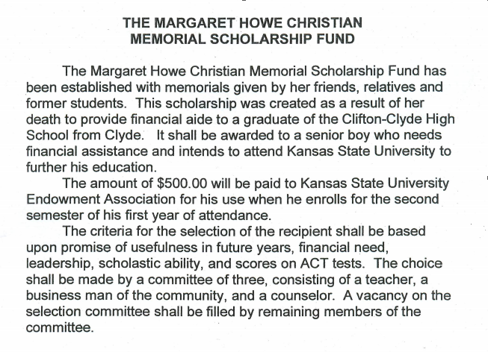

Margaret Howe Christian Memorial Scholarship Fund Application
(Please type neatly)

Name of Applicant: _____________________________________________________________________
(Last) (First) (MI)

Parents or Guardians Names: ____________________________________________________________

Address: ______________________________________________________________________________

What will your major be? ________________________________________________________________

How will you be useful in society in the future years after you graduate from College?

Explain your financial needs while attending college:

Write any leadership roles you have had both in school and in the community:

Applicant’s Signature:__________________________________ Date: ____________________________

Please return the scholarship application to the Clifton-Clyde High School Counselor on or before April 15th.

