

**MENU IS SUBJECT TO CHANGE DUE TO AVAILABILITY:**

**NOTIFICATION STATEMENT: The St. Helena Parish Child Nutrition Program does not purchase Peanuts or Peanut Butter for meals; however,**

**Some products sold may contain nuts and some products are produced in plants that use nuts and may contain traces of nuts.**

**\*\*\*According to the new meal pattern, meals will be served in portion size which is divided into the grade group for the**

**Selected school. The grade groups consist of PK-6th and 7th-12th. Each school must serve the correct portion in order for district to be in compliance**

Sweet Potato Swirl 2.7oz

Canned/Fresh Fruit 1/2 Cup

100% Fruit Juice 4oz

FF/1% Milk Choice 8oz

White, Chocolate

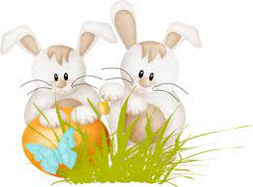

Ham Biscuit 4.25oz

Canned/Fresh Fruit 1/2 Cup

100% Fruit Juice 4oz

FF/1% Milk Choice 8oz

White, Chocolate

Mini Waffles 2.65oz

Canned/Fresh Fruit 1/2 Cup

100% Fruit Juice 4oz

FF/1% Milk Choice 8oz

White, Chocolate

Banana Muffins 2oz

Canned/Fresh Fruit 1/2 Cup

100% Fruit Juice 4oz

FF/1% Milk Choice 8oz

White, Chocolate

Mini Pancakes 3oz

Canned/Fresh Fruit 1/2 Cup

100% Fruit Juice 4oz

FF/1% Milk Choice 8oz

White, Chocolate

French Toast Sticks 3.3oz

Canned/Fresh Fruit 1/2 Cup

100% Fruit Juice 4oz

FF/1% Milk Choice 8oz

White, Chocolate

Sausage Biscuit 3.25oz

Canned/Fresh Fruit 1/2 Cup

100% Fruit Juice 4oz

FF/1% Milk Choice 8oz

White, Chocolate

Cereal/Graham Crackers 2oz

Canned/Fresh Fruit 1/2 Cup

100% Fruit Juice 4oz

FF/1% Milk Choice 8oz

White, Chocolate

Sweet Potato Swirl 2.7oz

Canned/Fresh Fruit 1/2 Cup

100% Fruit Juice 4oz

FF/1% Milk Choice 8oz

White, Chocolate

BREAKFAST PRICES

STUDENTS—FREE

TEACHERS--$2.50

AT COST--$3.00

Pop Tarts 3.53oz

Canned/Fresh Fruit 1/2 Cup

100% Fruit Juice 4oz

FF/1% Milk Choice 8oz

White, Chocolate

Pancake Wrap 2.85oz

Canned/Fresh Fruit 1/2 Cup

100% Fruit Juice 4oz

FF/1% Milk Choice 8oz

White, Chocolate

Cereal/Graham Crackers 2oz

Canned/Fresh Fruit 1/2 Cup

100% Fruit Juice 4oz

FF/1% Milk Choice 8oz

White, Chocolate

Banana Muffins 2oz

Canned/Fresh Fruit 1/2 Cup

100% Fruit Juice 4oz

FF/1% Milk Choice 8oz

White, Chocolate

Mini Waffles 2.65oz

Canned/Fresh Fruit 1/2 Cup

100% Fruit Juice 4oz

FF/1% Milk Choice 8oz

White, Chocolate

Ham Biscuit 4.25oz

Canned/Fresh Fruit 1/2 Cup

100% Fruit Juice 4oz

FF/1% Milk Choice 8oz

White, Chocolate

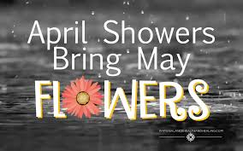



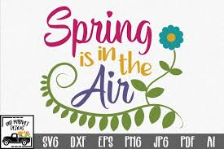

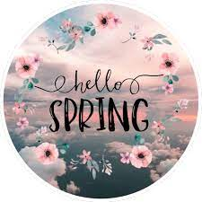



Banana Muffins 2oz

Canned/Fresh Fruit ½ Cup

100% Fruit Juice 4oz

FF/1% Milk Choice 8oz

White, Chocolate

**APRIL 2021**

St. Helena School District