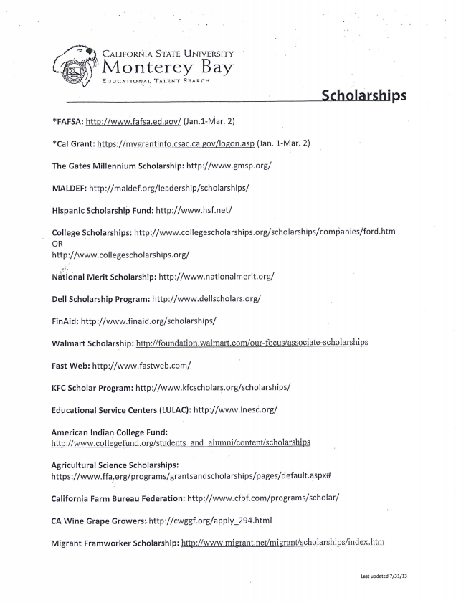
CALIFORNIA STATE UNIVERSITY
xIVlonterey Bay
EDUCATIONAL TALENT SEARCH
Scholarships
*FAFSA: http://wwWfafsaedgovl (Jan.1—Mar. 2)
*Cal Grant: https://mygrantinfo.csac.ca.gov/logon.asp (Jan. 1-Mar. 2)
The Gates Millennium Scholarship: http://www.gmsp.org/
MALDEF: http://ma|def.org/|eadership/scholarships/
Hispanic Scholarship Fund: http://www.hsf.net/
College Scholarships: http://www.col|egescholarships.org/scholarships/comyianies/ford.htm OR http://www.collegescholarships.org/
Naliiiio‘nal Merit Scholarship: http://www.nationalmerit.org/
Dell Scholarship Program: http://www.dellscholars.org/
FinAid: http://www.finaid.org/scholarships/
Walmart Scholarship: http://foundation.walmart.com/0Ur-focus/associate-scholarships
Fast Web: http://www.fastweb.corn/
KFC Scholar Program: http://www.kfcscholars.0rg/scholarships/
Educational Service Centers (LULAC): http://www.lnes¢.org/
American Indian College Fund: httD://www.co]legefundgg/students and alumni/content/scholarshjns
Agricultural Science Scholarships: https://Www.ffa.,erg/programs/grantsandscholarships/pages/default.aspx#
California Farm Bureau Federation: http://www.cfbf.com/programs/scholar/
CA Wine Grape Growers: http://cwggf.org/apply_294.htm|
Migrant Framworker Scholarship: httn://WWW.migrant.net/migrant/scholarships/index.htm
Last updated 7/31/13
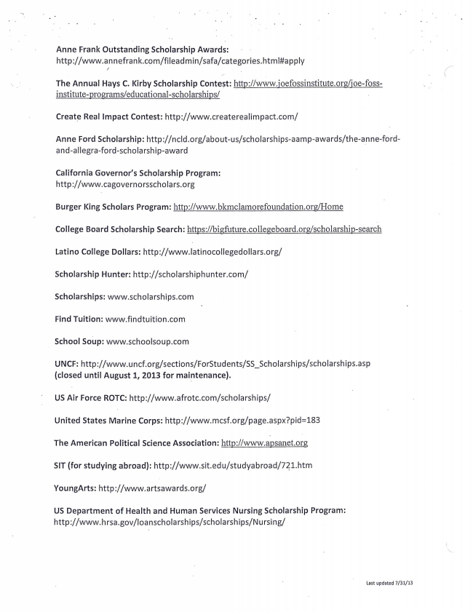
Anne Frank Outstanding Scholarship Awards: http://www.annefrank.com/fileadmin/safa/categories.htmI#app|y
The Annual Hays C. Kirby Scholarship Contest: http://www.ioefossinstitute.0rg/ioe-fossinstitute-programs/educational~sch01arships/
Create Real Impact Contest: http://Www.createrealimpact.c0m/
Anne Ford Scholarship: http://ncld.org/about-us/scholarships-aamp-awards/the-anne-fOrdand-allegra-ford-scholarship-awa rd
California Governor's Scholarship Program: http://www.cagovernorsscholars.org
Burger King Scholars Program: http://www.bkmclamorefoundati011.01'g/Home
College Board Scholarship Search: hfcps://bigfi1ture.collegeboard.org/scholarship-search
Latino College Dollars: http://WWW.latinocollegedollars.org/
Scholarship Hunter: http://scholarshiphunter.com/
Scholarships: www.scholarships.com
Find Tuition: www.findtuition.com
School SoLlp: www.schoolsoup.com
UNCF: http://Www.uncf.org/sections/ForStudents/SS_Sch0|arships/scholarships.asp (closed until August 1, 2013 for maintenance).
US Air Force ROTC: http://Www.afrotc.com/scholarships/
United States Marine Corps: http://www.mcsf.org/page.aspx?pid=183
The American Political Science Association: http://wwwa'psanetorg
SIT (for studying abroad): http://www.sit.edu/studyabroad/7Zl.htm
YoungArts: http://www.artsawards.org/
US Department of Health and Human Services Nursing Scholarship Program: http://www.hrsa.gov/loanscholarships/scholarships/Nursing/
Last updated 7/31/13

