Mandatory Lead in

Water Testing

Training Module 6:

Reimbursement

Table of Contents

Overview 3

Covered Expenses 3

Reimbursement Process 3

Reimbursement Schedule 3

Required Documentation 4

Completing the Template 4

Submitting Documents 8

Using the Secure File Transfer Protocol (FTP) 8

Overview
When the legislature required schools to test water for elevated levels of lead in 2017, they also provided funding to reimburse schools for the associated costs. ODE has also secured grant funding from the federal Water Infrastructure Improvements for the Nation Act (WIIN Act) administered by the EPA. Funding from this grant will be used to supplement the state money so that we can get more money out to schools. All testing for lead in water from January 2019 forward is eligible for reimbursement. While proper documentation will be required to receive reimbursement, it is largely the same documentation required to verify compliance with the statute.

Covered Expenses
- Actual lab costs for testing water samples
- Associated costs (such as sample bottles if your testing lab does not provide them), and
- Shipping expenses. In some cases, ODE will also cover mileage reimbursement to take samples to the lab where shipping is not possible or practical.
ODE will NOT pay consultant fees or directly reimburse labor costs to collect samples. However, in addition to covering the direct lab costs, we will reimburse schools an additional amount on a per sample basis to help offset collection costs. This additional amount will be issued once a year. So for instance, if we are able to pay $15 per sample, and you have submitted 100 samples, we will reimburse an additional $1,500.
The amount paid for each sample will be determined each year by a calculation based on the number of and cost of all samples claimed for the year and the total funds available. The maximum amount will be capped at $40 per sample.

Reimbursement Process
In order to receive reimbursement, you must submit a request with all required documentation by email to Brian Hodges-French. Once received, your submission will be reviewed, verified and recorded in our Master Tracker which tracks all test results and reimbursements statewide. Submissions that are incomplete or incorrect will be rejected, but you will have the opportunity to make corrections. If there are discrepancies between the amount requested and the amount invoiced by the lab, you will have the option of correcting the discrepancy or receiving payment for the lesser of the two amounts. Once ODE has approved your submission, you will be notified of the amount to request through the Electronic Grant Management System (EGMS). That amount will be verified against the records and released by ODE at the appropriate time.

Reimbursement Schedule
Reimbursements for lab costs will be disbursed twice each year. Disbursement of the per sample payment as offset for collection costs will occur once each year after all lab costs for the year have been disbursed. Disbursement will be made through EGMS and will require completion of a grant agreement which will be incorporated into the EGMS system. The schedule is as follows:
- Reimbursement requests received July 1 through December 31 will have a disbursement target of March 31.
- Reimbursement requests received January 1 through June 30 will have a disbursement target of September 30.
Please submit you reimbursement requests as early as possible. There is significant work involved in processing, verifying and recording your submissions and the volume is expected to be high. A significant number of requests submitted at or near the deadlines, could result in a delay of the disbursement date. Please help the process move smoothly for all by submitting early and responding quickly to any requests for corrections, clarification and additional information/documentation.

Required Documentation
In order to receive reimbursement, you must submit a request by email to Brian Hodges-French which must include the following:
- Lab invoices. These must be directly from the testing lab. We will not reimburse based off of consultant invoices, as they sometimes add an upcharge to the actual lab cost.
- Receipts for shipping and any other associated costs you are requesting reimbursement on. If you are seeking reimbursement for mileage for delivering samples to the lab, you must submit documentation such as Google Maps showing the mileage from the district office to the testing lab.
- Fully completed Reimbursement Template(s). Contact Brian Hodges-French to receive the latest version of the Template or find it on the Healthy and Safe Schools webpage. You must submit a separate template for each individual building tested. Ideally, these will be submitted as separate tabs in a single workbook. All templates must be submitted as live Excel documents. PDF versions of the Template will NOT be accepted.
- A summary document outlining exactly what you are requesting for reimbursement. This should include total number of samples, cost per sample, miscellaneous costs and the total requested.

Completing the Template
Templates must be filled out completely and accurately! We expect to be tracking in excess of 100,000 water fixtures for years to come. Because of the sheer volume of testing, we need to be able to copy and paste information directly into the Master Tracker without making changes or adjustments. This means I will be very insistent that all portions of the template must be filled out correctly.
You may add rows as necessary to accommodate more samples, but do NOT add or modify any of the columns. If you think you need to add columns or modify them please contact ODE for additional technical assistance.
It is highly recommended that you complete and submit one completed template for a single building for review and confirmation that everything is correct before submitting for all tests. This will help insure that if something is not filled out properly, the error can be corrected before you have filled out all of your documents. This will make the process more efficient. Required inputs include:
- Inst. Name: This is the name of your district, ESD, or charter school.
- Inst. ID #: This is your 4 digit institutional ID code established by ODE.
- School Name: This would be the name you use to identify the particular school or campus. Remember you will also be testing non-instructional facilities such as your district office and bus/maintenance shops.
- Building Name: This would be the name of the particular building. If there is only one building associated with a school, this would be a repeat of the school name. If there are multiple buildings at a school or campus, it would be what you call the building or a description of the building function, such as Main Building, Gym, Cafeteria, etc.
- Building ID #: This is the 8 digit Building ID Number found in the School Facilities Building Collection database administered by Michael Lammers. Every building with power and a foundation must have a Building ID Number. Portables also must have a Building ID Number, even though they don’t necessarily have a foundation. If one has not already been assigned in accordance to the state wide protocol, contact Michael Lammers to get a proper number assigned (Portable and Modular units may not have an actual foundation, but are still included in the Building Collection).
- Date: This is the date that samples were drawn. If more than one date is included for the samples drawn in the request, you should use the earliest date, or the date the majority of the samples were drawn.
- Building Fixture Count: These are the boxes in the upper right corner of the form. You will need to input the following numbers. The Total Fixtures box will automatically calculate the total.
  - the count of the total number of fixtures in the building that are required to be tested (even if you have not tested all of these fixtures at this time),
  - the number of fixtures that are exempt from testing because of the type of fixture, such as eye wash stations, emergency showers etc., and
  - the number of fixtures that are exempt from testing as all new. If none, input zero.
- Fixture Location/Description: In this column, you will input the unique location description for each fixture. The description should be sufficient such that a person without specific knowledge of your building would be able to find the fixture in question based only on this description.
- Fixture ID #: This is the Fixture ID Number you have assigned to each fixture using the ODE fixture numbering protocol. It will be a 13 digit number. Please see Training Module 2 – Fixture and Sample ID Numbers for additional information.
- Initial Test Date: This column would be the date that the initial samples were actually drawn, NOT the date that the lab received or tested the samples.
- Initial Test Result: This would be the result from the first sample drawn for a given fixture (the ‘Draw’ sample). This must be the test result represented in parts per billion (ppb), but do NOT include ‘ppb’ in this column. Just input the number.
- Number of Retests: If additional tests were required because the Initial Draw test was high, record the number of additional tests in this column. Do NOT include the Initial test in this number.
- Final Test Result: Input the final test result once the problem has been corrected. It is NOT necessary to record any test results for samples drawn between the Initial sample and the Final sample. This number must represent the result in parts per billion (ppb), but do NOT include ‘ppb’ in this column. Just input the number.
- Misc. Lab Cost: Use this column to record miscellaneous costs such as metal digestion or rush fees. In most instances, this column should not be placed on the same row as results for a fixture, but should be put in a separate row, with detail of what the expense is for filled out in the Fixture Location/Description column (see illustration below). If you are unsure, ask.
- Shipping Expense: Use this column to record shipping expenses. Also, if you are requesting reimbursement for mileage to drive samples to the testing lab, include that here as well. This column should not be used on the same row as results for a fixture, but should be put in a separate row, with detail of what the expense is for filled out in the Fixture Location/Description column (see illustration below).
- Lab Cost per Sample: In this column, input the cost for each sample, on a per sample basis. You will need to input this number for each row, as appropriate.
- Total # of Tests and Reimbursable Amount: These columns as well as the totals at the bottom will automatically calculate and populate the necessary blanks.
On the following page is an example of a Reimbursement Template for a fictitious school to illustrate what a completed document should look like. For a copy of the latest version of the Reimbursement Template, please email Brian Hodges-French or find it on the Healthy and Safe Schools webpage. An Excel version of the example is also available on this webpage.
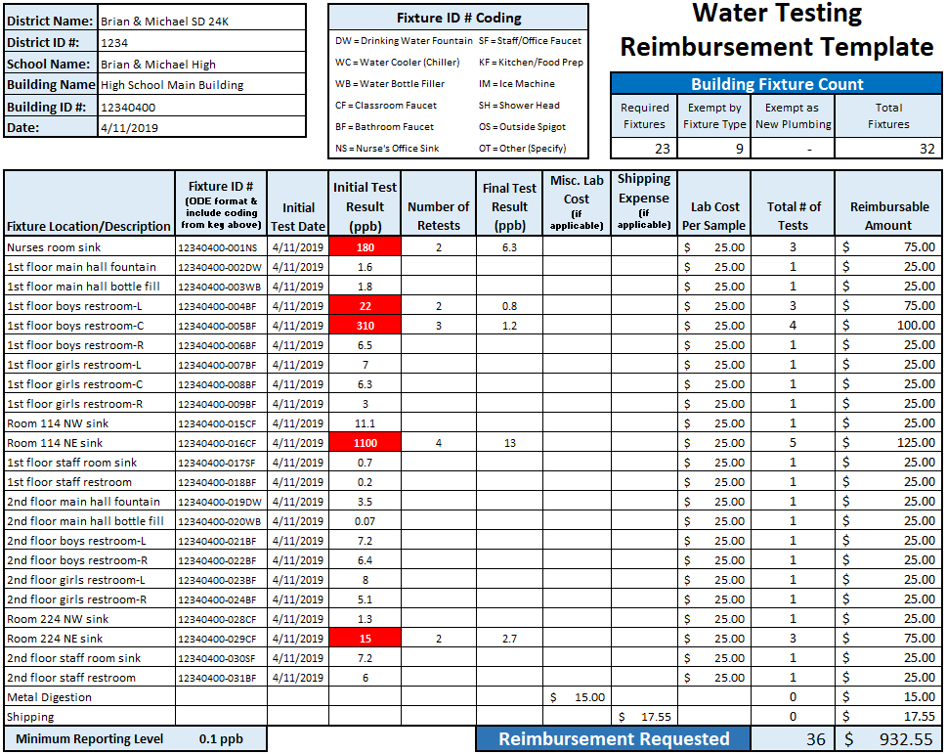

Submitting Documents
All reimbursement documents must be submitted by email to Brian Hodges-French.
- Lab invoices and receipts should be sent as PDF files. Please be sure they are legible.
- Templates MUST be sent as live Excel files.
- The summary document may be sent as a Word document, PDF, or Excel file.
For files 5 MB or larger, you must use the ODE Secure File Transfer Protocol. Sending files in excess of 5MB through standard email will result in the file not arriving. In some cases, you might be notified that the file did not go through, but often there is no notification. If you do not receive acknowledgement that your submission has been received, please follow up to ensure we have received your submission. Alternatively, you may choose to break your submission up into smaller pieces.

Using the Secure File Transfer Protocol (FTP)
- Go to the ODE “Secure File Transfer” site: https://district.ode.state.or.us/apps/xfers/
- Under the “ODE Email List,” scroll down to find: brian.french@ode.state.or.us
- Select brian.french@ode.state.or.us from the “ODE Email List” list on the left.
  - Double-click on the email address or drag and drop the email address into the “ODE Recipients” list.
- For recipients outside the ODE system, type their email address in the “Outside Recipients box.”
  - If you wish to enter additional recipients, enter a comma (,) or semicolons (;) and then enter the recipient's email address.
- Under the section “Email of Person Sending the File,” type the sender's email address in the textbox.
- Under the “Locate the File to Send,” click on “Select File” to upload the desired document
  - Please note that only one upload can be completed at a time.
  - The following are acceptable file extensions: .txt, .doc, .docx, .xls, .xlsx, .pdf, .htm, .html, .asp, .aspx, .ppt, .pptx, .ppsx, .csv, .gif, .jpg, .jpeg, .zip, .dat, .mdb, .xml, .smf, .dbf, .pps.
  - NOTE: The following characters are invalid in the filename and may break the file transfer. < > : " ? / | \ *
- In the “Enter Your Message Here” textbox, enter in any pertinent information the recipient should know about this document.
- Click on the “Send File” button and your document is now on its way to the “Recipient(s).”
- An email will be sent to each of the recipients with a link to this website.
  - When the recipient clicks on that link, the recipient will be able to download the file.
  - An email will be sent to you informing you that an email has been sent in your name.

