STATION 1: SCREEN CAPTURE

1. Screen capture your favorite website
2. 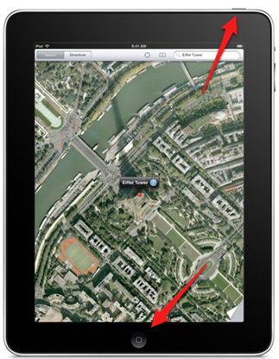::App Icons:Photos.pngFind it in photos and show someone near you

STATION 2: SHUT DOWN

1. Hard shut down

*Hold 5-seconds and power slide off* 

2. Hard restart

STATION 3: MOVE ICONS

1. Rearrange your icons
2. Move an icon to a different page



STATION 4: MULTITASKING GESTURES

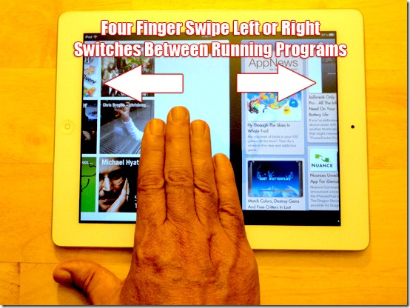Multi-tasking bar: 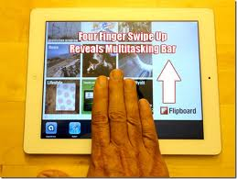4-fingers up

Navigate between pages: 4 fingers R-L

STATION 5: MULTITASKING: GO HOME

1. Open the Safari Browser ::App Icons:Safari.png
2. 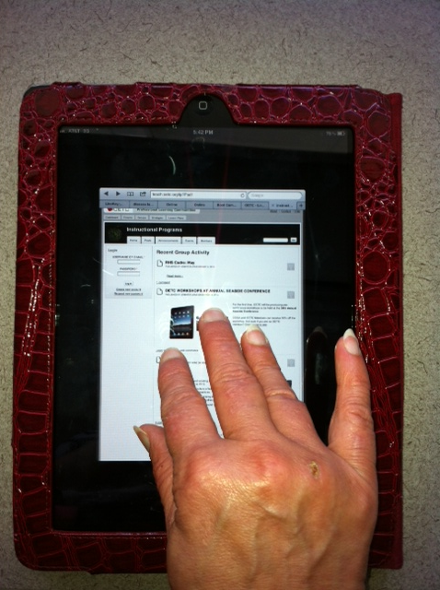4-finger swipe close-in

STATION 6: LOCK AND MUTE

1. Lock rotation (General>Settings)
2. 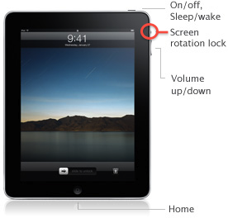Quickly mute

STATION 7: CHANGE YOUR WALLPAPER

* ::App Icons:Camera.pngTake a picture of something cool
* 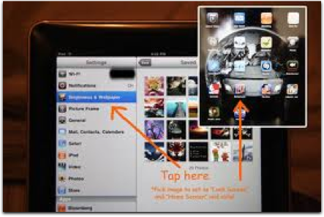::App Icons:Settings.pngMake it your home screen

STATION 8: MAKE FOLDERS

Rearrange icons and put into a folder

* ::App Icons:Camera.png::App Icons:Photos.pngDrag your photos on top of your camera

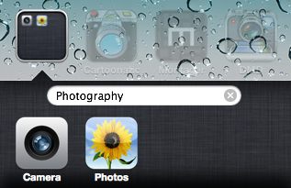

* Take it out of the folder

STATION 9: SPOTLIGHT or BUBBLE

* Copy text from a webpage
* 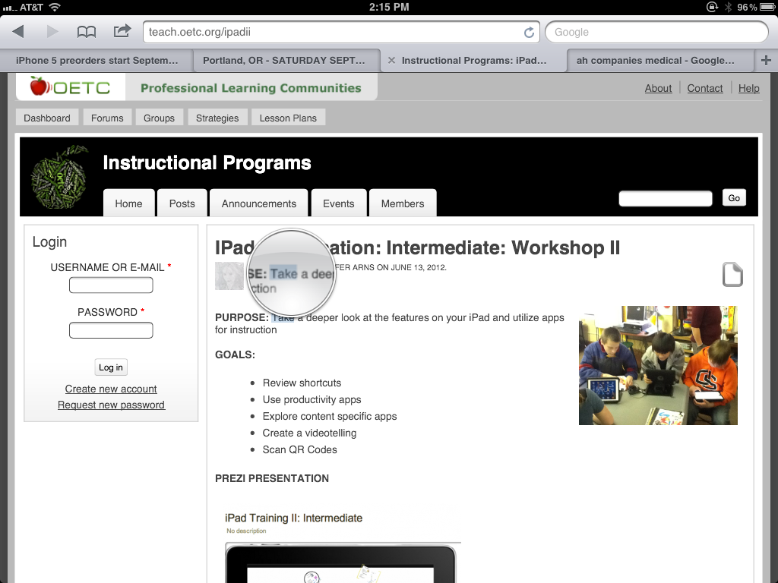Paste in a note

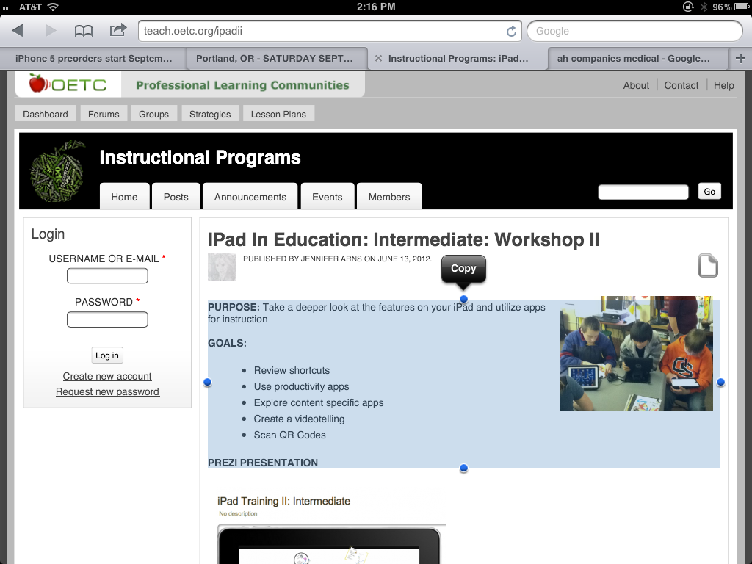

STATION 10: TAP HEADER IN SAFARI

* Go to a webpage with a lot of content like teach.oetc.org/iPad
* Scroll to the bottom of the page
* Tap the time at the top of the page and see what happens

STATION 11: SEARCH FOR APP OR WEBPAGE

* Using four fingers swipe down from the top of the screen to find search screen
* Enter name of

App (iBrainstorm)

or web

search

Station 12: The “Undo Arrow”

*Gently shake your iPad for a quick undo ~ be careful

*Hit the ".?123" **button**. This brings up a keyboard including an "undo" button.



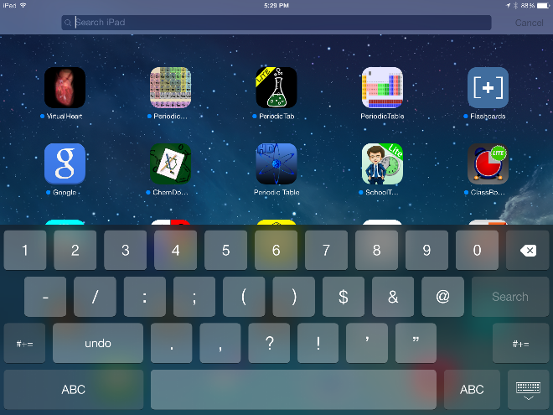

Station 13:

*Create Your Own

Station 14:

*Create Your Own

Station 15:

*Create Your Own