HARRINGTON SCHOOL DISTRICT NO. 204
SCHOOL BOARD OF DIRECTORS MEETING
January 27, 2021
Work Session @ 6:00 PM
Regular Board Meeting @ 6:30 PM
High School Library or
Via Zoom through Harrington School District Website

The Board Work Session consisted of the following topic:
- New Elementary and Secondary class schedules starting Monday, February 1st.
- January is School Board Appreciation month, so Mr. Massie had Certificate of Recognition awards for each of the board members. The elementary put together a virtual video for the school board thanking them for all that they do for our school. The PTA also wanted to recognize the school board and thank them for their dedication to our school.

CALL TO ORDER: The regular board meeting was called to order by Board of Directors Chair Darren Mattozzi at 6:30 PM.

MEMBERS PRESENT: Present at the meeting were Board of Directors Chair Darren Mattozzi and via zoom were Vice President Mark Kramer, Shannon Sewall, Linda Mielke, and Cade Clarke. Staff members present were Superintendent Wayne Massie and Principal Tiffany Clouse and via zoom were Jane Talkington, Mike Cronrath, Betty Warner, and LaMarr Larmer. Community Members Justin and Heather Slack were also present via zoom.

FLAG SALUTE: The flag salute was led by Darren Mattozzi.

CONSENT AGENDA:
The Consent Agenda included the December 18, 2020 meeting minutes; January 2021 accounts payable and payroll. Warrants: General Fund BMO MasterCard Wire equaling $1,018.51, General Fund Warrants #812622-812625 (First Run) equaling $530.85; GF #812627-812654 (Second Run), equaling $32,120.18; GF #812671 (Final Run), equaling $8,089.58; Payroll Warrants #812655-812668, equaling $219,704.15; ASB BMO MasterCard Wire equaling $0; and ASB Fund Warrants #812669-812670, equaling $2,036.90; Private Purpose Trust Fund Warrant #0, equaling $0; Transportation Fund Warrants #0, equaling $0; Capital Projects Fund Warrant #812621 (First Run), equaling $67,517.97; Capital Projects Fund Warrant #812626 (Second Run), equaling $75.46.
Mark Kramer made and Cade Clarke seconded the motion to approve the consent agenda. The motion carried 5-0.

DELEGATIONS:

ASB: Monday, February 1st we are planning a blood drive held at the school from 11:30 – 3:30 pm. The board would like an update monthly either taped or via zoom from the ASB.

REPORTS:
BOARD:
Mr. Massie shared information on the legislative report. The ESSER/Covid funds – Some money could go through OSPI and the legislature first before it is distributed to districts, so we may not receive it right away.
There is discussion on adjusting experience factors for certificated instructional staff.
Mr. Mattozzi mentioned that all school board meetings should be virtual only until we get the go ahead to meet in person. Unless you hear from Mr. Massie, we need to stay virtual.

Mr. Mattozzi would like to get the following committees up and running by March:

2021 BOARD MEMBER/COMMITTEE ASSIGNEMENTS:
Bargaining Committee: Mark Kramer and Darren Mattozzi
Legislative Rep: Darren Mattozzi (June 2021)
WIAA Rep: Cade Clarke
Business/Tech Committee: Darren Mattozzi and Cade Clarke
Library Committee: Linda Mielke and Shannon Sewall
Special Ed Committee: Darren Mattozzi and Linda Mielke
Curriculum Committee: Darren Mattozzi and Linda Mielke
CTE Committee: Mark Kramer and Linda Mielke
Nutrition Committee: Mark Kramer and Darren Mattozzi (Shannon Sewall - alternate)
Safety Committee: Cade Clarke and Darren Mattozzi
Truancy Committee: Shannon Sewall and Darren Mattozzi (Cade Clarke – alternate)

AD – Mike Cronrath:
Mr. Cronrath conveyed some interest in a combo middle school boys football team with Odessa. He has not spoken to our student who is interested, but he would like approval to sign for the combo. The student who is interested in going to Odessa will be responsible for their own transportation. Once sports practices start we will need transportation for our athletes to Davenport. Mrs. Sewall wondered how many students are on the bus and he thought at least a couple and we could probably use the van.

- WIAA Report
  - General Information.
COVID-19 ACTIVITY LEVEL
On January 5th, Governor Inslee announced his “Healthy Washington — Roadmap to Recovery,” COVID-19 phased recovery plan.
      - Lincoln County is part of the “East” region that includes Ferry, Stevens, Pend Oreille, Adams, Garfield, Asotin, Whitman, and Spokane counties.
      - The plan is now a two-phase system “in accordance with regional case counts.” More phases are still being developed.
      - All eight regions of the State started, and continue to be in Phase 1.”
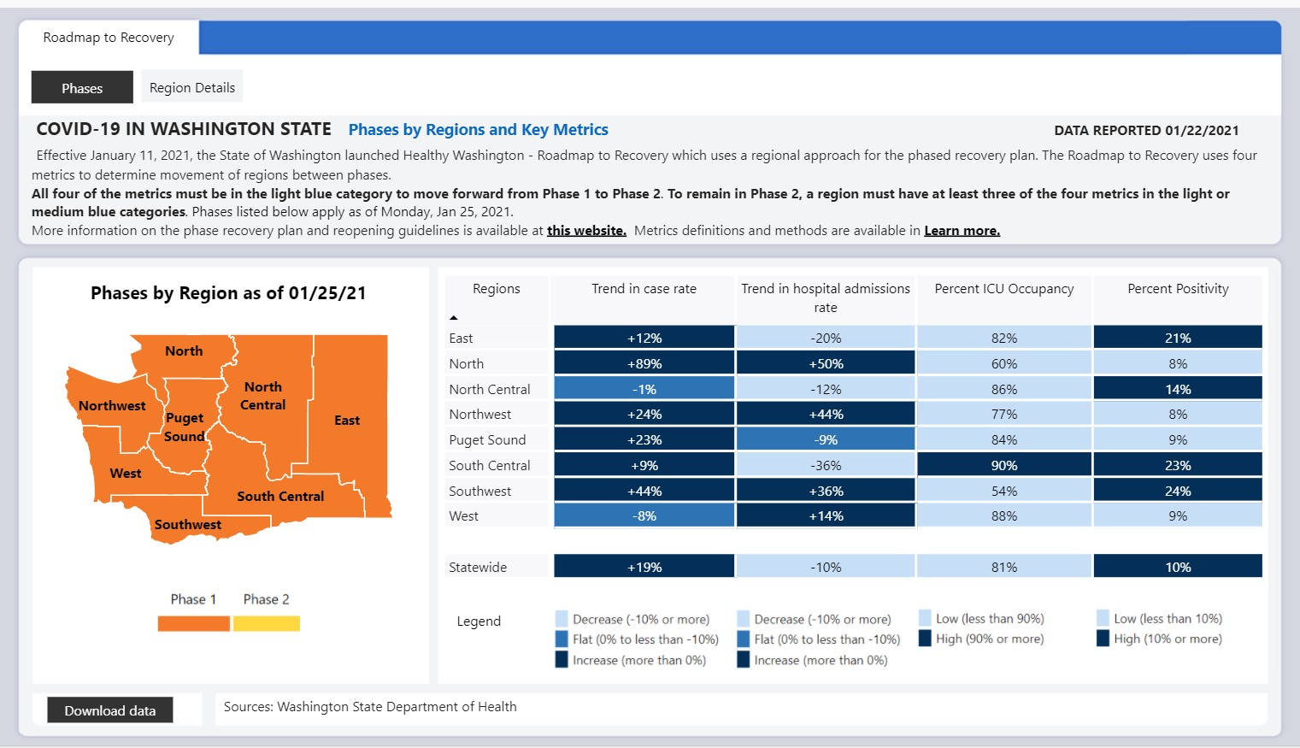
      - DOH dashboard: https://www.coronavirus.wa.gov/what-you-need-know/covid-19-risk-assessment-dashboard

**Please see the attached “Healthy Washington Sport and Activity Guidelines” at the end of this report for a clear explanation of the Governor’s Plan, the breakdown of phases and their impact on activities, and an informative FAQ related to Athletics.

  - WIAA Executive Board.
On January 6th and 19th, the Washington Interscholastic Activities Association (WIAA) Executive Board met, and made the following announcements based on the Governor’s Plan.
    - The WIAA Executive Board voted to amend its season schedule, moving traditional Fall sports to WIAA Season 1, with traditional Spring sports to Season 2, and traditional Winter Sports to Season 3.
      - Season 1: February 1 through March 21
        - MS/HS Cross-Country and Volleyball
      - Season 2: March 15 through May 2
        - MS/HS Track and Field, HS Golf, HS Tennis
      - Season 3: April 26 through June 13
        - HS Basketball and Cheerleading

    - While the Executive Board provided a uniform season schedule concluding in regional culminating events, it has granted each WIAA league or district around the state the ability to reschedule seasons to best fit their local communities.
      - Harrington will participate in the NE1B Schedule (under “1B MEETING” below), and coordinate with the NE2B schedule as needed to fill games.

- NE1B/2B Report
  - General Information.
    - 2B MEETING:
      - The NE2B League was concerned about providing a more comprehensive plan for the Season schedules, including decision dates and contingency plans.
        - Due to the uncertainty of even beginning Fall sports, and being in Phase 2 by February 1st, they desired a way to keep the open coaching period going for as many sports/activities as possible, so that no one sport was put at a disadvantage.
        - Once a school district begins official practices for one sport, the open-coaching period ends for all other sports.

    - 1B MEETING:
      - Voted on Amendments – see attached Amendments, and how NE1B voted.
      - Seasons.
        - LOTS of discussion took place about how to get the maximum effect for our kids. We considered going with the proposal of the NE2B, but in the end, came up with our own, based on the idea of giving Season 2 Spring sports additional time.
        - Approved to have Season 1(6weeks), Season 2 (8 weeks), and Season 3 (6 weeks) with the following dates. dates.
          - Season 1 - Fall Sports Feb. 1 - March 13
          - Season 2 - Spring Sports March 15 - May 8
          - Season 3 - Winter Sports May 10 - June 19
        - We are waiting for final WIAA Executive Board Approval.
      - District 7 Dues.
        - District 7 has tried to find a way to reduce the dues paid by the schools, because of Covid.
        - Normally the fee is $500 + $2/student (9-12). This year it will be a flat $600 for all 1B schools, $700 for all 2B schools, and $800 for all 1A schools.

        - Actually becomes a $40 increase for Harrington ($10 increase for Columbia, $8 increase for Northport. All other schools see a decrease).

- Middle School Sports
  - SE1B League
Athletic Directors for the SE1B League are meeting on Tuesday, January 26th to discuss MS Sports.
    - We have submitted estimated teams and number of athletes for their consideration in regards to MS Volleyball and MS Basketball.
    - They are VERY concerned about how to run those sports at the same time as HS sports, as most of them utilize the same coaches at the MS and HS levels.
      - We are in the same situation for MSVB,
        - Coaches Ikehara and Kruger coach at both levels. This could very well determine if we are able to have MSVB this year.
        - Additionally, our 8th graders would likely play up to the HS level, decreasing the numbers available.
        - MS Cross-Country will also be running (in the NE1B/2B) at the same time, should MSVB become a Season 1 sport.
      - MS Basketball numbers are very low.
    - We need to consider if we are willing to send out Middle School athletes to the SE League to participate. Or if we are willing to bring those schools to Harrington to participate.
        - NE1B schools are already running their schedules concurrently with the HS.

- Fall / Winter / Spring Programs Report.
  - Fall Sports
Practices for Middle School and High School Cross-Country and High School Volleyball are slated to begin on, or shortly after, February 1st.
    - IF we are in Phase 1 at that time.
      - MS/HS Cross-Country can practice and go to meets.
        - They MUST adhere to Lincoln County DOH guidelines.
        - They MUST wear masks at all practices and events.
        - There are to be NO spectators at any events.
        - Practice dates and times are still being discussed. The Calendar of Events are still being developed in conjunction with the NE2B League.
      - HS Volleyball can practice, but NO competitions are allowed until we reach Phase 2.
        - They MUST adhere to Lincoln County DOH guidelines.
        - They MUST wear masks at all practices and events.
        - They MUST stay in consistent pods of 6, or fewer players.
    - IF we are in Phase 2 at that time.
      - BOTH sports can practice and go to competitions.
        - They MUST adhere to Lincoln County DOH guidelines.
        - They MUST wear masks at all practices and events.
        - There are to be a MAXIMUM of 200 total people (athletes, coaches, officials, and spectators) at any events.
- Activities Report. – No report

- Miscellaneous Items
  - Pixellot Camera System.
We have submitted a request for an agreement with Pixellot. I will have it for the Board Meeting on Wednesday for your examination (I have NOT committed us to ANYTHING…I promise!).
    - The unit costs $1500 for the installation in the Gym.
      - This includes the camera, computer, software, and all other installation requirements (wire, brackets, labor, etc).
      - Once it is in, it is essentially a set-up and forget system. It only needs to be checked on occasionally, and the camera lenses cleaned.
      - Events must be scheduled in the NFHS system, and then are recorded automatically.
      - The system is cloud based, so all videos are available either live, or for download.
      - No other cost to the school, except that we forfeit streaming revenue for
Mr. Mattozzi would like the board to look at the agreement before moving forward.

PRINCIPAL – Tiffany Clouse:
      - An Attestation Letter will be sent out early next week. Parents are to take temperatures and attest either online or sign the attestation cards that we send out. The children with the cards will wear the them on a lanyard around their neck.
      - The new schedule starts on Monday, February 1st. We are extending the day from 11:30 a.m. until 2:00 p.m.
      - The board accepted a board grant for Panther t-shirts for all students in grades Pre-school-12th, all staff and board members in the amount of $1500.
      - We have advertised for a para-pro position. We are able to use $22,000 carry over Title monies for some of the expenses. We are looking to hire someone for 3 ½ to 7 hours per day.

SUPERINTENDENT – Wayne Massie:
- Construction update – There is a small leak in the line in the cooler in the kitchen. They are trying to trace the hole. There still isn’t any heat in the gym, so there needs to be more duct work done, maybe during spring break. McKinstry is working on regulations with Avista related to the gym heat. In the office, work continues on HVAC. The return air in the counselor’s office and COVID rooms are nearly complete. The brick wall next to the roof above the pool is an area that is prone to leaks needs to be fixed. The cost may be between $4,000-$5,000 out of contingency funds.
- Through the lighting incentive agreement, we should receive $4,500 back from the gym lights.
- Desks were purchased for Mrs. Sanford’s kindergarten room and she was thankful for the approval. The children love them.

Darren remarked about the Department of Enterprise Services is a place that schools can buy surplus school supplies that are inexpensive.

- Extension of COVID 19 sick leave – this leave expires on 12/31/2020. There is a possibility of extending it for a two-week period with stipulations on employees following the rules like they are supposed to do. There needs to be a meeting in regards to this and make it retroactive. More information needs to be gathered from some other districts on how their process works and check with our attorney.

NEW BUSINESS:
- Cade Clarke made and Mark Kramer seconded the approval of the Maintenance and Service Agreement with McKinstry. With much discussion on the yearly cost and the 4% increase every year, Mr. Mattozzi would like to see the language before approving. There needs to be a work session with McKinstry to explain this service agreement. The warranty will not start until the project is totally done, so we have some time. Linda Mielke made and Mark Kramer seconded the motion to post-pone to the March 2021 regular scheduled board meeting. The motion carried 5-0.

- Shannon Sewall made and Cade Clarke seconded the motion to add to the agenda the possibility of Middle School Football combination with Odessa. The motion carried 5-0.

- Linda Mielke made and Mark Kramer seconded the motion to authorize Superintendent Wayne Massie and Athletic Director Michael Cronrath to sign the WIAA paperwork for a Middle School Football combination with Odessa. The motion carried 5-0.

- Call for questions from the audience.
Citizens who desire to speak to the Board will please give their name before beginning their comments. A limit of three (3) minutes will be allowed per patron. The Board Chair may allow for more time. The Board does not take action on issues or topics introduced at this time. Personnel issues and employee performance cannot be discussed in public meetings and should be referred to the Superintendent/Principal.

- Mark Kramer made and Cade Clarke seconded the motion to adjourn the meeting. The motion carried 5-0.

The meeting then was adjourned @ 7:40 PM.

_________________________________ _____________________________
Chairman of the Board Secretary of the Board

_________________________________ _____________________________
Board Member Board Member

_________________________________ _____________________________
Board Member Board Member

