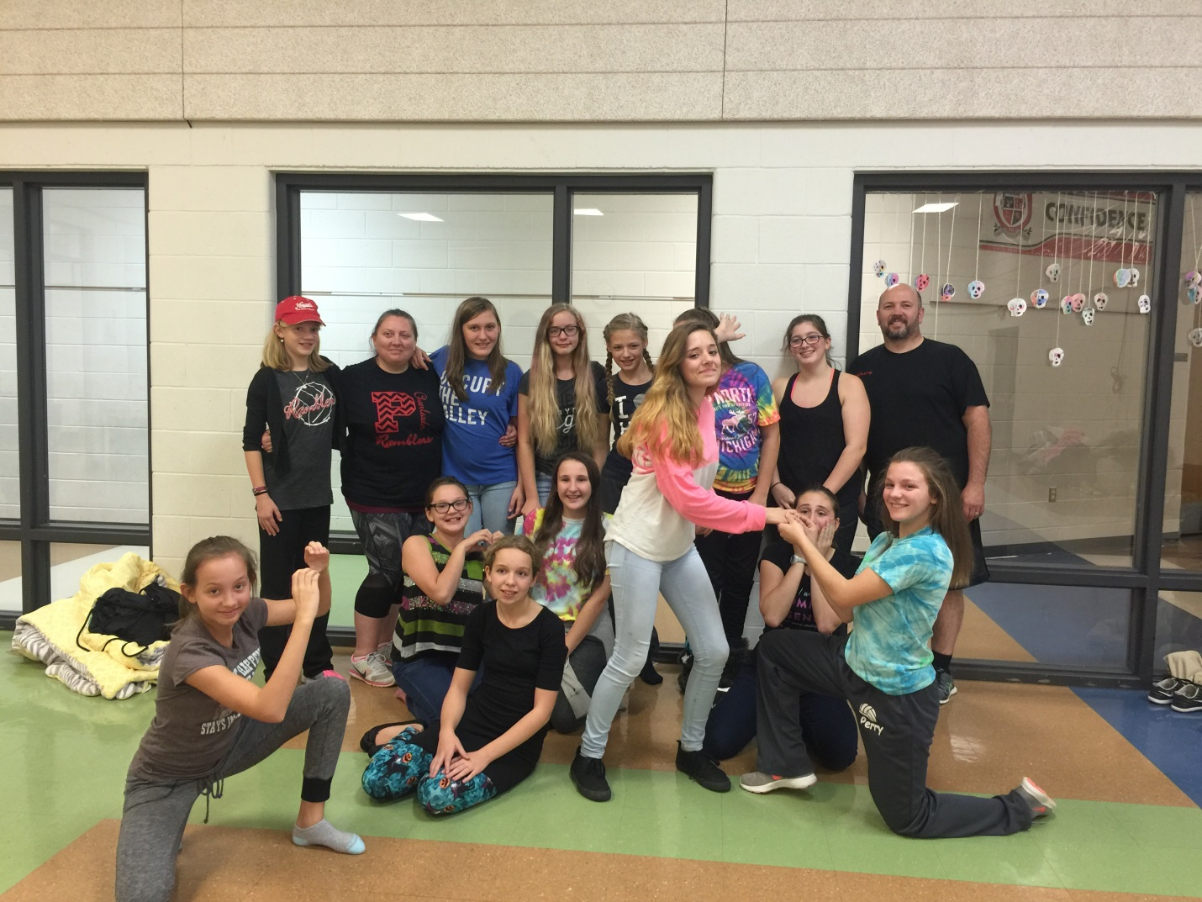

*2017 Volleyball Camp Registration*

Athletes Name: ___________________________________

2017-2018 Grade Level: ____________________________

Family Email: ____________________________________

Family Phone: ____________________________________

Parent Name: ____________________________________

Address: ________________________________________

T-Shirt Size: (Circle One) YM YL AS AM AL AXL

(Shirts are only guaranteed to be on hand for those who early enroll)

Coaches Information

Varsity Volleyball Coach

Stephen Fitzpatrick

Cell: 989-239-8211

Email: [fitzsteve72@aol.com](mailto:fitzsteve72@aol.com)

Assistant Coaches:

JV Volleyball Coach

Liz Speaks

Freshman Volleyball

Coach Chris Dejarlais

*1ST – 8TH GRADE VOLLEYBALL CAMPS*

* Perry High School Auxiliary Gym July 25th – 28th
  + 2017-2018 1st – 5th Grade 4:00pm – 5:30pm
  + 2017-2018 6th – 8th Grade 6:00pm – 8:30pm
* Cost of Camp (Includes T-Shirt)
  + $25 if paid in full before July 1
  + $30 if paid on or after July 1

*Mail or drop off completed form with check (no cash please) to 2125 W. Grand River Rd. Owosso Mi. 48867 OR Perry High School care of Volleyball 2555 Britton Road Perry Mi 48872.*

*Please make checks out to: Perry Girls Volleyball*

***PERRY***

***YOUTH***

***VOLLEYBALL***

***CAMP***

***2017***