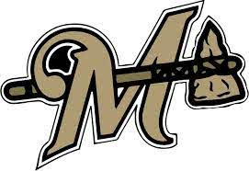
2021 Marietta High School Track
Fri March 26 Madill
Tues March 30 Marietta
Fri April 9 Plainview
Fri April 16 Ada
Fri April 23 Ardmore
Sat April 24 LCC (Madill)
Tues April 27 Velma
Sat May 1 Regionals (Plainview)
Fri/Sat May Undetermined State (Catoosa)

2021 Marietta MS Track Schedule
Thurs March 25 6/7/8 Madill
Mon March 29 6 Plainview
Thurs April 1 7/8 Marietta
Thurs April 8 7/8 Plainview
Tues April 13 6/7/8 Atoka
Sat April 24 MS LCC (Madill)

