Peter Brown visits Stony Brook!

Renowned author and illustrator, and one of Hopewell’s very own, Peter Brown, is coming for a virtual visit to Stony Brook! The SBPTO would like to offer students the opportunity to purchase copies of his works (purchasers will receive signed bookplates after the event).

Thank you to The Bear and the Books for their assistance with the book orders!

Please complete the order form on the reverse of this page no later than February 26, 2021.

Grades PreK-2
Mr Tiger Goes Wild  $19.00 | 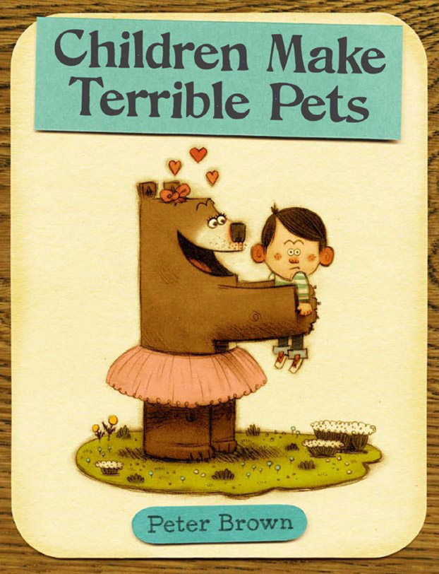  Children Make Terrible Pets $19.00 | 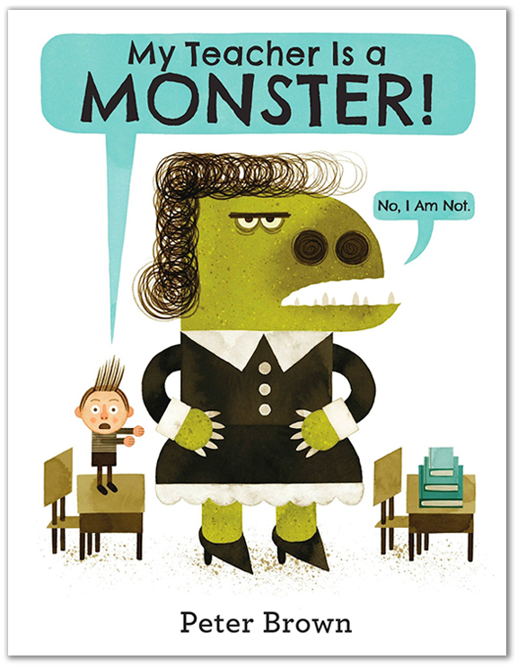  My Teacher is a Monster  $19.00
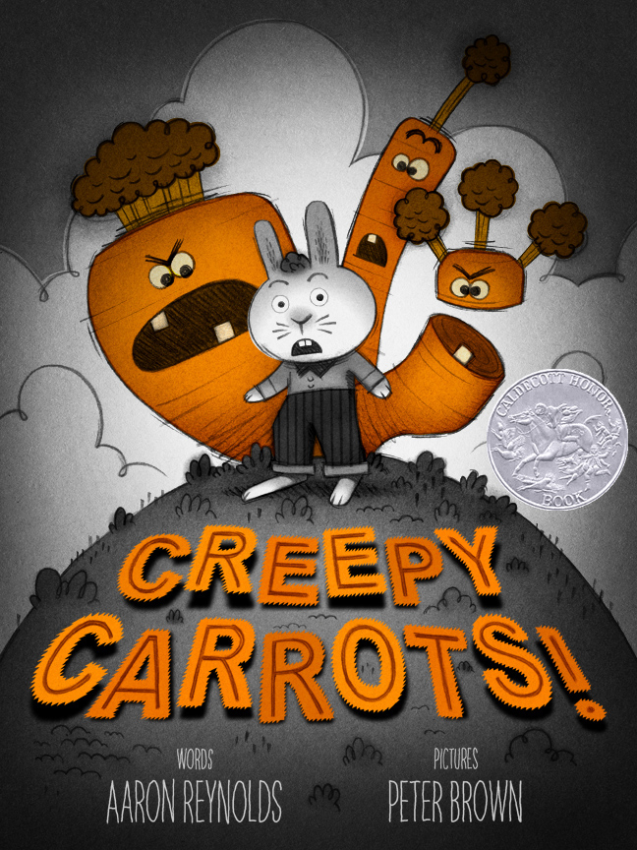  Creepy Carrots  $18.00 | 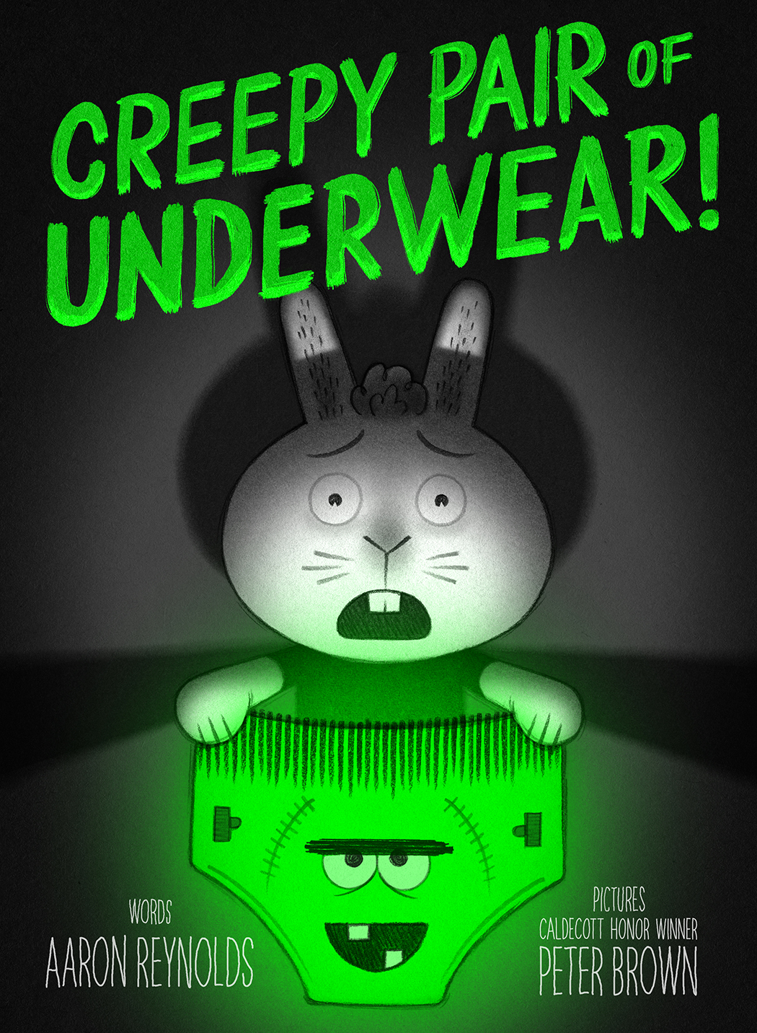  Creepy Pair of Underwear  $18.00 | 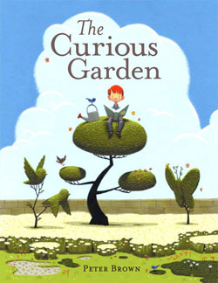  Curious Garden  $19.00

Grades 3-5
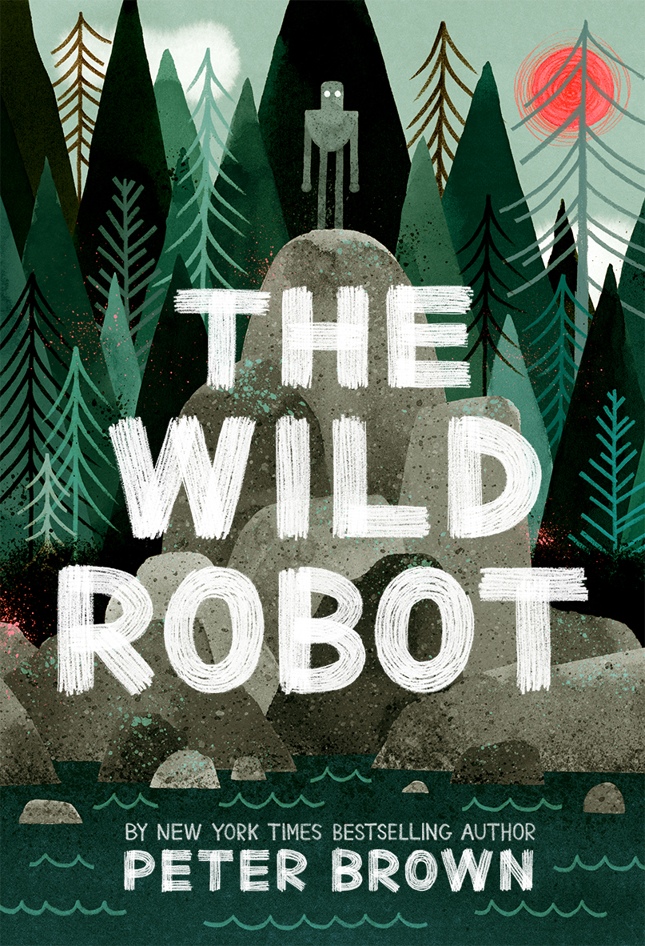  Wild Robots  $9.00 | 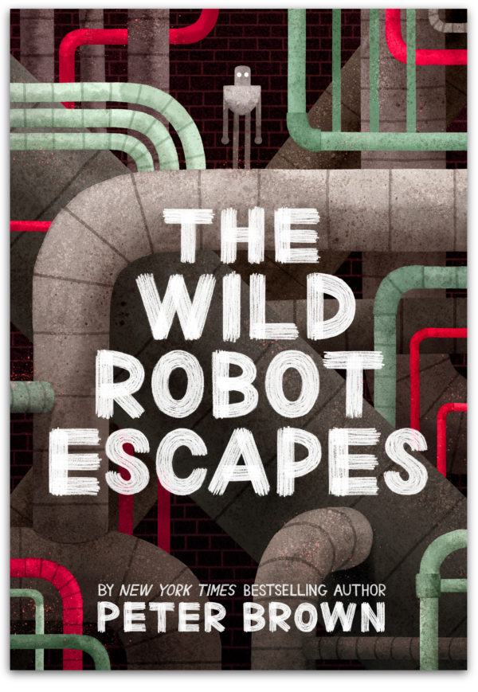  The Wild Robot Escapes  $9.00 | 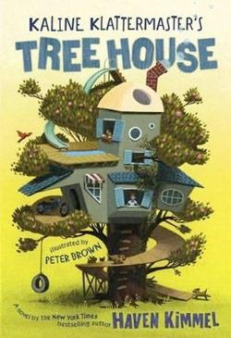  Kaline Klattermaster's  Tree House  $8.00
Please contact Bridget Port at stonybrookpto@gmail.com with any questions.

Sponsored by: 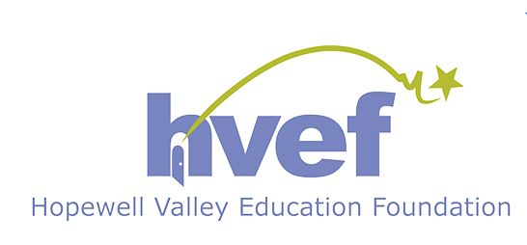

SB PTO Author Visit

Book Order Form

Please complete the form below and return with cash or check (made out to “SB PTO”) in a sealed envelope marked “BOOK ORDER”, no later than February 26, 2021.

Student’s Name:________________________________________________________

Teacher:______________________________________ Grade:_______________________

Please indicate the number of copies:
 | Mr Tiger Goes Wild  (hardcover) $18.99 |  |  | Curious Garden  (hardcover) $18.99
 | Children Make Terrible Pets (hardcover) $18.99 |  |  | The Wild Robot  (paperback) $8.99
 | My Teacher is a Monster  (hardcover) $18.99 |  |  | The Wild Robot Escapes  (paperback) $8.99
 | Creepy Carrots  (hardcover) $17.99 |  |  | Kaline Klattermaster's Tree House (paperback) $7.99
Creepy Pair of Underwear
(hardcover) $17.99

Total enclosed:$________________
Contact email / phone number:______________________
Is this a gift for your child? (gift books can be held in the office for parent pickup): ___________

