COVID-19 RETURN TO SCHOOL GUIDELINES
FOR STUDENTS & FAMILIES

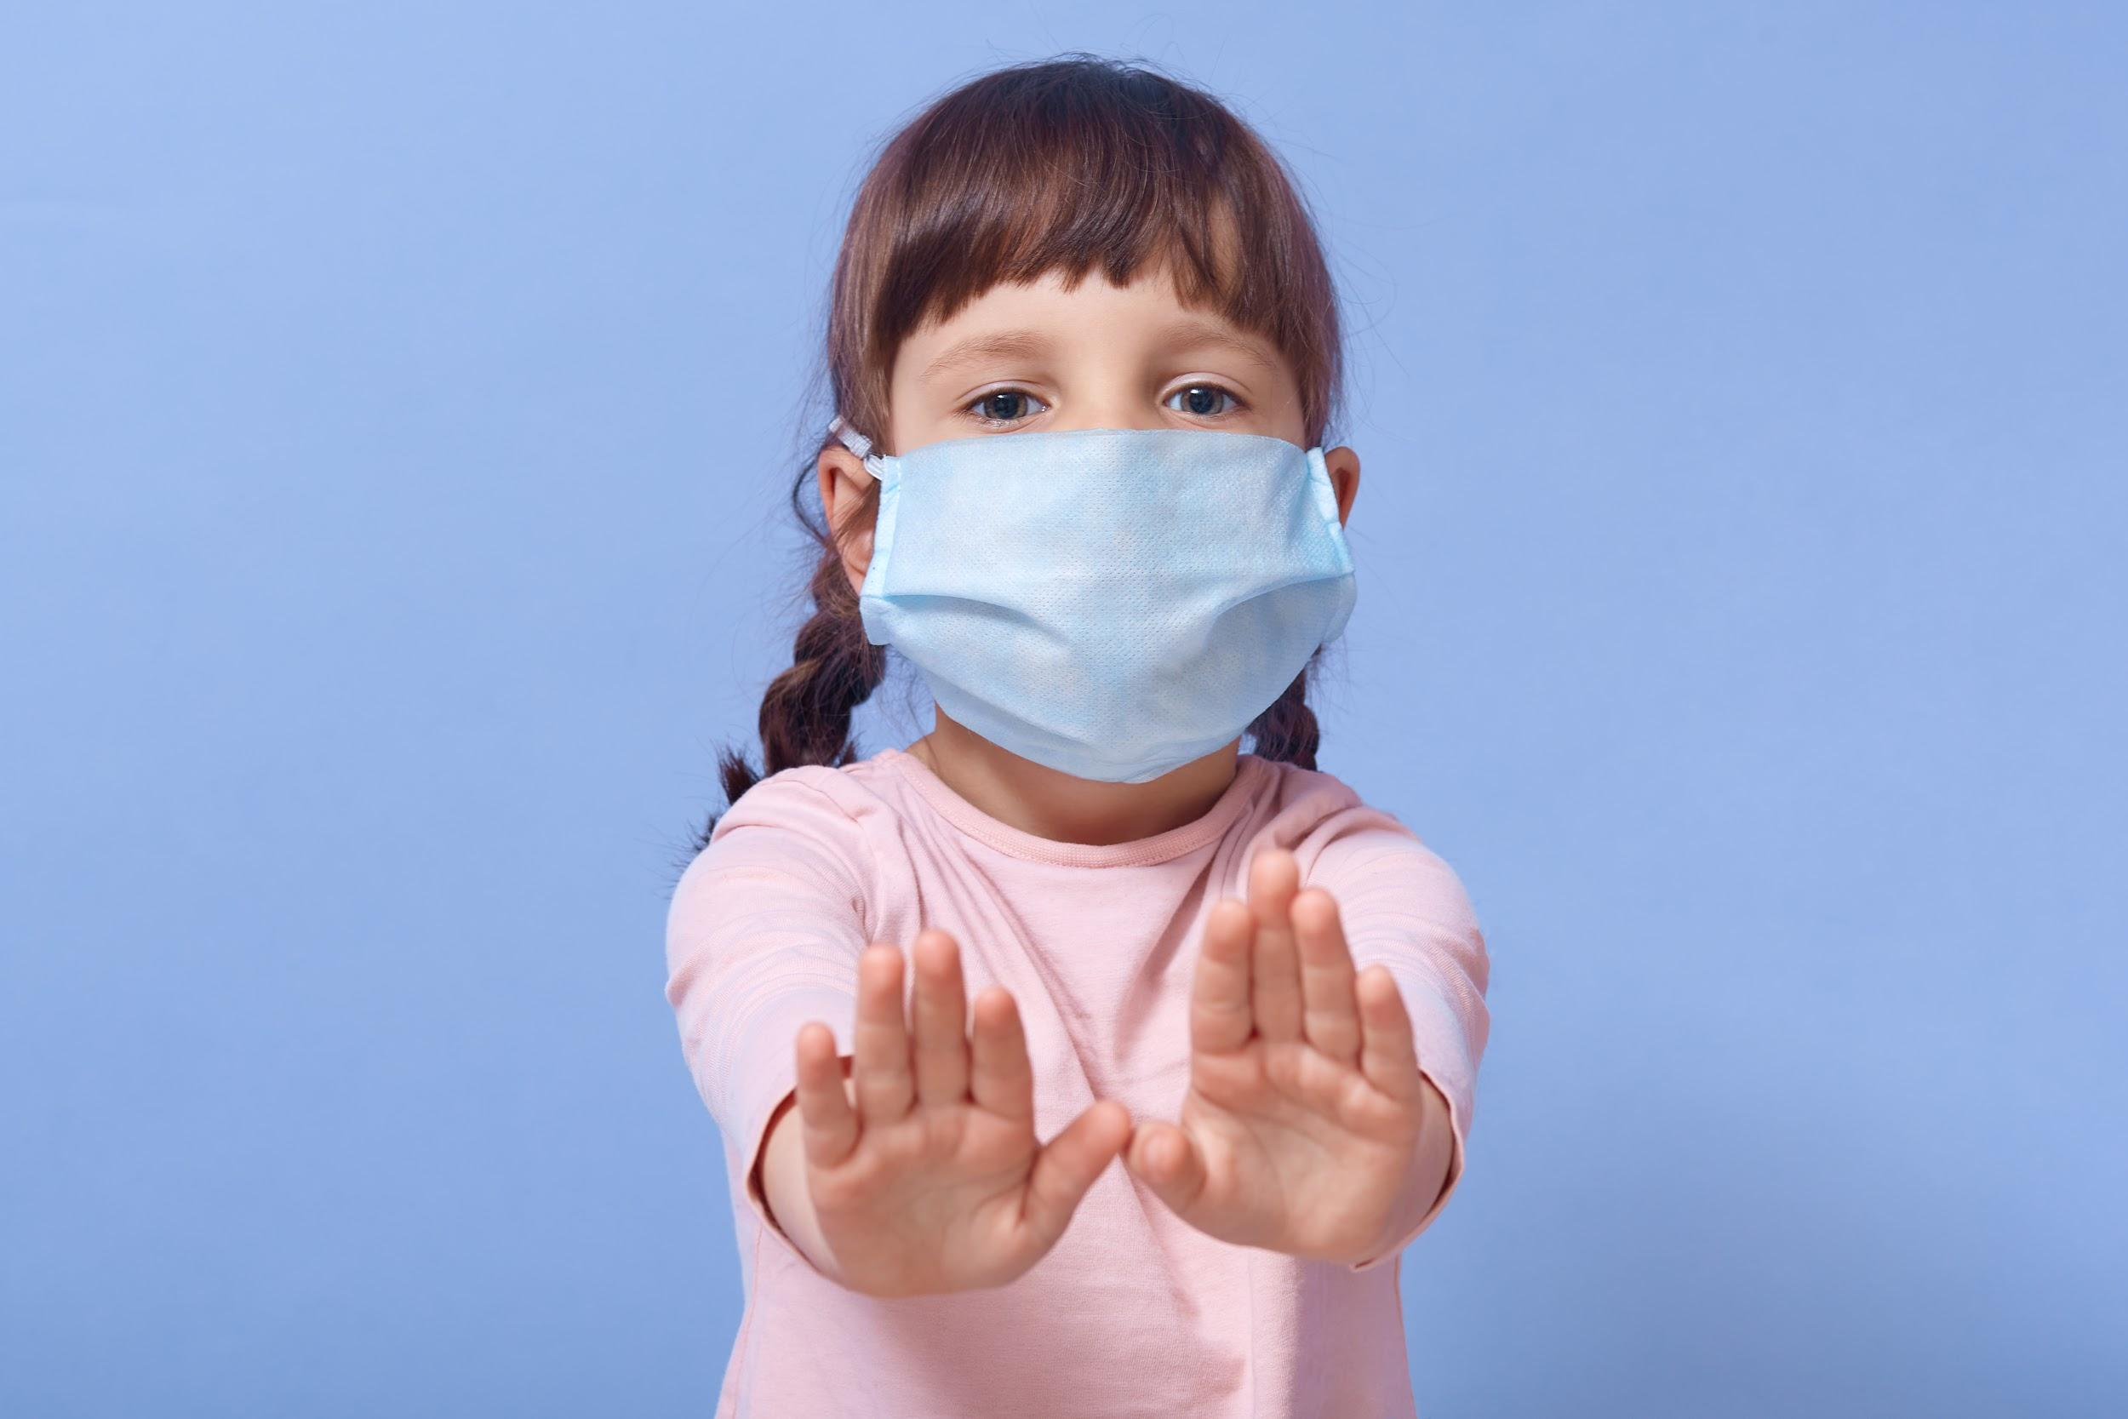

Addendum to the Student Handbook
UPDATED: 12/8/2020 based on current Maine CDC Guidelines
The Dayton School Board approved this document in a public session on August 6, 2020.
The School Board recognizes the unprecedented times in which schools operate and
the fluidity of our public health scenario, deputizing the Superintendent to make changes
to this document, without Board approval, based on emerging legal or health guidance.
MESSAGE FROM SUPERINTENDENT JEREMY RAY
In response to COVID-19, the Dayton School Department (DSD) will comply with the guidelines set forth by the Maine Centers for Disease Control (CDC), as well as the State of Maine, which are incorporated herein. These DSD Guidelines will be in effect from August 1, 2020 to December 31, 2020 and will be updated with the latest CDC and State of Maine guidelines. Our goal is to continue to minimize the risk of possible transmission of COVID-19 and safely bring back as many students as possible to an in-person school setting to maximize learning. Therefore, these DSD COVID GUIDELINES are mandatory for all students and their families.

The year we are about to embark upon will be a difficult one for students, parents/guardians, and staff. We consider the safety of your children as our collective responsibility and staff will be flexible as we undergo processes that were not present in previous school experiences. With a continued focus on positive relationships, meeting our students’ social/emotional needs and the overall wellbeing of the “whole child”, we strive to successfully meet this challenge and become stronger for it.

_____________________________________________________________
“We have a chance to do something extraordinary.
As we head out of this pandemic we can change the world.
Create a world of love. A world where we are kind to each other.
A world where we are kind no matter what class, race,
sexual orientation, what religion or lack of or what job we have.
A world we don't judge those at the food bank because
that may be us if things were just slightly different.
Let love and kindness be our roadmap.”
- Johnny Corn
_____________________________________________________________
HEALTH & SAFETY

DAILY SELF-ASSESSMENT:
- Prior to boarding the bus or drop-off, Parents/Guardians will need to complete a self-screening assessment daily for their child to check for symptoms of COVID-19. Certain responses will require that a child remain home. In this event, Parents/Guardians should contact their child’s School Nurse. The self-screening will be available in paper form or an online app.
- Daily self-assessment questions:
- Have you tested positive for COVID-19 in the past 28 days?
- Do you live with someone who has been diagnosed with COVID-19 or is still symptomatic in the past 14 days?
- Have you been directly exposed to someone with COVID-19 or identified as a close contact?
- Do you have any of the following symptoms that are unexplained or different from their known health conditions:
  - Fever 100 degrees or higher?
  - Chills or repeated shaking with chills?
  - Sore throat?
  - Difficulty breathing/shortness of breath?
  - Unexplained muscle aches?
  - New cough?
  - New loss of smell or taste?
  - New runny nose or nasal congestion (different from their normal allergies or seasonal hay fever)
  - Vomiting or diarrhea in the last 24 hours?
- In the past 10 days have you traveled outside the US or outside Maine, NH, or VT?

FACE COVERINGS/MASKS:
- All students are required to wear a face covering/mask that covers their nose and mouth when in the presence of others or maintain six (6) feet of distance--about two arm’s length-- at all times throughout the day. See CDC guidance on social distancing. Maintaining three (3) feet of distance is acceptable between and among students when combined with the other measures outlined in this list of safety requirements.
- Face coverings must be worn when entering or exiting buildings, while traveling in hallways, and generally when moving about the school. Exceptions may include, but are not limited to:
  - While eating
  - While sitting at their desk in the classroom when more than 6 feet apart
  - While on the playground, if social distancing allows
  - While participating in music practice, if permitted
  - When the student’s face cannot safely be covered due to a medical condition in which case a doctor’s note must be provided and the student would wear a face shield.
- Face coverings must be worn by all students utilizing transportation by bus or van.
- All students will be provided with two face coverings (age appropriate design and size). If disposable, these should be replaced daily. If cloth, these should be washed daily. Gaiters, bandanas, and masks with valves are not allowed. Face coverings are subject to meeting current dress code standards in regards to the appropriateness of language/images, etc.
- Face shields may be an alternative for those students with a medical, behavioral, or other challenges who are unable to wear masks/face coverings. Face shields worn in place of a face covering must extend below the chin and back to the ears.

PREVENTION MEASURES:
- All students must practice proper handwashing guidelines and use hand sanitizer upon entering the school, their classroom, before and after donning or removing a face covering, and throughout the day. Hands should be washed with soap and water for at least 20 seconds when visibly soiled, before and after eating, and after coughing/sneezing and using the restroom.
- All students must practice proper CDC infection control measures:
  - If coughing or sneezing, students must cover their mouth and nose with a tissue, or the inside of their elbow, and immediately discard the tissue.
  - Avoid touching their eyes, nose, or mouth.
  - Avoid touching any surfaces unnecessarily.
  - Refrain from physical contact, including hugs and hand-shakes.
- Restroom procedures will be established at each school to limit the number of students in the hallway and restrooms at one time.
- Students should only bring to school what is absolutely essential for each day. Any items brought to school should fit into a single backpack.
- Classrooms will be reconfigured to allow physical distance with students facing one direction.
- The use of lockers will be suspended. Students will be allowed to carry a backpack with them.
- Sharing of items (electronic devices, toys, books, and other games or learning aids) will be discouraged and restricted.
- Each child’s belongings will be separated from others’ and in individually labeled containers, cubbies, or areas.
- Curriculum nights, open house and back-to-school events will be facilitated virtually.
- Field trips, assemblies, and other large gatherings will not be allowed.
- See CDC’s informational video on how to Stop the spread of germs

FOOD DISTRIBUTION/MEALS:
- Students will remain in classrooms for all snacks and meals.
- Students will maintain six (6) feet of physical distance while eating breakfast and lunch as students will be unable to wear face coverings during these times.
- Students are encouraged to bring a full water bottle each day as water fountains will be closed. Bottles may be refilled using our filling stations.
- Water filling stations will be sanitized along with all other “common touch” surfaces.
- Shared food is prohibited. Parents are asked only to send food for their child and not class consumption (i.e. birthdays; holiday celebrations).
- Students will be required to practice proper handwashing/sanitizing prior to eating.
- All food served to students will be covered and individually wrapped, including utensils.

PLAYGROUND USE:
- Use of designated playground equipment and supplies will be allowed under close monitoring.
- Use of face coverings/shields will NOT be required during this time as long as physical distancing is maintained.
- Limits will be placed on the number of students on equipment at one time.
- No more than 50 students may congregate in one section of a play area at a time.
- If needed, at least three (3) areas of each playground will be established and student groups will be assigned to remain in each area each day. These areas will rotate so that students are able to use the entire playground over the course of several days.
- Students will wash their hands/use sanitizer before and after using playground equipment.
- Playground equipment (e.g. swings, slides, etc.) will be sanitized after each recess period before the next group uses them. Playground supplies (e.g. balls, jump ropes, hula hoops, etc.) will be stored in special bins that are labeled specifically for each group’s use. These supplies will be sanitized after each use.

SPECIAL EDUCATION

- Dayton School Department will plan for special education students, to ensure they receive necessary services and accommodations.
- Determination of additional PPE requirements will be made by the Special Education Director based upon the unique needs of each student/situation. Additional PPE may be provided for staff working with young children, students with IEPs or student’s with specialized health plans such as, but not limited to:
  - Clear face coverings and/or Face shields
  - Kevlar sleeves/arm protectors
  - Gloves
  - Gowns
  - Plexiglass barriers for student desks
TRANSPORTATION

- Parents/Guardians are encouraged to transport their child to and from school, if able.
- Students are required to wear a face covering at all times while on the bus/van, including upon entry/exit.
- Students must use hand sanitizer when they enter the bus/van.
- Families should be vigilant to limit contact between other parents/students at bus stops and direct contact with the bus driver as much as possible by maintaining a six (6) foot distance.
- Students will be seated one student per row and distanced according to guidelines with the seat directly behind the driver remaining open. Families will be allowed to sit together.
- Seats in the back of the bus must be loaded first and then move forward. The bus should be emptied from the front and then the back.
- Students will need to practice social distancing when exiting the bus. The bus radio will be used to dismiss by rows.
- Several windows need to be opened to improve air ventilation.
- Up to two (2) children are allowed in each van, depending on the size of the van. If a second adult monitor is required, only one (1) child will be allowed. The total capacity of a van should not exceed three (3) people at any given time.
- Bus drivers will clean and disinfect frequently-touched surfaces between uses as much as possible. High-touch areas in buses such as seat backs, handrails, stability poles, bars, windows and window ledges and the possibility of spraying busses between runs.

PARENTS/GUARDIANS/VOLUNTEERS

- Parents/Guardians will minimize face-to-face meetings by utilizing alternative methods to receive updates (i.e. email, conference call, phone call, web-based meetings).
- Any Parent/Guardian needing to enter the building for an IEP meeting or other important business will need to be screened and should utilize reception windows as main office spaces are restricted to administrative and office staff.
- Parents/Guardians will be asked the same screening questions as students prior to entry to any school building. If any response is “yes”, the parent/guardian will not be allowed into the building. If allowed into the building, parents/guardians:
  - Must wear a face covering while in the buildings.
  - Must use the sanitizing station upon entry, maintain a social distance of six (6) feet.
  - Must attend to their specific business and leave immediately following.
- Upon entering the building, volunteers must follow the same guidelines as visitors listed above.

TECHNOLOGY

- In a hybrid or remote instruction model, 1:1 devices will be provided to each K-5 student. These devices will be transported by the student between school and home.
- Parents/Guardians agree to return the borrowed devices at the end of the school year, unless otherwise determined, to be cleaned and disinfected.
- Sharing of devices between students will be discouraged. If it is required devices will be sanitized after each shared use.

CLASSROOM SETTING (If In-Person Instruction Occurring)

- Classroom seating will be configured with maximum allowable space between students and all desks facing the same direction.
- Schedules will be developed in a way that will limit student movement and/or interactions between student groups throughout the day.
- Employees will modify instructional plans to reduce student contact, sharing of materials or equipment and maintain appropriate physical distancing to the greatest extent possible.
- Common touch surfaces will be sanitized throughout the day.

REMOTE INSTRUCTION (If In-Person Instruction Occurring)

- Any Dayton School Department student across grades PreK-5 will have the option of participating in remote instruction, including any student with health and safety concerns, elevated health risks or a family member with elevated health risks.
- These remote learning programs will be graded.
- Students who elect to participate in this remote instruction program to begin the 2020-21 School year must remain in the program at least for a month.
- Assigned instructional staff will also coordinate to ensure programs such as Special Education, 504, RTI, or ELL programs are provided to students remotely as needed.
WHEN SOMEONE IS SICK

- Parents/Guardians will avoid exposing others by ensuring their child remains home if they experience any signs or symptoms of Respiratory Illness or a fever of 100.4ºF or higher. Please refer to the screening questions above and contact the School Nurse if any are present.
- Students will not be penalized for missing school when required to stay home under these guidelines. School nurses will ask about symptoms when absences are reported.
- If a student develops a fever during school hours, a medical isolation area is designated in all schools for students to wait for their parents to pick up their child immediately.
- Students should not return to school unless they are fever free for 24 hours (1 day) without fever-reducing medication and symptom-free for 24 hours. If they test positive for COVID-19 or are designated as being in close contact with someone who has, they need to remain home for 10 days from the onset of symptoms regardless of a negative test result.
- Any area used by a sick person will be closed until proper disinfection has been completed.
EXPECTATIONS IF TESTED POSITIVE FOR COVID-19:
- Parents/Guardians will notify the School Nurse if their child, or anyone in their household, has been confirmed to have COVID-19. As a response to protect the health and safety of our students and staff, areas will be sanitized and CDC guidelines followed to notify all families and employees that have come in contact with and/or have been exposed to the student in the most confidential manner possible.
- Under the current Maine CDC guidance for PreK-12 Schools, a student who has tested positive for COVID-19 will need to remain home for 10 days after onset of symptoms AND be symptom free, including no fever for 24 hours (without medication to lower the fever), before returning to school.
- Students who have had close contact with someone who tests positive for, or is diagnosed with, COVID-19 must quarantine at home for 10 days and continue to monitor symptoms for 14 days. Close contact is defined as “anyone you have been within 6 feet of an infected person for a cumulative total of 15 minutes or more over a 24-hour period starting from 2 days before illness onset (or, for asymptomatic patients, 2 days prior to test specimen collection) until the time the patient is isolated.”
- Depending upon circumstances, this could include entire classrooms, clubs, bus routes, playground groupings, or schools.
- The school will work closely with Maine CDC on all contact tracing and other related protocols.
- During the time students are out of school, arrangements will be made to ensure they do not fall behind in their learning (i.e. remote instruction or make-up work following a healthy return).

EXPECTATIONS IF REQUIRED TO QUARANTINE:
- If an individual student is required to quarantine, they will be provided the option to transition into remote instruction and, if they participate, those days will not be counted as absences.
- If a classroom or multiple classrooms are required to quarantine due to a positive test, impacted students will transition to remote instruction during the quarantine period. If a student participates, those days will not be counted as absences.
- If a family travels outside of the state of Maine to one of the states NOT on the Governor's approved list for travel, the student must receive a negative COVID-19 test result OR quarantine for 10 days before being allowed back into school. If students participate in remote learning during the quarantine, those days will not be counted as absences.

TRAINING VIDEOS FROM THE CDC / RESOURCES

- Cloth Face Coverings Do’s and Dont’s
- Handwashing
- Social Distancing
- Stop the spread of germs
- Know the Symptoms of COVID-19
- American Academy of Pediatrics Maine Chapter School Re-Entry Resources
  - Assessing for COVID-19 in children with symptoms & no known exposure
- American Academy of Pediatrics (AAP) - Return to School During COVID-19
- AAP: Age-Based Tips to Help Juggle Parenting & Working at Home During COVID-19

- PROTOCOLS: Maine CDC guidance for PreK-12 Schools

