Jan. 25 | Mascot Monday | Wear Your favorite Kansas TEAM gear | 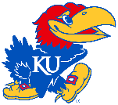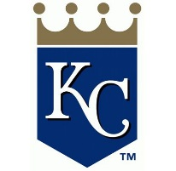
Jan. 26 | Twister Tuesday | Wear something backwards
Jan. 27 | Windy Wednesday | Hold onto your hats or crazy hair day
Jan. 28 | “There’s No Place Like Home” Day | Wear your pajamas to school!
Jan. 29 | Festive Friday | Wear yellow and/or a sunflower to celebrate Kansas’ 160th birthday!

