January, 2021 - School Board Update
The Board of Education met on Wednesday night for the regularly scheduled meeting. The session was called to order at 7:00 pm by President Mylissa Jennings. The board approved the agenda and heard from Mr. Murphy on the financial update of the district. The district started the month with $893,466.86. The district received $208,457.96; a majority was the local taxes received from Johnson County and Reimbursement for Rapid Relief (CARES Act). The district expended $179,027.52, which left $922,897.30 in the district bank accounts.
The consent agenda items were approved by the board. The consent agenda included the approval of two new substitutes and program evaluations for the Guidance & Counseling Program; the Student Health Program; and the District CSIP plan. During the principal reports, Mr. Wallace discussed the three district goals, which are:
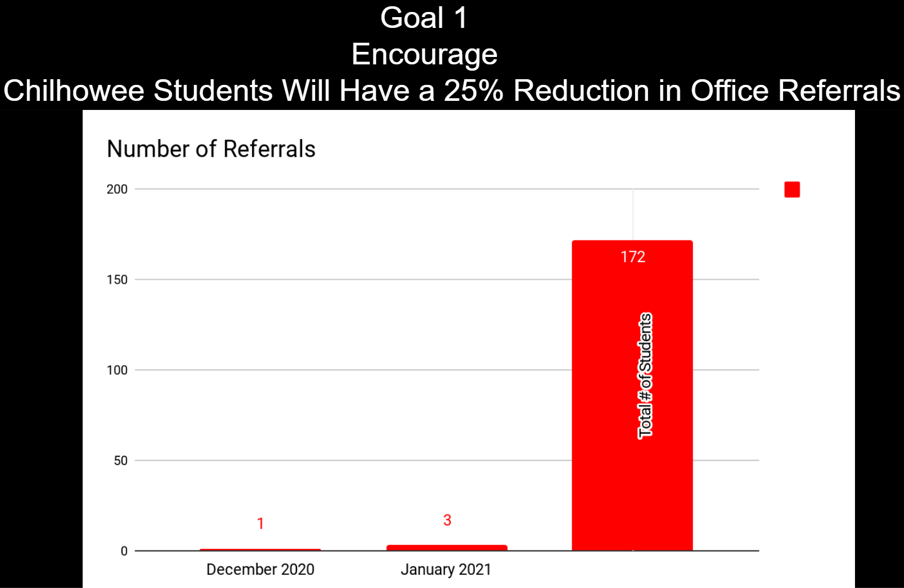
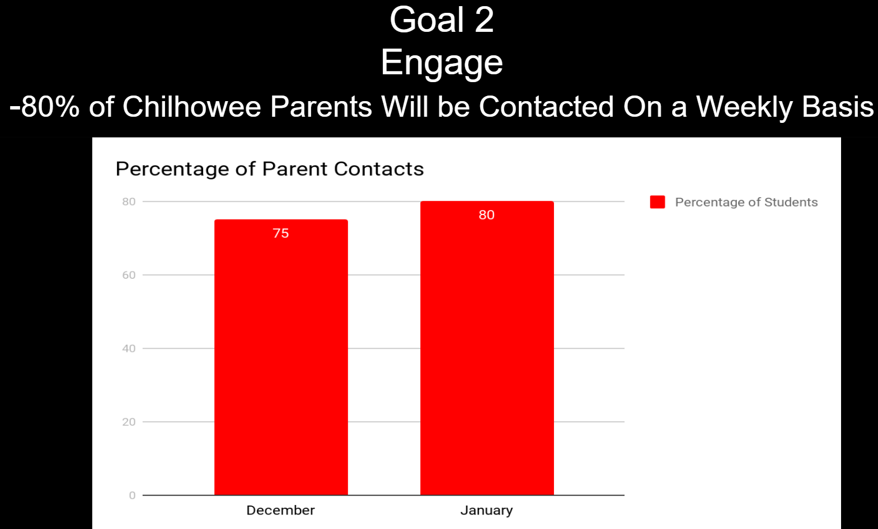
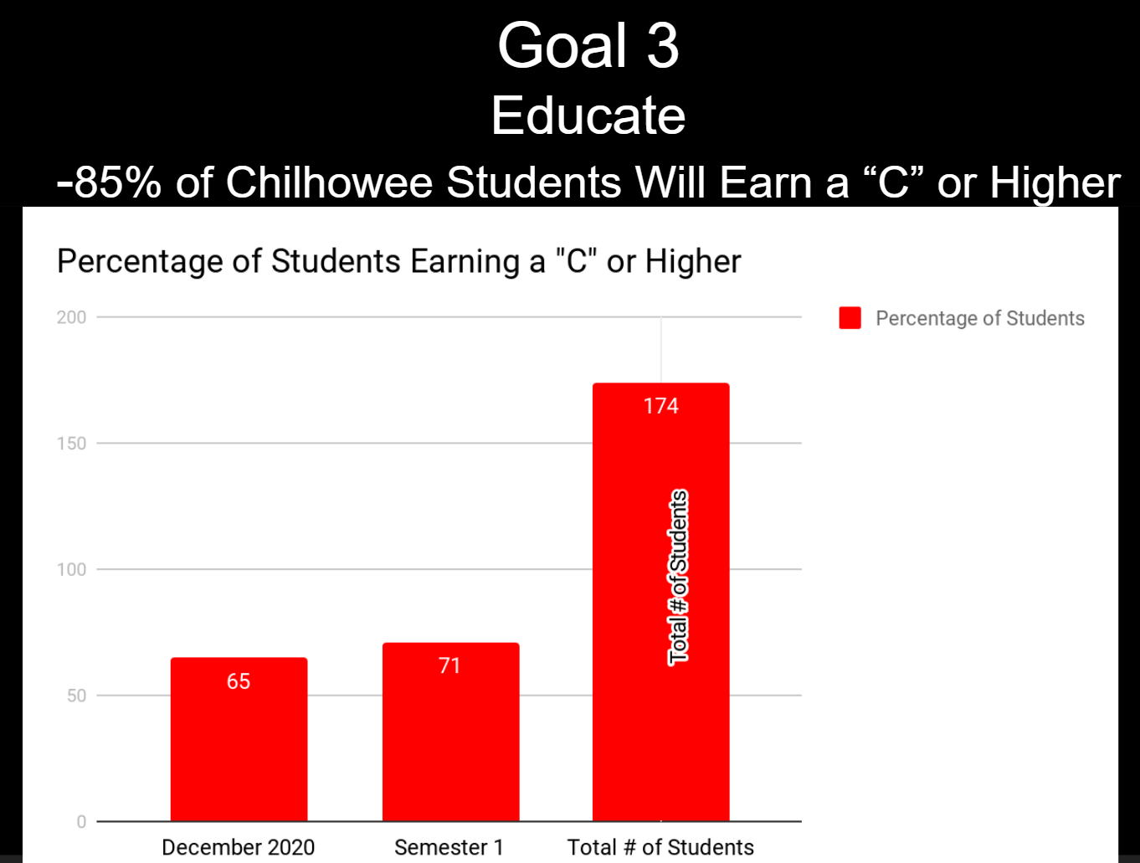
During the Superintendent report Mr. Murphy shared the most current Covid-19 information, which can also be found on the school’s website:
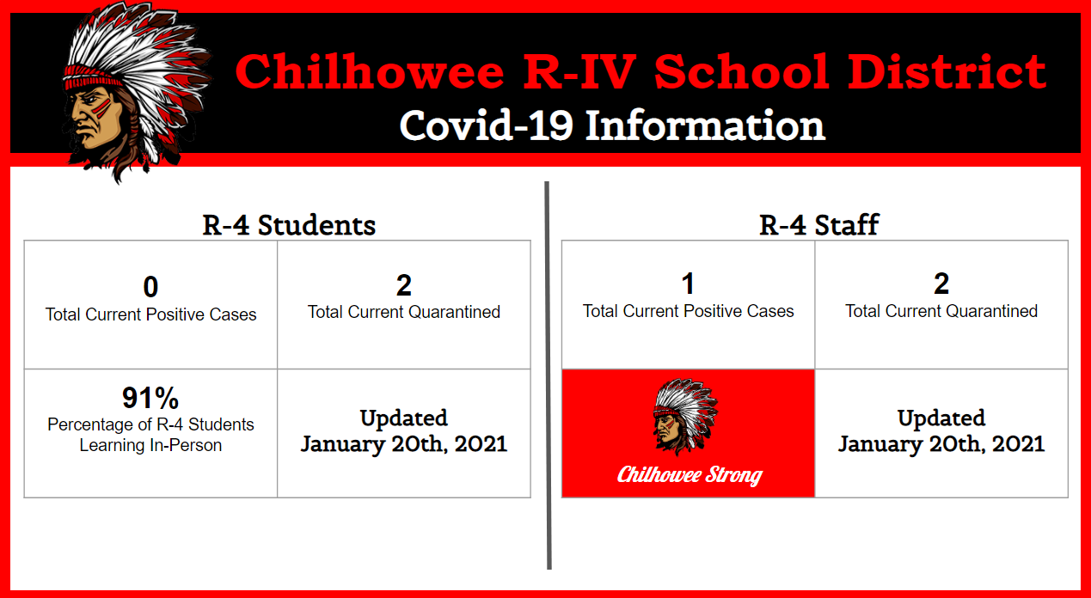
Mr. Murphy also shared that the district completed the Johnson County Rapid Relief CARES Act documentation and received $24,525.66 from the county for previous purchases aimed at technology and virtual learning solutions. Mr. Murphy also discussed communications between Johnson County Community Health Services and the District regarding Covid-19 Vaccination Phase 1-B. This phase of the state and county’s plan includes vaccination for school staff. Approximately 70% of staff elected to receive the vaccination. Mr. Murphy also wanted to recognize Tonya Coulter for her efforts in the kitchen during the past two weeks.
The old business agenda included:
- An invitation from Crest Ridge High School to coop for 11 man football. Potential costs were analyzed and the contract from Crest Ridge was reviewed. It was determined that at this time, it would be best to table this decision in order to gain further information.
The new business portion of the meeting included:
- Board candidate filing: The window for board candidates to file opened on December 15th and closed on January 19th. Two candidates filed for two open seats.
- 2021 Summer school was discussed, with the dates for summer school being June 2nd – 30th. It will be a full day from 8:00am to 2:30pm and the district will continue to utilize the Seamless Summer food service program. It is expected that meals will be served for free to anyone under the age of 18.
- CDC introduced reduced quarantine options and the district will put this updated quarantine procedure into place once the state and county adopt the plan (see below).
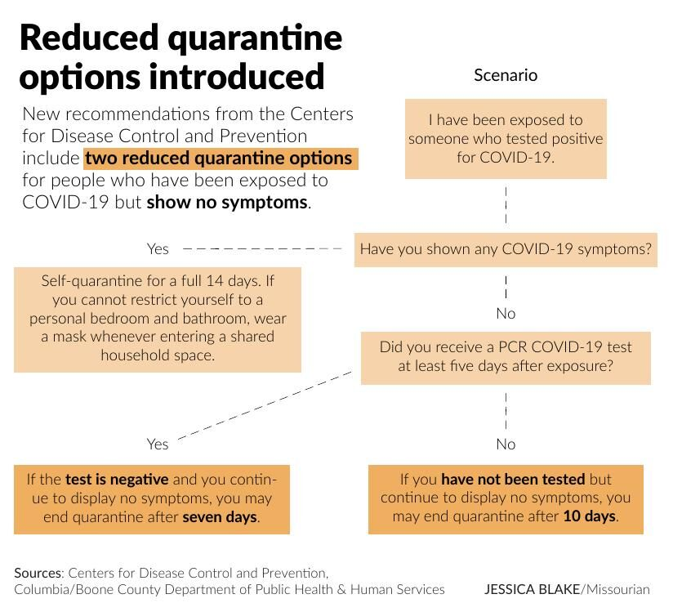
- The board approved a resolution addressing Emergency Paid Sick Leave (EPSL) due to Covid-19. The federal government did not extend the Families First Coronavirus Response Act (FFRCA) Emergency Paid Sick Leave (EPSL) past the December 31st deadline. Districts across the nation anticipated that the federal government would extend this act into the second half of the 2020-21 school year. In summary, this act provided federal funds to pay employees sick leave for up to 10 working days (2 weeks) when they were required to quarantine due to Covid-19. The resolution addresses this issue to support district staff should they face quarantine issues.
- The District will also be reducing staff breakfast and lunch prices to $1.00 for the remainder of the school year. Doing this will hopefully increase the number of staff electing school prepared meals while also further supporting staff during this challenging school year.
- Revision of Policy GCPB: In order to protect the district from certified staff breaching their contract, and ultimately taking a toll on student learning, the district adopted a penalty payment schedule that will be added to Policy GCPB and certified staff contracts for the 2021-22 school year.
- Track: The district will offer Junior High and High School Track as a regular yearly activity.
The board held an executive session after the regular meeting per RSMo 610.021 (3), (6) to discuss personnel and student information.
The next meeting for the Board will be on February 17th, 2021 at 7:00 pm in the Library-Media Center.

