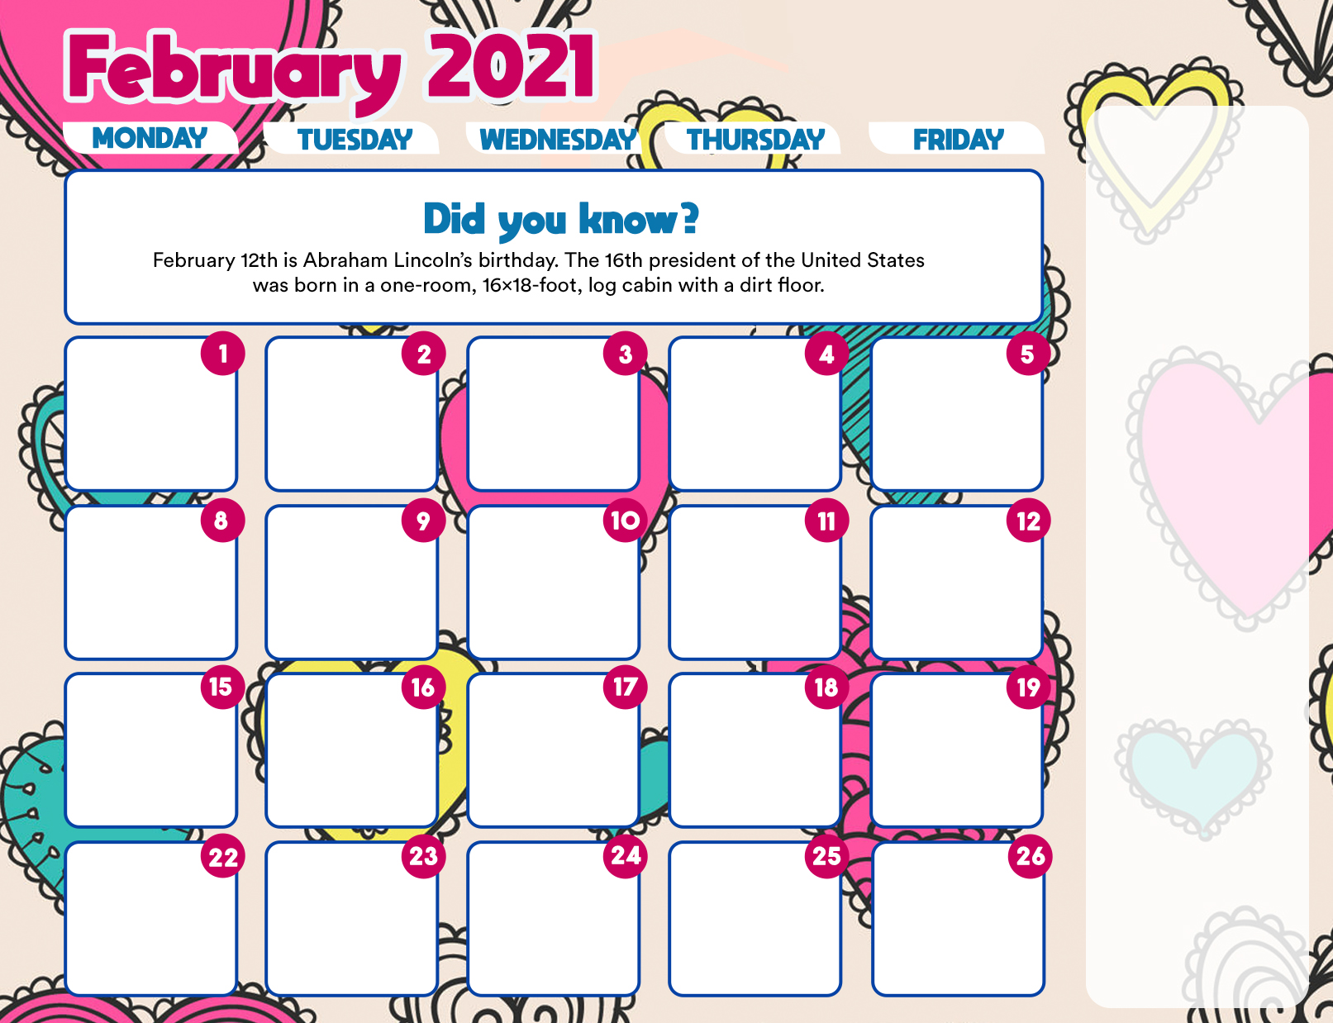

**French Toast Sticks**

**Sausage / Hash Brown**

**Broccoli / 100% Fruit Jce**

**Taco (Pork Taco Meat)**

**Green Beans**

**Diced Pears**

**Ice Cold Milk ->**

**NO PICKUP**

**Thursdays**

**\*\*\*\*\*\*\*\*\*\*\*\*\*\*\*\*\*\***

**Wed. Meals Continued**

**Grilled Chicken Patty on a Bun /Carrot Coins**

**Fresh Apple**

**Chicken Wrap**

**Baked Beans**

**Strawberry Cup**

**Hamburger on a Bun**

**French Fries**

**Diced Peaches**

**Ice Cold Milk**

**NO PICKUP**

**Thursdays**

**Wed. Meals continued**

**Mozzarella Sticks**

**Dinner Roll**

**Carrots / Mixed Fruit**

**Wild Mikes Pizza**

**Broccoli**

**100% Fruit Juice**

**\*\*\*\*\*\*\*\*\*\*\*\*\*\*\*\*\***

**Chicken Finger Subs**

**3 Bean Salad**

**Fresh Apple**

**Ice Cold Milk 🡪**

**Hamburger on a Bun**

**French Fries**

**Strawberry Cup**

**BBQ PORK ON A BUN**

**Baked Beans / Bagged Snack / Diced Pears**

**Ice Cold Milk**

**NO PICKUP**

**Thursdays**

**\*\*\*\*\*\*\*\*\*\*\*\*\*\*\*\*\*\***

**Wed. meals continued**

**Breaded Pork Chop**

**on a Bun / Peas**

**Diced Pears / Milk**

**3 Day Pick up**

**Bagel**

**Orange**

**100% Fruit Juice**

**Ice Cold Milk**

**and**

**2 - Breakfast Break Packs**

**Ice Cold Milk**

This institution is an equal opportunity provider and employer

**WINTER BREAK**

**2/15 – 2/19/21**

**NO PICKUP**

**Fridays**

**Cheese Pizza**

**Broccoli**

**100% Fruit Juice**

**Popcorn Chicken**

**Dinner Roll**

**French Fries**

**Apple Slices -🡪**

**Ham & Cheese Sandwich**

**Baked Beans**

**Strawberry Cup**

**PBJ on a Bun**

**Sweet Carrot coins**

**Diced Peaches**

**Ice Cold Milk**

**NO SCHOOL**

**STUDENTS**

**REORGANIZATION DAY**

**FREE Meal pick up**

**at the High School**

**Monday – 2 days**

**& Wed. – 3 days**

**Breakfast and Lunch FREE for all Children**

**FREE Meal pick up**

**at the High School**

**Monday – 2 days**

**& Wed. – 3 days**

**Breakfast and Lunch FREE for all Children**

**PICK UP FOR All STUDENTS REMOTE AND HYBRID. All children can have meals when not in school. Meal Pickup Monday**

**(2 day) and Wednesday (3 day)…..Pick up at High School**

**NO PICKUP**

**Fridays**

**BREAKFAST**

**2 Day Pick up**

**Muffin**

**Apple**

**100% Fruit Juice**

**Ice Cold Milk**

**and**

**1 Breakfast Break Pack**

**Ice Cold Milk**

**NO PICKUP**

**Tuesdays**

**NO SCHOOL**

**NO SCHOOL**

**NO SCHOOL**

**NO SCHOOL**

**NO PICKUP**

**Fridays**

**NO PICKUP**

**Tuesdays**