Thanksgiving Letter 2017
“For everything created by God is good, and nothing is to be rejected when received with thanksgiving, for it is made holy by the invocation of God in prayer.” (1 Tim. 4:4-5)

Dear People,
As we prepare for a time with family and friends sharing around the table, Thanksgiving is the opening door for the holiday season. Thanksgiving is a holiday with Christian roots. It is a season of reflection.
In the midst of an unrested world and country, we Christians are called to be grateful. We are in a social and political atmosphere which is very complex and divided. Division is not a characteristic of a Christian life. Thanksgiving, being grateful is!
It is hard to take to heart St. Paul’s words to Timothy: “For everything created by God is good, and nothing is to be rejected when received with thanksgiving.”
It is a beautiful invitation to be grateful this Thanksgiving, even for difficult times and struggles in my personal life, family, our country and our world. The only way to be grateful is to walk in the Christian path of the theological virtues: Faith, Love and Hope.
When despair and pessimism, division and fear seem to direct our actions, our Christian community must stand up with Faith, Hope and Love.
This Thanksgiving is a great opportunity for us to celebrate not only a national holiday but a Christian one. How? Being grateful is a huge step towards producing an impact in our world. Keep building the Kingdom of God among us.
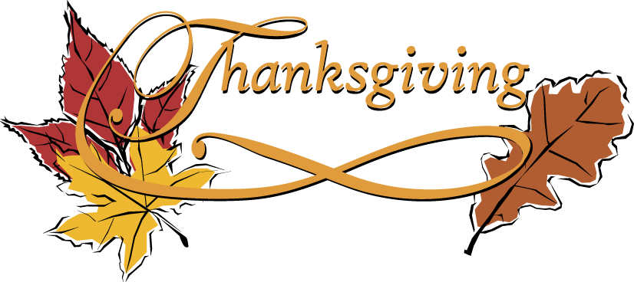
I am grateful to all of you for your support and love. I am grateful for my IHM family.
You are in my prayers of thanksgiving!
Happy Thanksgiving 2017!

Fr. Ruben Quinteros
Pastor

