Turtle Lake - Mercer School
Remote Learning Plan

Table of Contents
Pandemic – Epidemic Job Roles 4
Communication Plan 5
Level of Continuation 5
Ensuring Student Success through Robust Relationships 5
Health and Safety Considerations 6
Attendance Procedures 6
Ensuring Equitable Services for Students and Families during Closure 7
Preparing for Distance Learning 7
Staff Development 8
Student Development 8
Sample Letters and Resources 8
Student Access to Devices 8
Internet Access 8
Ensuring Access 8
No Access Options9
Access to All Classes/Courses 9
Services Assurances to Students with Needs 10
At-Risk 10
Special Education and 504 10
English Language Learners 10
School Counseling 11

High-Quality, Effective, Standards-Based Education 12
Provisions for instructional support 12
Assessments 12
Grades 12
Academic progress monitoring 13
Student Meals & Feeding 13
Human Resources Processes, Protocols, and Policies 13

Pandemic – Epidemic Job Roles

Turtle Lake-Mercer has the infrastructure to engage as a faculty and to engage with students exclusively through an online format.
At this point, all staff are on site maintaining safe social distancing protocols.
Custodians are on site using CDC recommended cleaning procedures.
https://www.cdc.gov/coronavirus/2019-ncov/community/organizations/cleaning-disinfection.html
The cafeteria staff on are site preparing breakfast and lunch for students and children ages 1 - 18. They also deliver the meals to homes by dropping them off at the front door and providing directions for safe consumption and storage directions.
Staff in the building are practicing social distancing of six feet or greater. All staff in the building have their own office/room to which they report for work. At the conclusion of each day, the custodians clean those used areas using the recommendations from the CDC.

Staff
- Staff must be available from 8:00 – 3:45 on scheduled school days according to the 2020 – 2021 school calendar.
- If Turtle Lake Mercer implements school wide remote learning, staff will engage with students synchronously through such teleconferencing platforms such as Zoom, Microsoft Teams. Staff will also engage with students asynchronously through such platforms as email.
- If Turtle Lake Mercer implements school wide remote learning, staff will meet virtually once a week to discuss progress and concerns of distance learning. This also includes weekly PLC meetings and monthly meetings with the School Leadership Team.
- Staff will post weekly overviews to their classroom websites on the Turtle Lake Mercer Public School website.

Special Education Teachers
- Special education and 504 students will be provided the same accommodations and modifications outlined in their IEP through this distance learning structure. Special education teachers will work with regular education staff to determine the appropriate modifications for any e-learning materials.
- Help may be provided via email and/or video conference calls during school hours.

Educational Support Personnel
- Assignments may vary depending on nature of duties and the condition of the buildings, Daily cleaning, and summer projects.
- Secretarial staff may vary depending on if staff is allowed into the buildings and/or the activities that could be completed at home - this would require establishing a schedule with the building principal.
- Paras will continue to work with students in their current assignments.
- Kitchen staff will continue to provide breakfast and lunch during the week for school-age children. Currently we are serving about 25 students.
- Bus drivers will be offered the opportunity to clean the bus barns and school grounds when the weather is appropriate.

Communication Plan
Parents and students will be notified by SwiftK12, tlm.k12.nd.us, and Facebook as part of the district's update on the coronavirus.

Staff will be notified by email, SwiftK12, tlm.k12.nd.us, and Facebook as part of the district’s update on the coronavirus.
Level of Continuation

In the event of a pandemic/epidemic that significantly impacts how we can provide educational services Turtle Lake - Mercer Public School intends to address the following practices and processes to achieve our desired outcomes.

Our Mission

To provide students a learning opportunity in a safe environment to become productive citizens.

Our Vision

We will create a community of lifelong learners in collaboration with our school, parents, and community. In a safe and caring environment, we will engage students in meaningful and relevant educational experiences. Graduates will be critical thinkers who can solve problems and effectively communicate, striving for their full potential in an ever-changing world.

Our Values

Excellence is expected: Growth, Responsibility, Respect, Commitment

Full Continuation: Students will be able to access grade-level and subject- matter content. Instructional support is provided, including assessment and evaluation of work. Measurable student progress is expected. Materials and instructional methods used might include all those listed above.

Ensuring Student Success through Robust Relationships
Our teachers are regularly reaching out to students via Zoom, Microsoft Teams, etc. During daily synchronous sessions, teachers will monitor individual student’s mental health and refer to the guidance counselor if they have concerns. The guidance counselor is also available for daily synchronous mental health sessions as indicated and communicated to families via her website and paper copy sent home with students supplies.

Health and Safety Considerations
The health and safety of students, staff and community members is our primary concern during a widespread health emergency. All actions Turtle Lake - Mercer Public School takes will be balanced with guidance from McLean County health Services, North Dakota Department of health, the CDC and community leaders.
Ensuring the safety of our students, staff and community stakeholders may impact the intensity, location, and duration of academic services we provide during a pandemic/epidemic.
Our district has reviewed the CDC guidelines and created appropriate protocols for cleaning, social distancing, and accommodating for students who are at-risk.

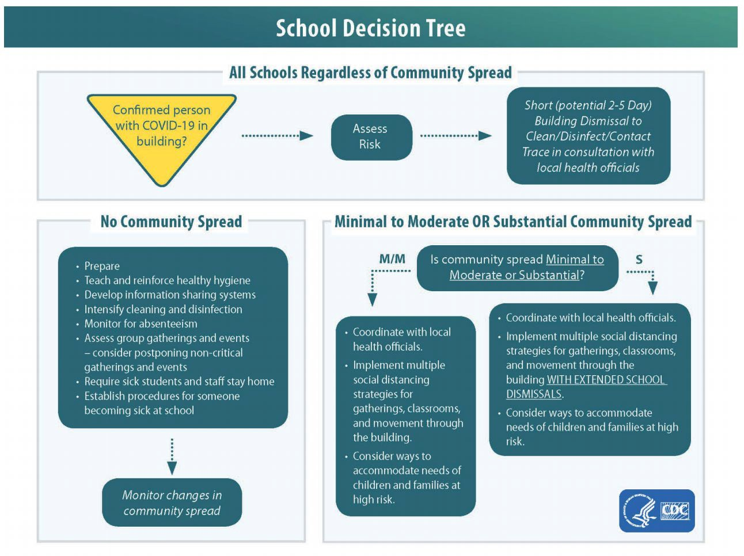

Attendance Procedures
Attendance policies will be flexed during a pandemic/epidemic event. The CDC provides guidance for schools on when to alter attendance practices and/or close schools.
· Student absenteeism due to EPIDEMIC will be addressed on a case by case basis by building administration
· Encourage families with symptomatic students to stay home

During an extended closure student engagement in learning opportunities is critical to all students continued academic growth. Attendance will still be monitored by teachers through student logins in asynchronous learning experiences and participation in synchronous learning experiences. Any student demonstrating prolonged absence or disengagement is a cause for concern. Teachers, paraprofessionals, and/or school administration shall contact that student’s parent/guardian to seek input and assist them as needed to ensure student participation.

Ensuring Equitable Services for Students and Families during Closure Preparing for Distance Learning

- Every student will have the choice to either attend school through traditional or remote learning. Students need to make their decision by August 10th at NOON or in coordination with administration if applicable. Once students have made their decision, they will attend school in their chosen format for the duration of the semester.
- Students who choose to attend school through remote learning will still be subject to all TL-M grading, late/missing work, attendance, and eligibility policies
- Students who choose to attend school through remote learning will be allowed to participate in extracurricular events.
- In the event TL-M moves to school-wide remote learning, staff and students will have a minimum of two days to prepare.
- In grades K – 4, students have classroom iPads that will be sent home for student use to access eLearning opportunities. In grades 5 – 12, students will use their school issued laptop to access eLearning opportunities.
- If students choose remote learning, it is the responsibility of students to have internet
- In the case students need internet when mandatory remote learning is required, parents should contact the school for assistance.

Student Supplies and Technology for Parent Pickup
We will be allowing parents to come pick up their own student supplies such as pencils, textbooks, and general supplies in the event remote learning is required.
- PreK-Grade 3 Students: whatever supplies students have will be left in cubbies,
- Students in Grades 4-6: whatever supplies students have will be in their hallway lockers.
- Students in grades 7-12: whatever items students have will be in hallway lockers

Students with Last Name Starting with
- A-B – 8:30 a.m. - 9:30 a.m.
- C-G – 9:30 a.m. - 10:30 a.m.
- H-K – 10:30 a.m. - 11:30 a.m.
- L-P – 11:30 a.m. - 12:30 p.m.
- Q-S – 12:30 p.m. – 1:30 p.m.
- T-Z – 1:30 P.M. TO 2:30 p.m.

How to Connect Your Home Wi-Fi
- Go to the lower right-hand corner of your laptop screen.
- Click on the Wi-Fi tab. It should look like this:
- Clicking on Wi-Fi logo will give you possible connection points.
- Enter your Wi-Fi login info as received from your home internet provider.

How to Access Your Teacher’s Website
- Open our school’s website at http://www.tlm.k12.nd.us/
- Find “Turtle Lake Mercer Public School” at upper left of page.
- Locate appropriate grade level, such as elementary, high school, or k-12 departments
- Select appropriate teacher and click on their hyperlinked name
- Navigate individual teacher site as desired

Staff Development
- All teachers have access to a laptop, iPad, or computer for use at school and at home.
- We will utilize our Ed Direction coaches, Athena Nadeau, Laura Scarpulla, and Carrie Miller, who are available and equipped to support the faculty through individual coaching, team meetings, admin coaching, and additional online resources.
- Teacher PLCs will continue to meet one time per week for collaboration in-person and/or using Zoom conferencing.
- Teachers are encouraged to sign up for the NDCEL ND Distance Learning Tutorial Course.

Student Development

Letters and Resources
https://nodak-my.sharepoint.com/:f:/g/personal/sheila_schlafmann_k12_nd_us/EtCKv20o31JDhPHb0hVUiJEB2rsSJhF9unVvjQmGvIkX4w?e=vHUo4c

Ensuring Access
In grades 1 – 4, students have classroom iPads that will be sent home for student use to access eLearning opportunities. In grades 5 – 12, students will use their school issued laptop to access eLearning opportunities.

No Access Options
All students K – 12 have been sent home with a school-issued iPad or laptop. Turtle Lake Mercer will work with students who don’t have internet access on a case by case basis.

Our district has the infrastructure and professional capacity is in place to support eLearning days as an emergency measure in the event of a health emergency that necessitates extended school closure. The school staff will work with individual families to accommodate as needed if there is no internet access.

Access to All Classes/Course

- Elementary:
  - During online learning, students in grades PreK – 6, will be provided work from their teachers in ALL of their subjects following the standard school day/week of 8:30 a.m. to 3:15 p.m. Classroom instruction will be livestreamed via Zoom.
  - The expectation for all PreK through sixth grade students will be to use their teacher’s website to find assignments and instructions to access materials.
  - Teachers will provide daily assignments on the website, and paper copies will be available in the office as needed. Each family will need to come to the school at least once to gather supplies and technology if needed at a designated time.
  - Teachers will be available via email (or other pre-established modes of communication like Zoom) Monday through Friday 8:00 a.m.-3:45: p.m. Please check their website to be informed on contact information.
  - All specials (PE, Music, Library, Counseling) will follow their regular weekly schedule.
  - Teacher PLCs will continue to meet one time per week for collaboration in-person and/or using Zoom conferencing.
  - All teachers will provide a weekly lesson overview on their website.

- Middle/High School:
  - During online learning, students in grades 7-12, will be provided work from their teachers in ALL of their subjects following the standard school day/week of 8:30 a.m. to 3:15 p.m. Classroom instruction will be livestreamed via Microsoft Teams.
  - Students in ITV/Dual Credit Classes will follow the schedules established by the institution in which students are attending their classes.
  - The expectation for all 7-12 high school students is to use their school-issued or personal laptops and K12 accounts to access their teachers’ websites to find assignments. Assignments, deadlines, and instructions to accessing websites such as Microsoft Teams will be found on teacher websites. Teachers will be available to answer student questions via email or Microsoft Teams from 8:00 a.m.-3:45 p.m. M-F.
  - Work co-ops will not meet during this closeout period.
  - ALWAYS REFER TO TEACHER WEBSITES (www.tlm.k12.nd.us) FOR UPDATES/INSTRUCTIONS/QUESTIONS.
  - All teachers will provide weekly lesson overviews on their website.

Services Assurances to Students with Needs At-Risk
- Reading Strategist and Title I students will continue to meet with teachers as needed via video conferencing using supplemental instructional resources. Students who currently receive supplementary instruction will continue via a curriculum sent home. Students of high academic need will be scheduled for individual supplementary instruction via video conferencing. Assessment and progress monitoring of all will continue remotely through STARS. The Title 1 teacher will have open office hours to work with teachers, parents, and students to ensure academic supports are provided for students in need.
- Online Reading Tutoring Opportunity: Our Reading Strategist will be offering 15- minute reading tutoring sessions via zoom meetings during our distance learning time at TLM. The reading strategist will reach out to the families of the students she is currently serving to set up a time to meet.
- Classroom teachers will be in contact with both the Title I and reading strategist teachers to refer any students they observe having academic concerns.

Special Education and 504
- Students with special needs will have assignments modified or provided based on their IEP goals from their special education teacher or related service provider.
- In accordance with recommendations received from the North Dakota Department of Public Instruction and Souris Valley Special Services, special education students will receive the same kind of distance education as regular education students with additional modifications and supports.
- In order for things to run more smoothly for our special education students, Mrs. Delker, our special education teacher, will be available by email from 8:00 a.m. to 3:45 p.m., Monday through Friday. Mrs. Delker and our crew of paraprofessionals will communicate weekly via ZOOM.
- Related services will be provided remotely.
- Materials will be sent home via email or can be picked up in the main office.
- Our special education staff will provide virtual assistance, in order to support students in completing lessons and work. Paras will check in with students as needed to help with organization, time management, and class assignments.
- Offering in-person special education services will be determined on an individual basis according to the student's needs and the safety of the environment.
- High school students that currently have study halls can email written assignments for review/revisions c/o Courtney.Graf@k12.nd.us.
- Classroom teachers will be in touch with special education regarding any students they have academic concerns with.

Communications and Plans
Case managers will connect with guardians of students on an IEP throughout partial or full closures.

Hosting an IEP Meeting
Dates for IEP meetings will be held as scheduled. All members will be present remotely via Zoom for Educators.

Services at School
The District shall provide services to students based on the needs outlined in each child’s IEP. Educational services and accommodations decisions shall comply with guidance from the DOE and NDDPI. These may include:
- Online learning through Zoom
- Additional supports provided remotely, such as phone and email if needed.

Services provided through Distance Learning
Distance Learning provisions will be offered considering all above preparations.

English Language Learners
Currently we do not have any ELL students.

School Counseling
Counseling will begin a regular schedule starting Tuesday, September 8th. PK – 1 Counseling lessons are every week, and grades 2-6 are every other week. Grades 7-12 will meet once a month via Microsoft Teams.
All students in grades 5-12 have their laptops and access to Office 365. One of the features in this suite of programs is Teams. A Team for each grade level has been set up and this is how resources will be shared, as well as, connect with students. Below are all of the ways students can connect with the counselor for help or to just check in during this time of school closures.
Microsoft Teams– Check your K-12 email to access this program. Mrs. Leingang has already added you to your class Team. Please look over the resources and complete the check-in form to help guide our future discussion.
Email/Individual Meetings– The counselor’s email is megan.leingang@k12.nd.us. Students can email at any time with a question or to request a one-on-one chat/video session through Teams.
Call or Text– This can be done with a Google Voice account which gives the counselor the ability to have calls or text messages sent even when the counselor is not in the office. The counselor can be reached at 701-203-5170.
High-Quality, Effective, Standards-based Education
During a closure it is our intent to deliver high-quality, grade-level appropriate learning opportunities that align with North Dakota Standards.
https://www.nd.gov/dpi/districtsschools/k-12-education-content-standards
Provisions for instructional Support
Teachers will be available Monday through Friday from 8:00 a.m. to 3:45 p.m. to provide students with academic support and direct feedback on student lessons. Teachers have also built into the instructional day direct teacher guided instruction through Microsoft Teams and Zoom. During direct one-to-one or small group instructions students will have an opportunity to ask questions and get teacher feedback.
Teachers will partner with parents to monitor student progress and ensure follow-through and submission of assignments as directed. Parents will provide a vital link in the academic chain encouraging students to use their academic time wisely and monitor submission of assignments.
Turtle Lake - Mercer Public School will continue to offer school guidance counseling lessons delivered digitally to students through Microsoft Teams, Zoom, Emails, and phone calls. Additionally, the counselor will adhere to the ASCA virtual learning guidance and ethics as they design synchronous and asynchronous digital lessons to address the needs of each student.
Assessments
Assessments will vary from teacher to teacher as they are guided by the content-standards. Assessments will include tracking daily student progress, worksheets, quizzes, tests, and short writing assignments, all of which will be time stamped and submitted digitally.
Grading
Turtle Lake - Mercer School District will continue to follow our policies, practices, and grading structure if school wide remote learning is required due to the pandemic. Students will be subject to 7-12 Late/Missing Work Policy.
Progress Monitoring
Monitoring student progress will be accomplished through Microsoft Team, and emails, as these digital tools allow us to review student submissions and provide feedback.
PLCs will continue to meet weekly to monitor student progress and address learning gaps that may surface. PLC groups will have access to specialists to assist them in providing resources and supports to students demonstrating academic need.

Student Meals & Feeding
The Turtle Lake-Mercer School will be offering breakfast and lunch for school age children. Should a student receive meals in the event of school building closure, our plan is to send the breakfast for the next morning with lunch.

If your family would be interested in breakfast, lunch, or both a form will be provided via SurveyMonkey.

Human Resources Processes, Protocols, and Policies

Human Resources – Supporting our Adults
During any crisis including a pandemic supporting our educators and support personnel is necessary to continue to provide quality and consistent educational services to our students. Continual evaluation and emergency planning for the business office, building principal, and District superintendent are essential to combating emergency situations as they arise.
Business Office Operations
Before the event of a full closure of schools and district operations due to a pandemic preparation shall be made to ensure continuation of payroll, funds receivable, funds payable, other essential services at remote/home, when possible.
The Turtle Lake - Mercer School Board has approved paying ancillary and certified staff during the duration of the COVID-19 closure. These payments shall be made as prescribed in our 2020-2021 expenditure budget.
Superintendent and Board Oversight
Before the event of a full closure of schools and district operations due to a pandemic preparation the Superintendent shall present a plan on how to address sick leave, personal leave, and leave without pay to the Board for approval.
Federal Programs & Funds
Turtle Lake - Mercer School District will continue to comply with the guidance and regulations of all federal programs that affect the Turtle Lake - Mercer Public School District.

