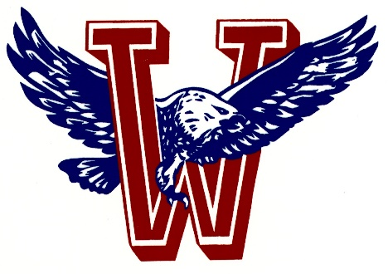
Athletics
Wellsville HS/MS

Pioneer League Regular Season:
1/12 @ Iola 5:00 PM
1/14 @ Prairie View 5:00 PM
1/19@ Wellsville 5:00 PM

1/21 Girls League @ Osawatomie 4:30 PM
1/22 Boys League @ Osawatomie 3:00 PM

Post season will include Districts, Regionals, and Sub-state.

Districts @ TBA
2/5 Girls
2/6 Boys Top 4 in each weight class receive medals and advance

Regionals @ TBA
2/12 Boys
2/13 Girls Top 4 in each weight class receive medals and advance

Sub-state @ TBA
2/19 Girls
2/20 Boys Top 4 advance to State

2/26 Girls State @ Salina
2/27 Boys State @ Hays

