Kindergarten E-Learning Choice Board
JANUARY
Please pick at least 2 activities each day to complete. Try to complete and explore new activities each day and then it is ok to repeat activities! Most importantly, HAVE FUN TOGETHER!

Row 1 | Listen to the song  “Vowel Bat.”  https://www.youtube.com/watch?v=f2hXa8dbK3o  Write the following words on a piece of paper and circle all of the vowels:  snowman  shovel  sled  hot chocolate  scarf  blizzard | Scholastic Clifford’s My Big World:  Listen and Read Magazine,  2Videos, Game, Hands-On Activity:  Arctic Giants  https://mybigworld.scholastic.com/issues/2020-21/010121.html | Use playdough to create 2-D shapes (circle, square, triangle, rectangle, oval and diamond.  Talk about the attributes of each shape (how many sides, how many corners, etc.)  Go on a shape hunt around your home and see how many shapes you can find! | Have a grown up draw the marshmallows on a piece of paper as seen below. You will then figure out what number is missing and write that number on the marshmallow.  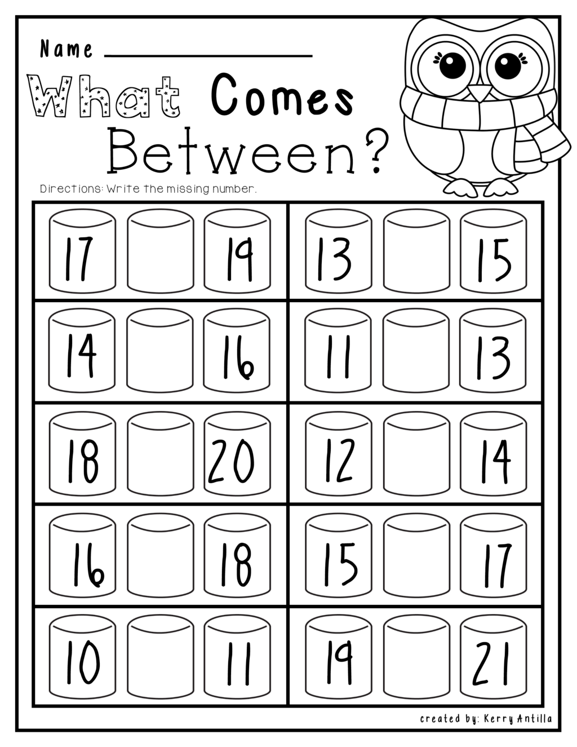 | Learn to tie your shoes with these friends:  Laurie Berkner  https://www.youtube.com/watch?v=VkOC_95FBTM  Kids Song  https://www.youtube.com/watch?v=L9QmTgAP7jk  Teach Children  https://www.youtube.com/watch?v=VA4AACzlhe8&list=PLJ0fXWIpgQGJIOhTXE7fbi7K4vp-7iBMx&index=28&t=0s
Row 2 | Scholastic Clifford’s My Big World:  Listen and Read Magazine  2 Video:  Game: Hands-On Activity:  My Winter Window  https://mybigworld.scholastic.com/issues/2020-21/010221.html | Watch the first part of the Jack Hartmann video in order to review the diagraphs “sh”, “ch” and “th”.  https://www.youtube.com/watch?v=NK8_Tvu6bJk&t=140s  Have a grown up say these words out loud and you tell your grown-up if you hear “sh”, “ch” or “th” at the beginning.  sheep  thumb  cheese  shark  chair  three | Explore the alphabet game on Starfall  Starfall Main Image ABCs Index  Practice saying the alphabet with the Jolly Phonics sounds and actions  See if you can name all of the Alphafriends! Listen to the song for help:  https://www.youtube.com/watch?v=2_cX4j_9fUU | Have a grown-up read you a winter/snowy book. Talk about the different parts of the book….front cover, back cover, title page, and talk about what the author and illustrator do. Help your grown-up turn the pages and show them where to start reading on each page. After listening to the story, draw a picture to show what happened in the beginning of the story, the middle of the story and the end of the story. | Winter Scavenger Hunt  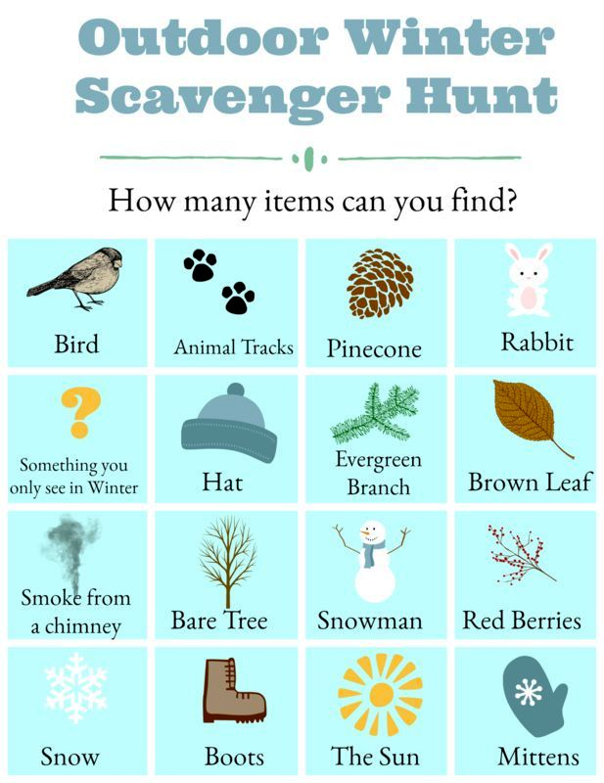
Row 3 | Practice writing your sight words in shaving cream or go outside and write your sight words in the snow.  the  and  I  like  to  we  see  a  come  me  with  my  what  are  now | Enjoy exploring Grovers’ Winter Games  on PBS Kids:  https://pbslm-contrib.s3.amazonaws.com/Sesame%20Street/PBSLM%20Games%20Delivery/Final%20PBS%20game%20builds/HTML5/wintergames_19/index.html | Listen to the read aloud story  “The Mitten”  https://www.youtube.com/watch?v=QA6ukHm9etg  Did you like this story?  What was your favorite part?  What was your favorite animal? Why?  Was this book fiction or nonfiction? | Scholastic  Let’s Find Out:  Listen and Read Magazine,  2Videos,  Game,  Hands-On Activity:  The Animals of the Mitten  https://letsfindout.scholastic.com/issues/2019-20/010220.html | Winter STEM Activity  MARSHMALLOW and TOOTHPICK Snowflakes  Have your child create several different snowflakes using marshmallows and toothpicks. Talk about how snowflake designs are symmetrical, or the same on both sides and have your child count how many toothpicks and marshmallows they used for each snowflake. Then have them draw a picture of their snowflake creations.  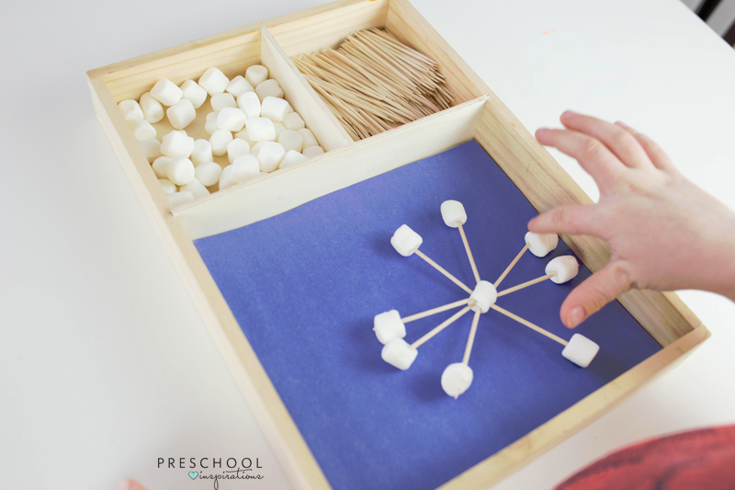
Row 4 | Have fun playing the  Super Snowboarder game on PBS Kids:  https://pbskids.org/molly/games/snowboard  Would you like to go snowboarding?  Why or why not? | Scholastic  Let’s Find Out:  Listen and Read Magazine,  2 Videos,  Game,  Hands-On Activity:  Three Polar Bears  https://letsfindout.scholastic.com/issues/2019-20/010120.html | Winter Snack  Listen to the story: Snowmen at Night  https://www.youtube.com/watch?v=r3mg4W7pjKQ  Have a grown up help you make a snowman snack using a variety of ingredients. | Write your numbers  1-30 as best as you can!  Count by 10’s to 100. Count by 5’s to 100.  Sing and count along with  “The Big Numbers”  song:  https://www.youtube.com/watch?v=e0dJWfQHF8Y | Have fun singing and building a snowman with the  Snowman Freeze https://www.youtube.com/watch?v=C0tVmABwMPssong:  Now draw a picture of the snowman you built in the song.  Write a sentence or two about your cute snowman.

MY BIG WORLD CODE:WVTPFSY LET”S FIND OUT CODE: WYPK92J

