H1N1 - Swine Flu
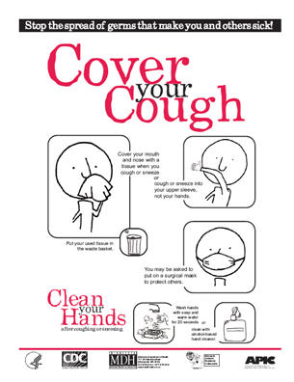

Preventing the Swine Flu
Swine Flu - A Guide for Parents
Swine Flu - Information for School
Staff
Link to Center for Disease
Control - Swine Flu
H1N1 Influenza Vaccine Consent Form
Influenza Vaccine Live, Attenuated- What You Need to Know
Influenza Vaccine Inactivated (the "flu shot") - What You Need to Know
WV Department of Education: Office of Healthy Schools - Pandemic Influenza
H1N1 Information for WV Schools
West Virginia Department of Health and Human Resources - H1N1 Vaccine Information
- Schedule of Immunization Clinics for the H1N1 (Swine) Flu
- Last day for Consent Form to be turned in
- Health Department H1N1 flu clinic schedule
- Schedule of H1N1 Clinics Elementary Schools (pdf)
- Schedule for H1N1 Clinic BCMS (pdf)
- Schedule for H1N1Clinic BCHS (pdf)

