Braxton County Schools
Tech Tip Page (TTP)

How to set up auto-sync for Microsoft Teams
- Click on the OneDrive icon (gray cloud) in the system tray (bottom right corner of your screen) and sign into OneDrive using your O365 username and password.
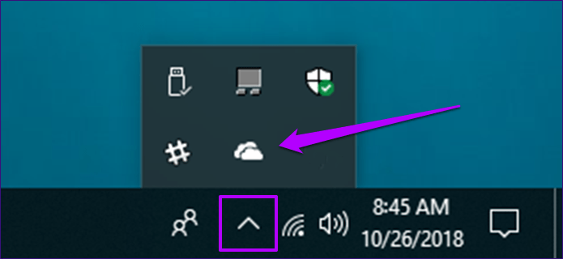

- Once signed in authorize OneDrive to synch with your laptop.
- Open Microsoft Teams.
NOTE: You will have to do each of the following steps in every Team that you have created for your classes.
- Click the Teams icon for your class.
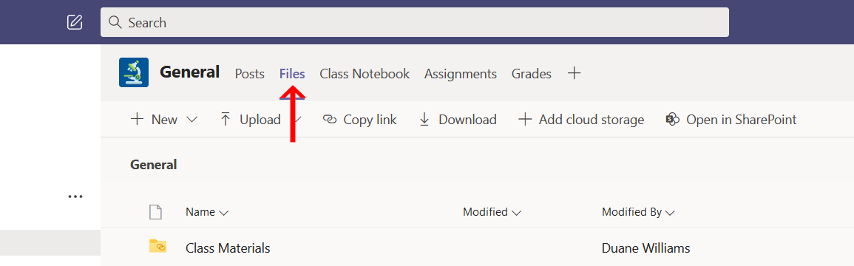
- Once your team opens, click the “Files” tab.

- Click the “Open in SharePoint button (you may need to click the three little dots and select SharePoint from a dropdown menu).
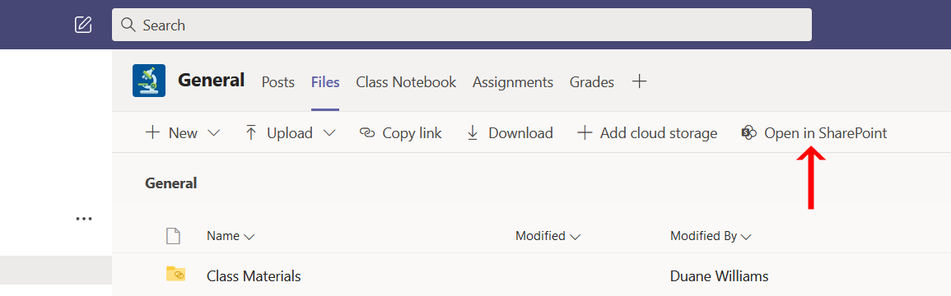

- A new window will open. Once that window opens click the “Sync” button. Select “Always allow” so that your files will auto-sync.
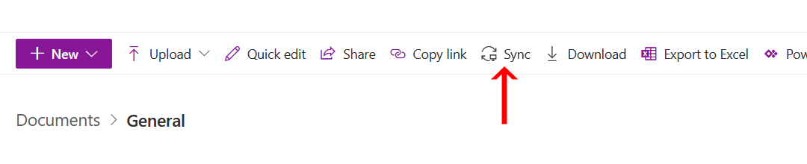

- Click on “File Explorer” (the little folder on the bottom of your screen).
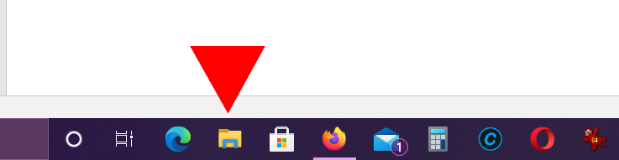

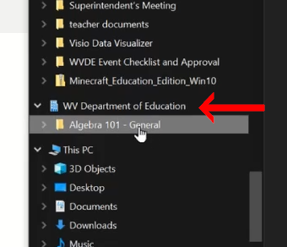
- Scroll down to the tab titled WV Department of Education and click it to expand it. This is not the OneDrive – WV Department of Education tab located at the top of the list. You will have to scroll down to find the correct tab.

- Once expanded, you will be able to see your individual classes, with one folder labeled to match your class name.
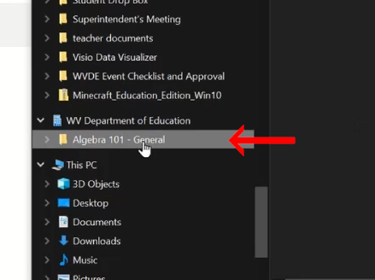

- Right click on the folder titled the same as your class and select “Always keep on this device”. You will have to do this for each class folder.
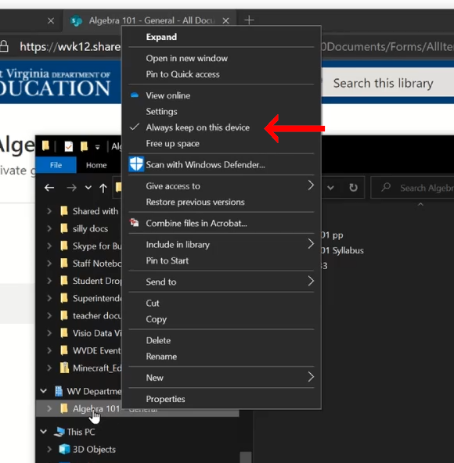

- Now when your students connect to any wifi device (not just at school) their OneDrive will auto-sync and download files from their teams and save them on their devices.

