Employee Online System

An Employee Online System has been officially launched. The system allows you to view your basic information as well as your pay information by choosing a navigational item listed on the left. The link to the site is https://wveis.k12.wv.us/Countempol/. (Highlight the link and then Ctrl + left click to follow the link.) A handout is attached for instructions in registering and using this site.

**All you need to register is your employee number and e-mail address**

Copies of your previous or current pay stubs are available for viewing/printing on this online system. W-2’s are also available. If you loose your W-2 or need additional copies of your W-2, you will need to go online to view and print them. By selecting View W-2 as PDF you will be able to see your W-2 in its proper format.

If any of the information in the employee demographics section appears to be incorrect please contact Peggy Williams @ plwillia@access.k12.wv.us with the correct/updated information.

WVEIS Employee Self Serve

This application will allow the employee to view basic information, checks and W2’s.

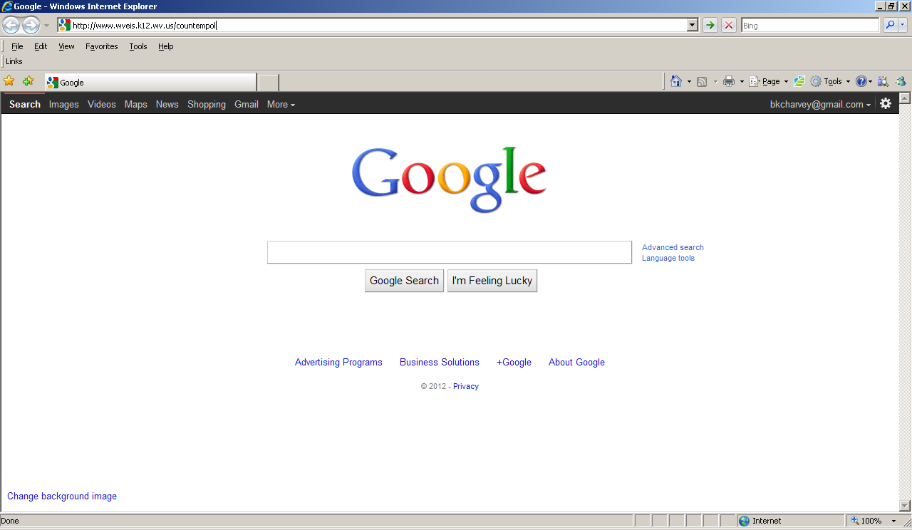

To access the website, type in https://wveis.k12.wv.us/countempol
.

Registering for the First Time

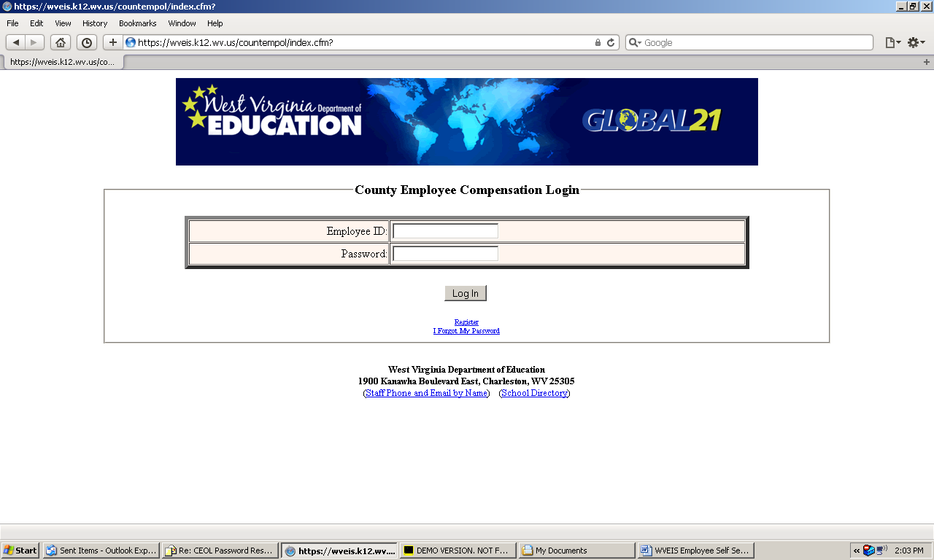

The first time user must register. Click on Register below the Log In button.

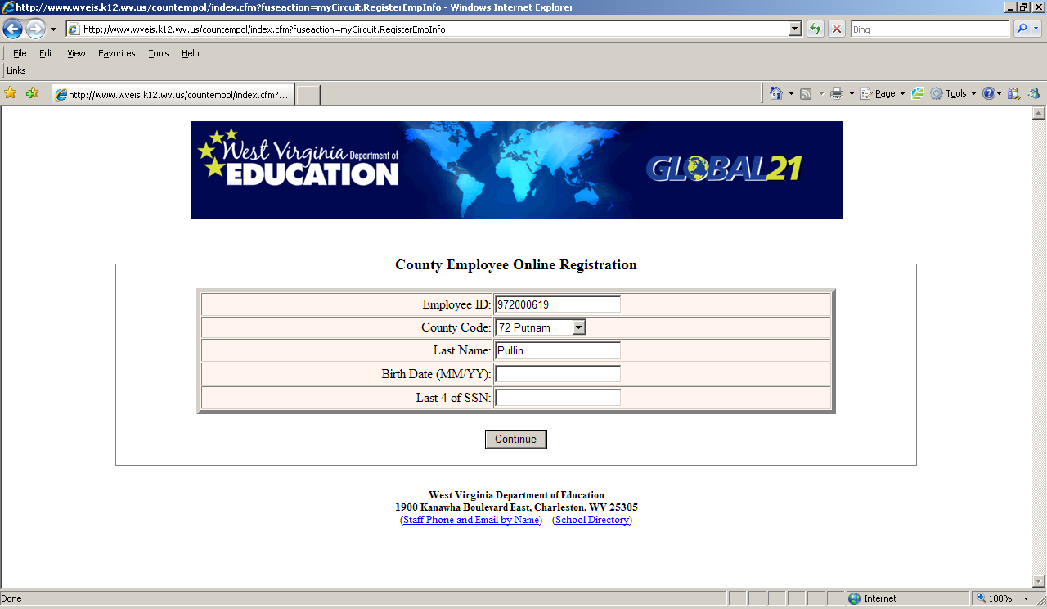

You will be asked to enter your Employee ID (found on your check stub or you can contact your payroll office), County Code, Last Name, Birth Date and last 4 of your SSN.

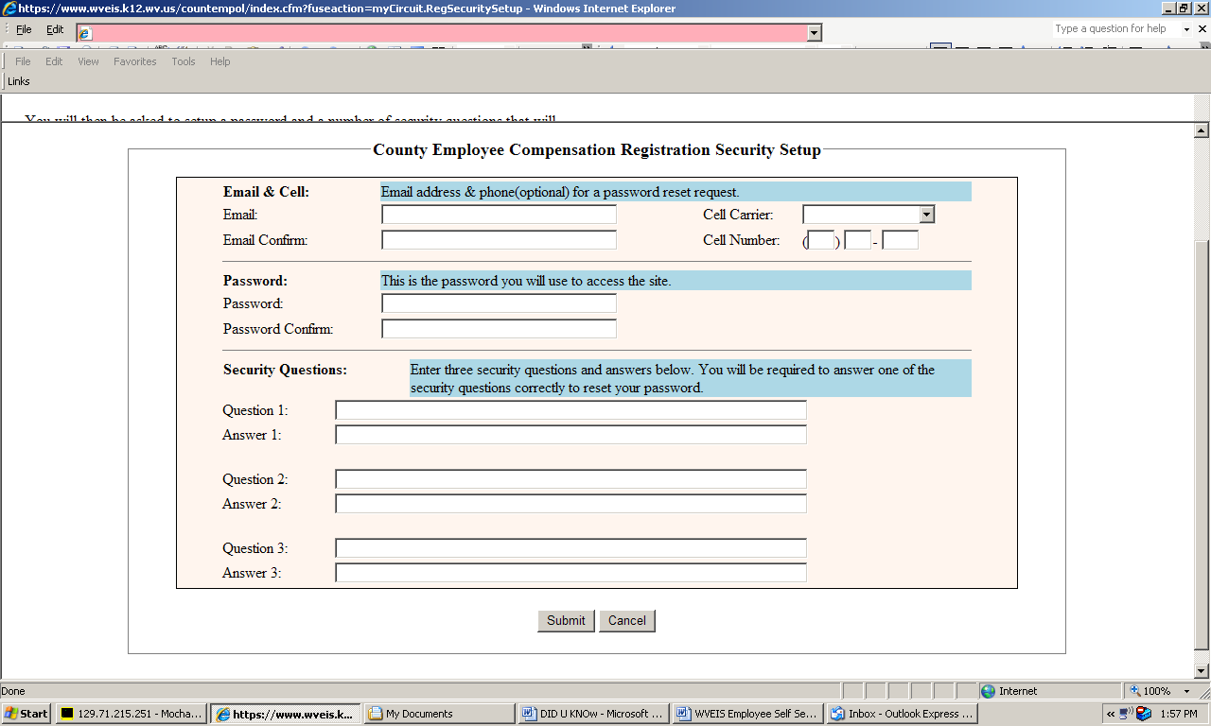

You will then be asked to setup a password and a number of security questions that will be used if you forget your password. The cell phone is optional but would be used to text you your pin should you need to change your password. Create and answer your own security questions. Click Submit when finished.

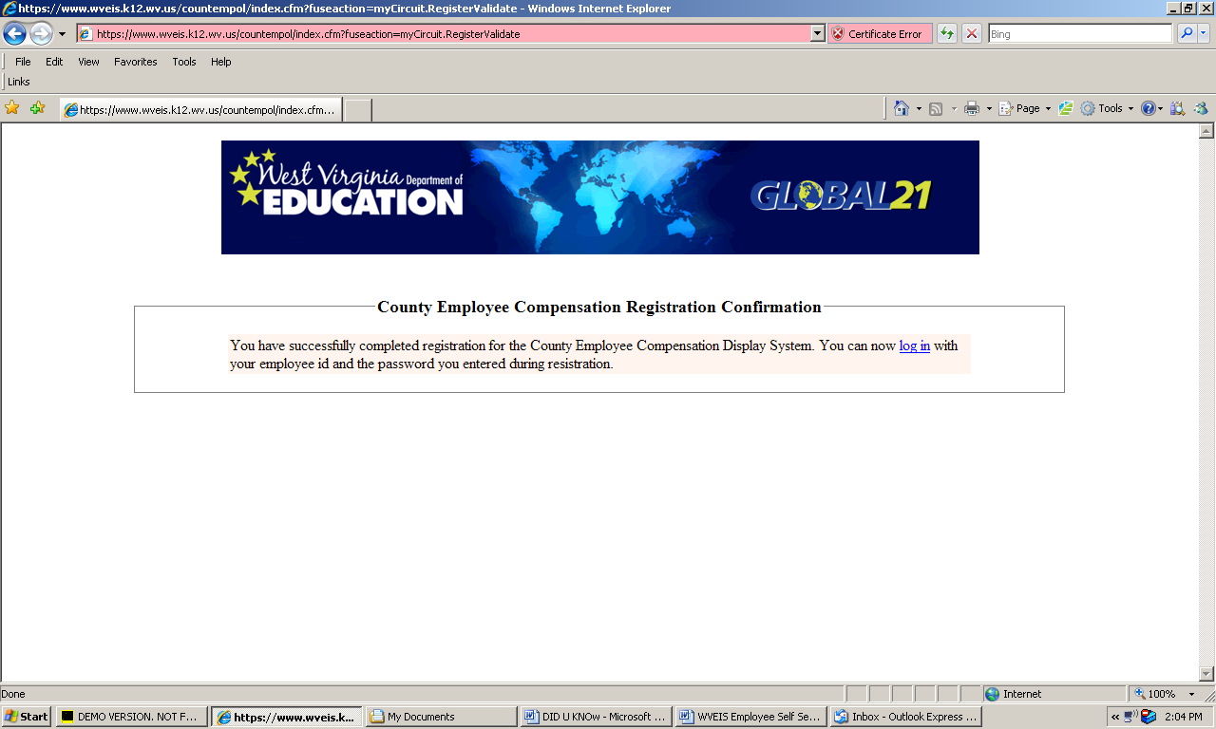

Once you have successfully registered, you will have the option to log in to view your employee and pay information. Click on ” log in” to continue.

Sign On
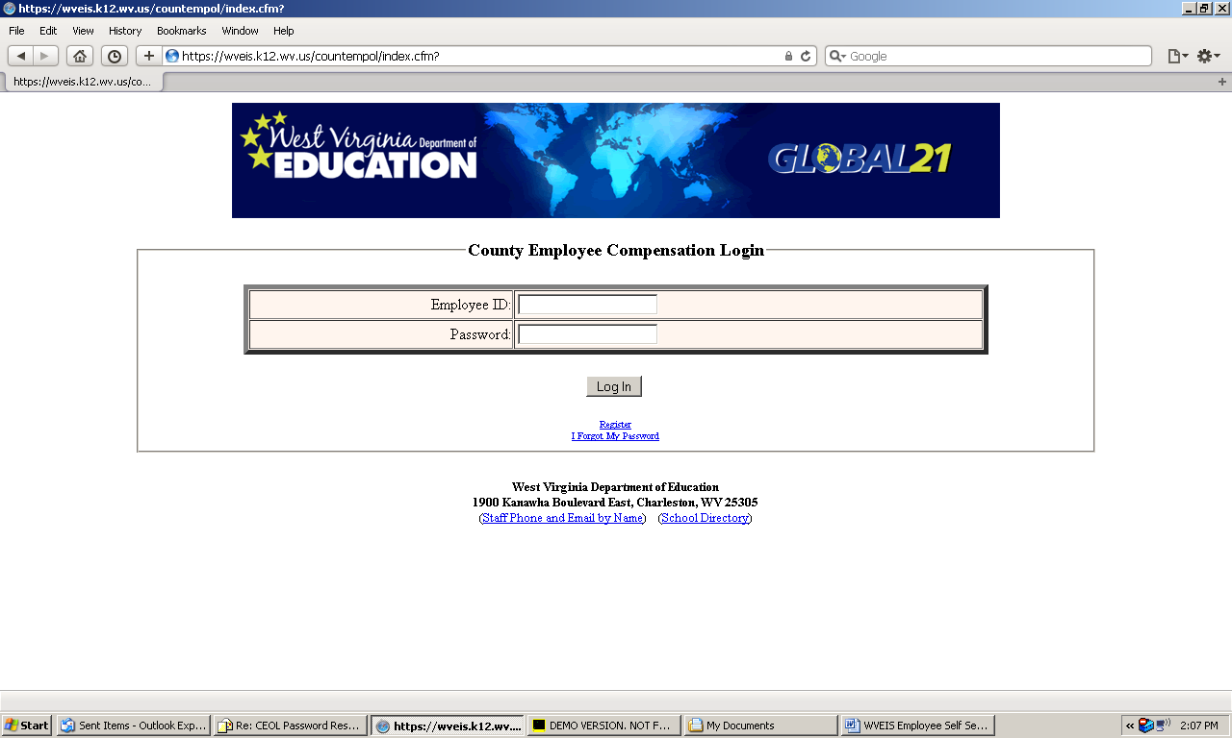
Enter your Employee ID (found on your check stub or contact your payroll office) and your password entered during the Registration or I Forgot My Password process. If you have not registered, refer to the registration process described above.

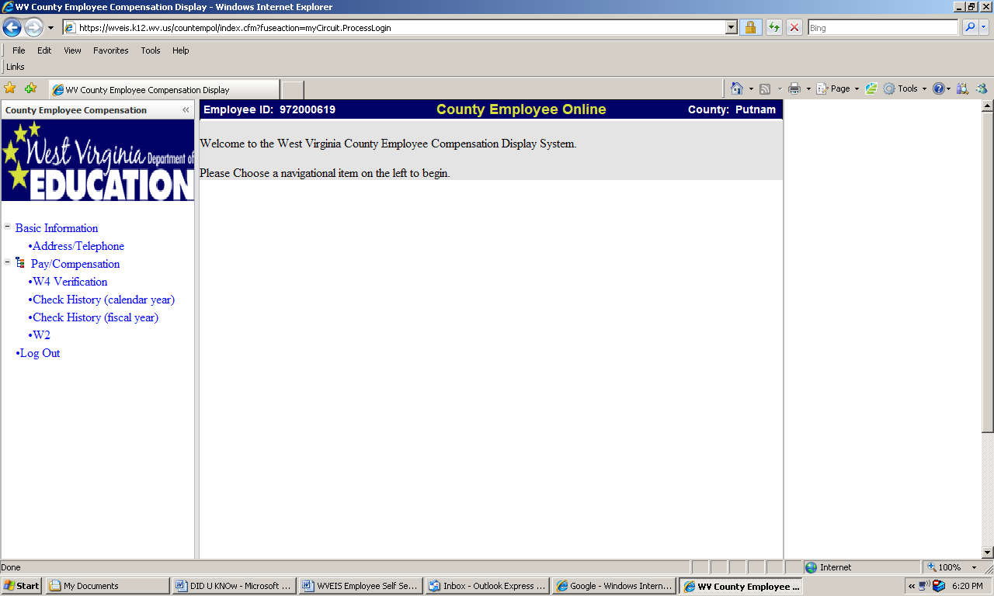
Once you are logged in, you have access to payroll and pay history information. Click on the information you want to view on the left side of the screen. If you have any questions or problems with the information, contact your payroll office. Once you are done, click on Log Out.

Resetting my Password

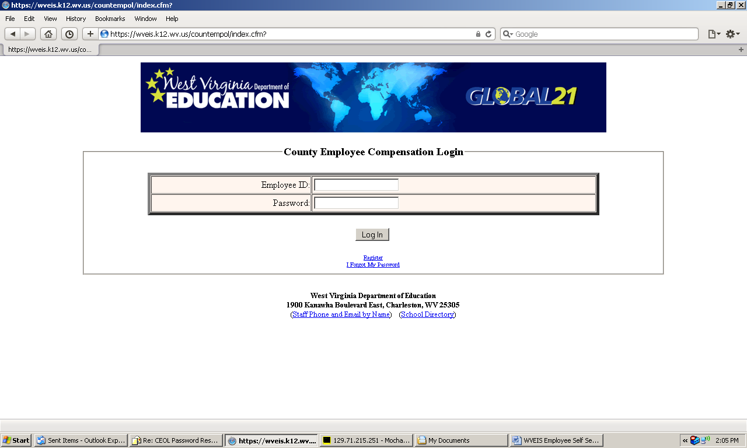

If you forget or want to change your password, you can reset it on the Log In screen. Click on “I Forgot my Password” under the Log In button.

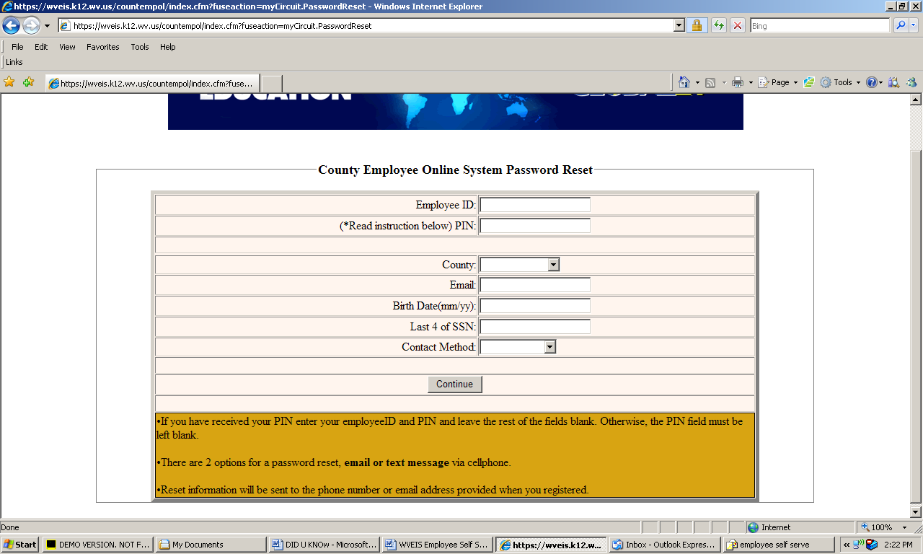

You may enter your PIN# or other information to have a text or email sent with your new password. You will only use a PIN to reset your password if you chose Text Message as your contact method during the password reset process.

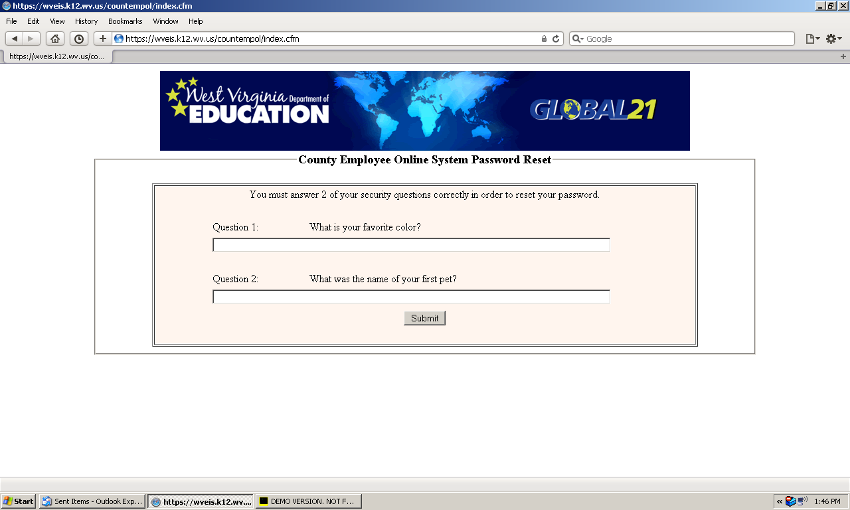
A screen will pop up to let you know an email or text has been sent. You will receive the following message: To reset your password for the County Employee Online Application, click on the link below.
Reset County Employee Online Password
Click on the link to continue the password reset process. You will be asked to answer a couple of security questions if using email.

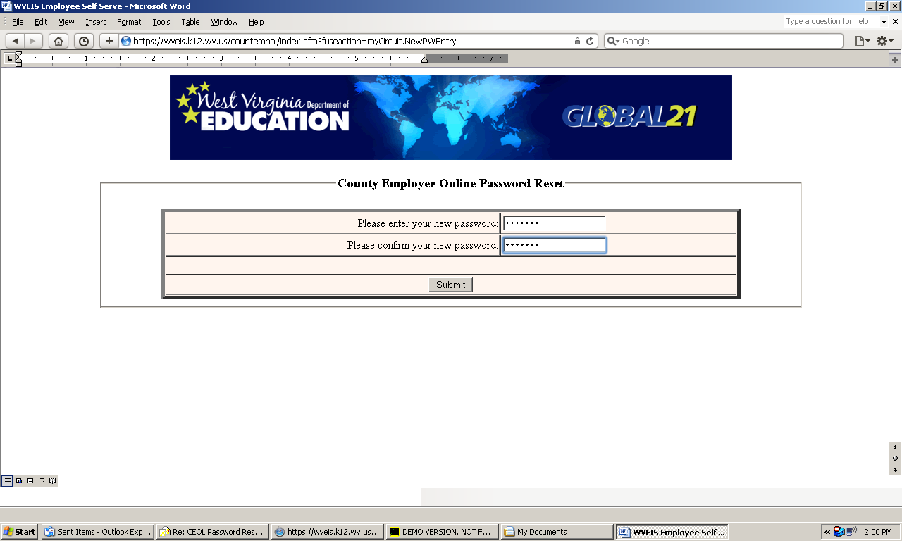
You will be asked to enter your new password.
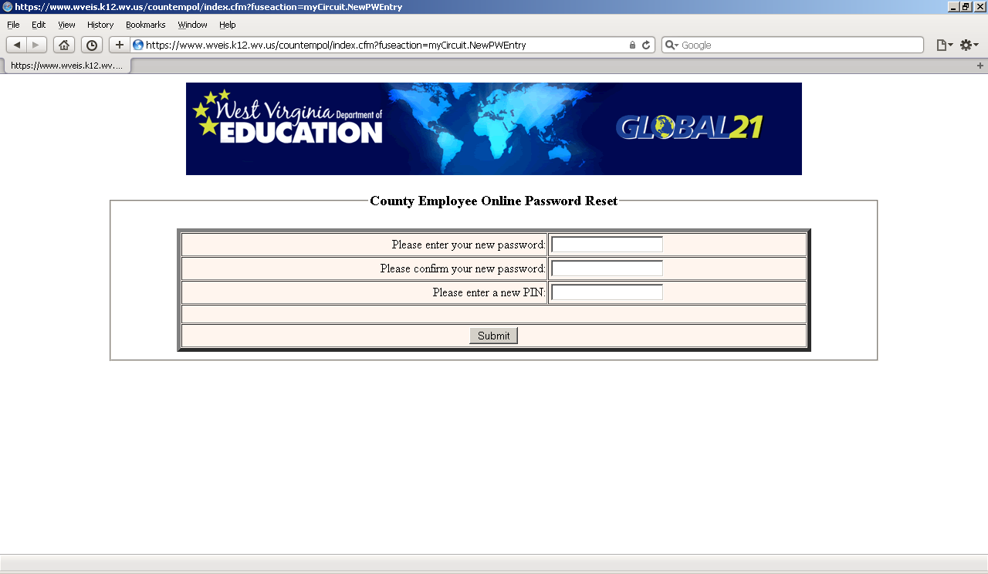
If you entered a PIN#, the screen will pop up to enter your new password and PIN#.
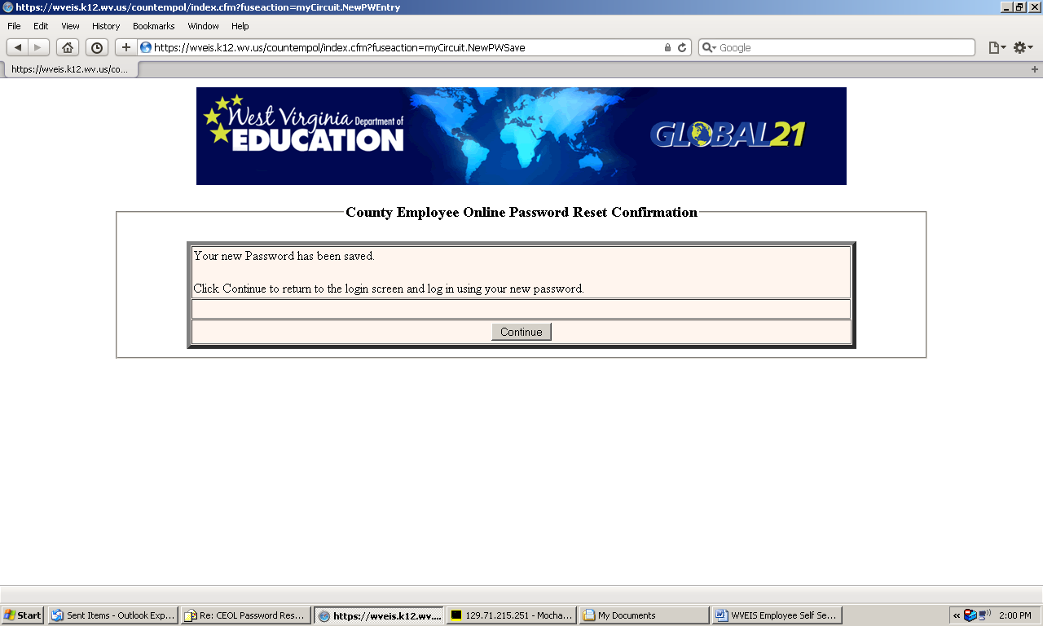
Click Continue to log in with your new password.

