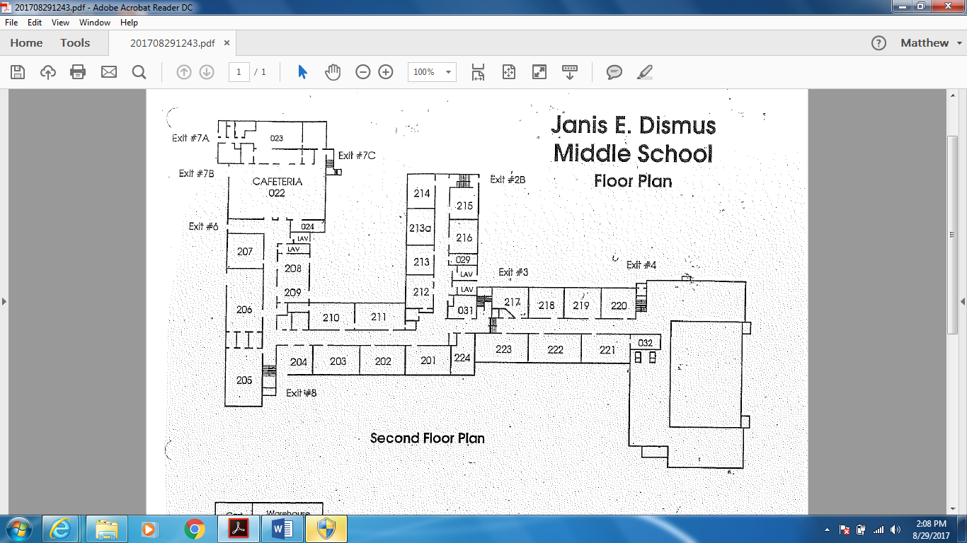

Greenhouse

Hards

Casanova

Matibag

Miller

Kotzias,

Dixon & Averill

Motyka

Dickert

Omar

Joyce

Lax &

Lavelanet

Eaton

Alarcon

Griffin

Colman

DeEsposito

Rosalles

Taveras & Iloski

Lagrega

The Zone

Capilli & Mejia

Palminteri

Morgan-

Black

Stronski

Cardenas

Martel

Cowan

**Math**

**AL**

**6th Grade**

**Science**

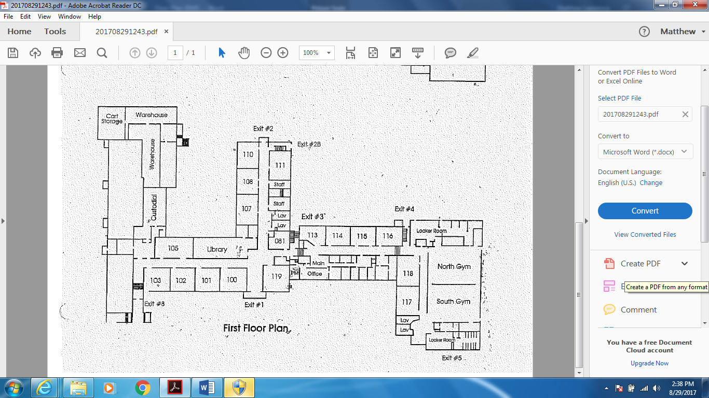

Lora & Pugh

Steelman

& Klein

Tisdale

Molano

Carney/

Corke-Ocello

Mina

Robinson

Lora-Morales

**Team Colors**

* **6th Grade: Cornell (Red) & UPenn (White)**
* **7th Grade: Harvard (Maroon) & Yale (Blue)**
* **8th Grade: Princeton (Orange) &**

**Columbia (Light Blue)**

* **Related Arts (Pink)**
* **World Language & ESL (Purple)**

Mitchell

& Priddy

6th SS / Telep

**World Lang / ESL**

**Social Studies**

**LAL**

Robertson/

Mika

Faculty Lounge

Lewbel & Garcia

Giampapa

Marcellas

Martin

Health

LaRusso

Yura/Oden