

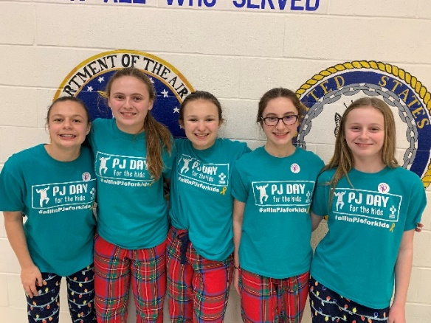

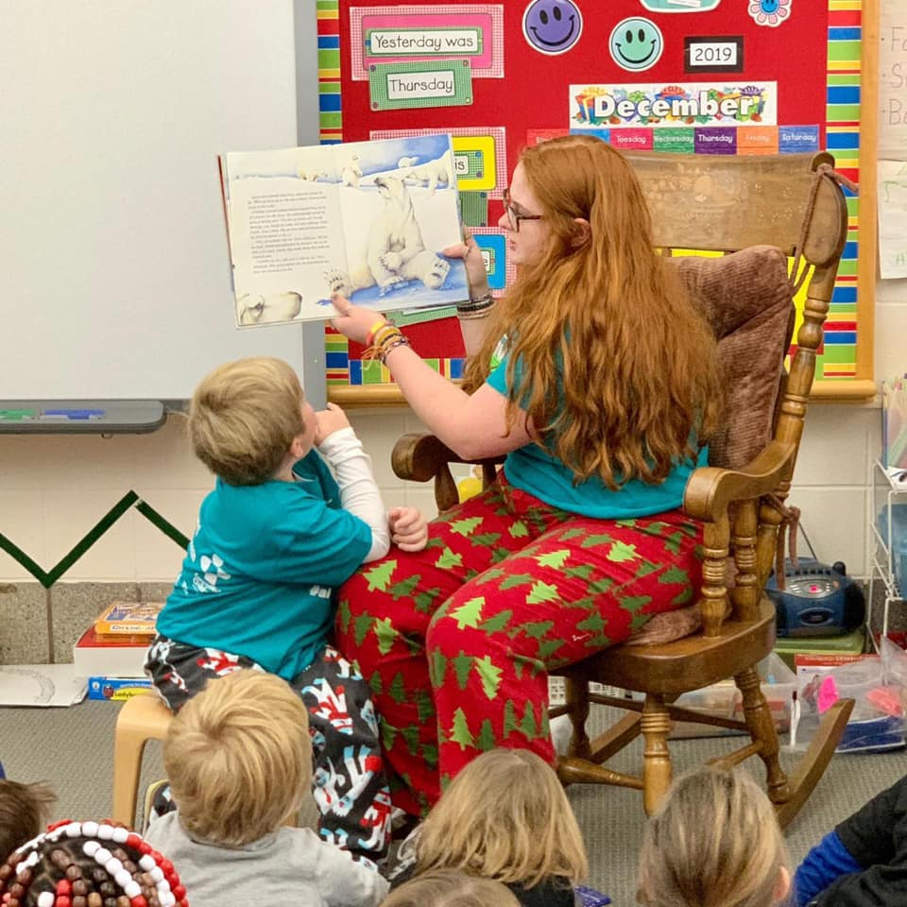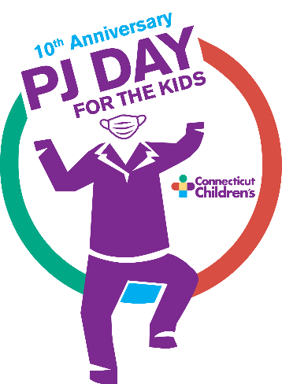

**PJ DAY FOR THE KIDS**

December 11, 2020

***…because cancer wasn’t cancelled!***

Cancer hasn’t stopped during the pandemic, so neither can PJ Day for the Kids. As long as children are battling cancer and our expert staff are treating them, the Center for Cancer & Blood Disorders needs your support.

The students and staff of

**John Trumbull Primary**

are invited to wear PJs for the day

OUR AMAZING PTO WILL MAKE A DONATION TO CCMC ON OUR BEHALF

…because kids in treatment don’t have a choice**!**

For more information and to locate your team/school online to make a gift, visit: [**http://give.connecticutchildrens.org/site/TR?team_id=4047&pg=team&fr_id=1290&et=gsgg4R3nRVwIguSa7m0auw**](http://give.connecticutchildrens.org/site/TR?team_id=4047&pg=team&fr_id=1290&et=gsgg4R3nRVwIguSa7m0auw)

*All proceeds benefit the Center for Cancer & Blood Disorders at Connecticut Children’s.*

*Wear appropriate attire for school.*