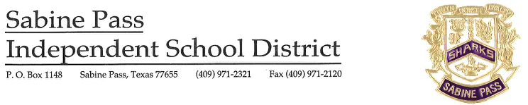

December 8, 2020

Dear Parents and Staff,

Earlier today, Sabine Pass ISD received confirmation that an Elementary Intermediate (3rd-5th grade) student who attends Sabine Pass School tested positive for COVID-19. The student tested via a quick test, and at this time is showing no symptoms. The individual was last on campus on December 4th, 2020. You are receiving this notice, because you or your child was present on the campus in the seven days prior to the individual’s diagnosis of COVID-19.

Sabine Pass ISD’s Mitigation Plan provides for extensive cleaning and sanitization protocols, as well as social distancing procedures, including the wearing of face masks. As such, CDC guidance provides that the risk of someone contracting COVID-19 from the student is low and this notice is being provided in an abundance of caution. Moreover, if you or your child was determined to have been in close contact with the individual, you may be contacted by the Health Department.

Please continue to closely monitor your health. Should you exhibit any symptoms of COVID-19, identified below which indicate a possible COVID-19 infection, please contact your health provider immediately. In addition, please continue all other safeguards outlined by the CDC including frequently washing your hands with soap and water, avoiding touching your face, wearing a mask in public, staying home if you feel sick, and cleaning frequently touched surfaces and objects daily.

COVID-19 Symptoms
Feeling feverish or a measured temperature greater than or equal to 100.0 degrees Fahrenheit
Loss of taste or smell | Difficulty breathing
Cough | Shortness of breath
Fatigue | Headache
Chills | Sore throat
Congestion or runny nose | Shaking or exaggerated shivering
Significant muscle pain or ache | Diarrhea
Nausea | Vomiting

Sabine Pass ISD will continue to comply with all state and local guidance and strictly enforce the District’s rigorous health screening, social distancing, and sanitization practices for all programs. The health and safety of our students and community remains our top priority, and the District will continue to work closely with the Local Health Department as it responds to individual cases of COVID-19. We appreciate your cooperation as we work through these challenges and continue to support our Sabine Pass ISD community.

