Welcome to Marysville Middle School

We are a ParentNet School and we invite you to become our partner in student success!

ParentNet brings Marysville Middle School families and school staff together to discuss the academic and social-emotional progress of our students.

Three ParentNet meetings will be held this school year. These meetings are great opportunities for families to meet each other and learn important topics from school staff and other speakers.
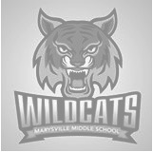
Attention:
MMS 6th Grade Parents
You are invited to a parent meeting

- Meet other 6th grade parents
- Talk about common 6th grade issues
- Meet some MMS staff
- Learn about what is happening at MMS

Save the dates:
- November 8th
- February 28th
- May 23rd
Meetings in the MMS Library from 6–7:30pm

It’s a great day
to be a
Wildcat!

