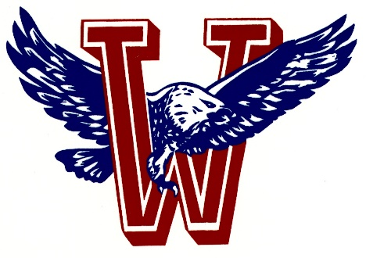
Athletics
Wellsville High School

Type of Activity: V/JV Boys and V Girls Wrestling Schedule 2020-2021

Wrestling 2020-2021
12/4 Burlington V 3:30 Canceled
12/8 @ Jayhawk w/ AC JV/V 5:00
12/11 Santa Fe Trail JV 4:00
12/17 (Wellsville Inv.) JV 4:15
12/18 Ottawa (Girls) Tourn V 4:30
12/19 Ottawa Tourney JV/V 9:00
1/09 Rossville Tourney V 9:00
1/11 (SFT, AC) V/JV 5:00
1/14 @ Oz w/ V/JV 5:00
1/15 (Wellsville Tourney) V 3:00
1/21 @ PV w/ Oz V/JV 5:00
1/25 (SFT, B’ton) V/JV 5:00
1/25 Girls League @ Oz V 5:00 league
1/28 @ Iola w/ AC V/JV 5:00
1/30 Atchison Tourney V 9:00
2/2 League Tourney @ Iola 3:00 league
2/6 Silver Lake Tourney JV/V 9:30

2/12-13 Regional Girls Wrestling TBD
2/19-20 Regional Boys Wrestling TBD
2/24-25 Girls State @ Salina TBD
2/26-27 Boys State @ Fort Hays TBD

