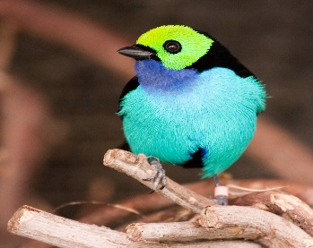
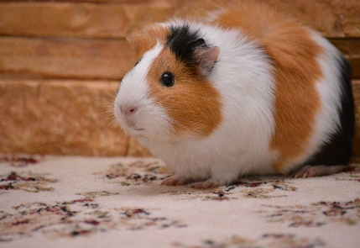
This Photo by Unknown Author is licensed under CC BY-NC-ND
This Photo by Unknown Author is licensed under CC BY-SA
This Photo by Unknown Author is licensed under CC BY-SA
Do you have the cutest pet?
Welcome all Carpenter families.
If you think you have the cutest pet…enter our Cutest Pet Contest.
Any pet photo can enter: Dogs, cats, bunnies, pigs, snakes, any and all critters.
School staff will judge the photos from every grade.
One lucky winner from each grade will win a special prize.
Entry fee is $3 for 1 photo or $5 for 2 photos
Payable by VENMO (M-ScottCarpenterPTA) or by cash or check (sent to the school address below or dropped off in the dropbox in front of the school):
Carpenter PTA Pet Contest
1 Par Ave
Old Bridge, NJ 08857
Picture entries can be emailed to CarpenterPTA@optonline.net. Remember to include the pet’s name, student’s name, grade, teacher, contact information and method of payment.
Get your entries in by December 31, 2020!
The lucky winners will be announced on 1/6/2021.
All money raised will go toward the 5th grade social committee.
Get creative, be silly and just have some fun!
Good Luck!

Any questions can be directed to Connie Leli at ConnieL31974@gmail.com or
732-642-9741

