Bureau Valley Elementary (Manlius) News
November
Unity, Excellence and Pride!
We are what we believe. What we believe unifies us.
We promise to our students and communities to provide a positive learning environment which promotes both academic and social success

Website-- www.bv340.org

Parent Reminders

- In Person Student Absences – Call BVJHE at 815-445-2121 by 9am.
- Remote Students – log in to teacherease.com and check in to e-learning by 10am.
- Pick Up/Drop Off at BVJHE- Allow all buses the right of way…NEVER pass a school bus with lights blinking or stop arm extended.

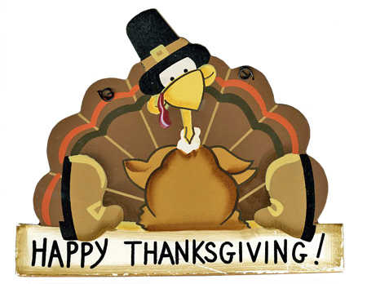

News from Mrs. Salisbury and Mrs. Kuelper’s
5th Grade Classes

The fifth grade students in Mrs. Kuelper's and Mrs. Salisbury's class searched grocery prices for a Thanksgiving meal. The students had to use their math skills and add decimals to find the total cost of a Thanksgiving meal. They searched grocery prices through www.walmart.com. The students could choose between purchasing a ham or turkey. They found the price per pound and calculated what it would cost if they purchased 10 pounds. They also found the price of green bean casserole, stuffing, corn, rolls, potatoes, and dessert. Most of our Thanksgiving meals ranged from $40-$50.

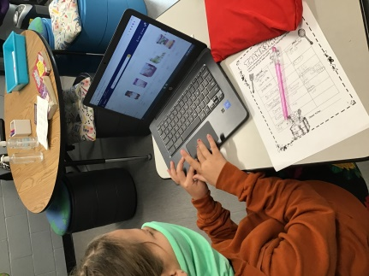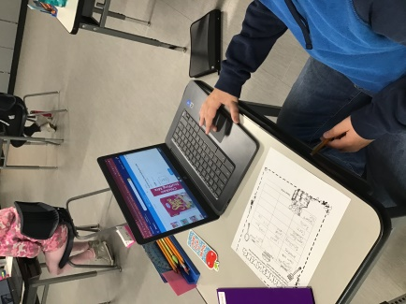

News from Mrs. Salisbury’s 5th Grade Class

Students in Mrs. Salisbury's 5th grade class researched and learned about The Age of Exploration. They learned more information about the most famous explorer Christopher Columbus as well as Ponce de Leon, John Cabot, Henry Hudson, and more.

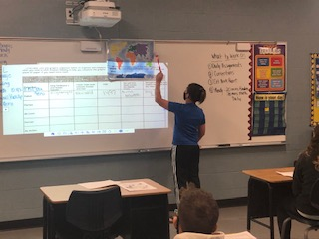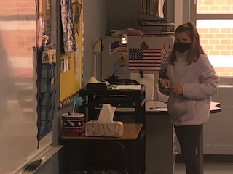

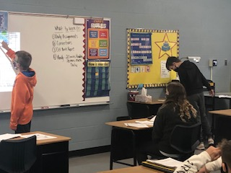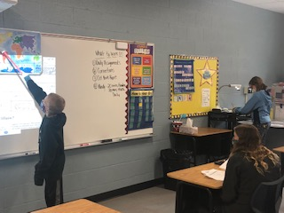

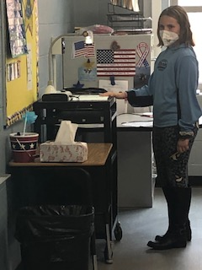

News from Mrs. Kuelper’s 5th Grade Class

Mrs. Kuelper's fifth grade reading class read The Homework Machine by Dan Gutman. The story is about a group of four fifth grade students named the D Squad. They have a secret, a homework machine that does their homework for them. Mrs. Kuelper's class drew a picture of what their own homework machine would look like based on how the book described the homework machine.

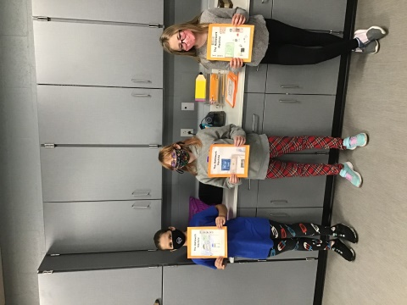

News from Mrs. Bell’s 4th Grade Class

4th grade completed a Mystery Science lesson about turkeys. They discussed the parts of a turkey and the differences in colors between a male and female. To finish, the students designed their own dancing turkey. They added feathers to see how many feathers the turkey could have and keep balanced to dance on the yarn. They discovered they could only add a few without becoming unbalanced.

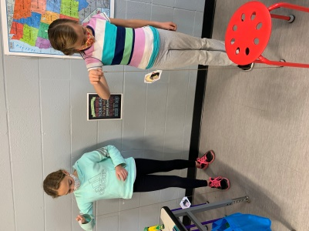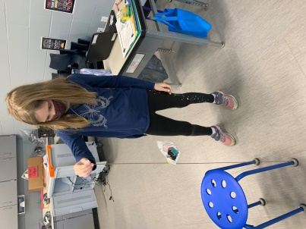
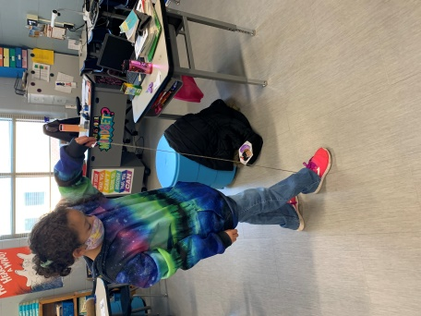

Ms. Bitting’s Third Grade Class

Ms. Bitting's 3rd graders recently learned about the Fall Harvest by shelling their own ears of corn and by examining soybean plants.

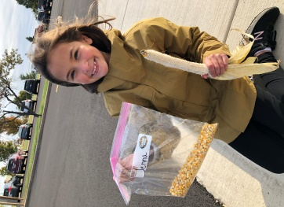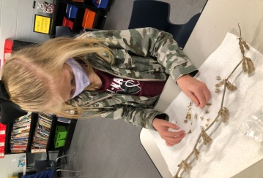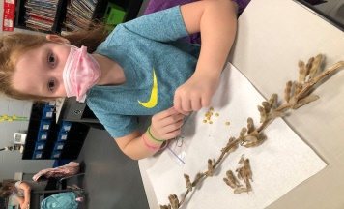

Mrs. McComber’s Third Grade Class

This month both Mrs. McComber's and Ms. Bitting's third grade classes have been working hard to memorize multiplication math facts. They have learned many multiplication strategies or tricks to help them one day multiply numbers with ease.

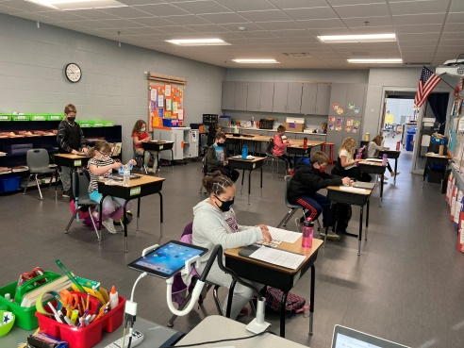

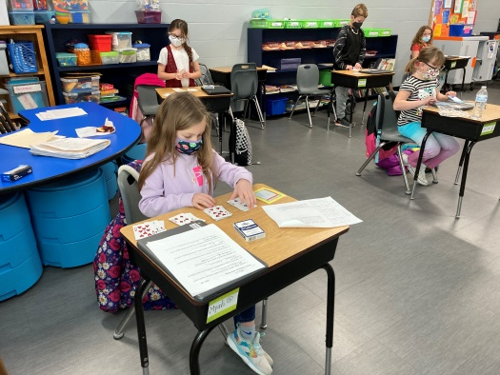

BVJHE SCHEDULE 2020-2021

12/8 3-8 Christmas Concert(Cancelled)
12/18 End of Second Quarter/First Semester
12/21-1/3 Winter Break
1/4/21 Teacher Institute
1/5/21 School Resumes
1/8 Report Cards home
1/18 Martin Luther King Day-No School
2/11 SIP Day 11 am-No Lunch Served
2/12 No School
Mid Term Ends
2/15 President’s Day-No School
2/19 Progress Reports Home
2/22 BVEC Speech Contest
3/5 Spring Pictures
3/12 End of Third Quarter
3/13 BVEC Art Festival
3/18 SIP 11am
3/26 Report Cards home
3/29 Spring Break Begins
4/5 Tenative-No School
4/6 School Resumes
4/22 SIP 11 am
4/23 Mid Term
4/30 Progress Reports Sent Home
5/19 Promotion 7 pm
5/24 Tentative Last Day of School
5/25 Tentative Teacher Institute

