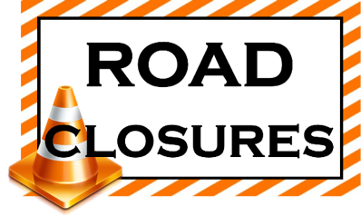
Jourdanton Elementary/ECC Pickup and Dismissal Change Due to Road Construction
The City of Jourdanton will begin construction on LaGarde and Peach streets beginning Monday, November 30th, 2020. Roads will be closed and our traffic patterns will be rerouted.
Please see the attached map to show routes to be taken.
The following procedures will be implemented:
ECC/Elementary students will be release at 3:20 pm to go to the bus, ASK, Smith Village walkers, the Hwy 16 cross walk and employee kids. Car pickups will remain in the classroom until their name is shown on the screen in the room. As the parent arrives, the teacher will be electronically notified and the student will be released for parent pickup.
Elementary- all traffic will route through the employee parking lot, pick up your child in front of the elementary office and you MUST take a right and continue with the traffic flow to the turnaround at the sports complex.
ECC- Parents will enter from LaParita Road on the East end of the employee parking lot. Students will exit the building on the sidewalk on the south side of the ECC building. You will continue around the corner to the left and enter the employee parking lot to exit at the same place you entered. You MUST take a right onto LaParita road and follow the traffic flow to the turnaround at the sports complex.
There is no exit out of Smith Village. Please do not attempt to cut through the Smith Village neighborhood. DO NOT attempt to make U-turns along LaParita Road. We will have staff and police to assist.
Drop off and Dismissal Procedures
 | AM | PM
PK, Kinder and 1st | Must be dropped off at the ECC entrance. | Must be picked up at the ECC or arrangements may be made to be picked up with a Junior High sibling at the Junior High.
2nd-5th | May be dropped off at the Elementary or with their sibling at the ECC and walk to their classroom at the Elementary in the morning. | May be picked up in front of the Elementary office.  May be escorted to the ECC or Junior HIgh for pickup with their sibling. You must notify the office to make arrangements in advance.
To help alleviate multiple stops, please contact the ECC/Elementary offices at 830-769-2121 to make arrangements for siblings to be picked up at one location.

DO NOT drop off PK, Kinder or 1st grade students at the Elementary entrance. They must be dropped off at the ECC.
DO NOT drop off PK-5th grade students at the Junior High.

Please be patient!

