**Middle School News Blast**

Good Afternoon Parents and Guardians,

Just a few reminders about the opening of school next week.

Schedule Change-  The schedule below will be for all 6th-8th grade students to follow whether remote or hybrid in order for all students to attend classes synchronously.  Students will not have a homeroom when they report to school in person.  They are to report directly to period 1 where daily attendance will be taken.  Also, no breakfast or lunches will be served.

PE Classes-   All PE classes will attempt to go outside for PE for as long as we can.  Please make sure your child is prepared with the appropriate clothing for the weather.

Doors for Hybrid Students-  All 6th -8th grade students will enter through Door #1 on the Fifth Street side of the building.  Doors will open at 7:40 for temp checks.  Please make sure you have completed the one-time health waiver in OnCourse before your child reports to school for the first time next week.

Lockers will not be available students.  Please make sure your child is prepared to carry all belongings.

Masks are required at all times.  Please send your child with at least one extra for emergencies.

Chrome books-  Please bring chrome book fully charged and charger to school every day.  Common classroom supplies will not be provided for the students (notebooks, paper, pencils…etc).

PMS Hybrid Schedule:

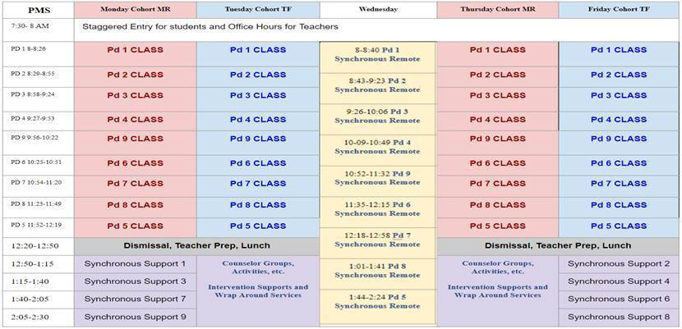

**Please note:** 5th period (lunch) and 9th period were switched in order to allow for a staggered dismissal for the middle school students.  8th period ends at 11:49am but will be slightly extended for the middle school dismissal as follows:

11:49-11:55am the 7th graders will be dismissed via the closest exit.

11:55-12:01pm the 6th graders will be dismissed via the closest exit.

12:01-12:07pm the 8th graders will be dismissed via the closest exit.

All 9th – 12th grade students will be dismissed at 12:19.

Sincerely,

**Kenneth E. Holloway**

Kenneth E. Holloway

Palmyra Middle School Principal

Chief Academic Performance Officer

